- The master schedule for parent product M is as follows:

Week | Gross Requirements
1 | 3400
2 | 4200
3 | 5200
4 | 6300
5 | 7500
6 | 3100
7 | 4600
8 | 5400
9 | 6600
10 | 7800

The policy is to carry no stock on-hand for m₁, which is a subassembly of M. Develop the planned-order release schedule for m₁, assuming a lot-for-lot sizing policy and lead time LT = one week.

- Use the information in Problem 5 to address the decision of the MRP manager who wants to try 2-period ordering. She requests that you compare your lot-for-lot plan with the 2-period plan. Also, she asks, "Would it help to have some SOH"? Make the comparison and answer the question.

9. Develop the lot-for-lot ordering scenario for DVR-alpha part Q, using Table 15-5 in the text and the product-structure tree in Figure 15-12. Note: Q appears more than once in the product-structure tree. Also, observe the number of units of Q that are required for each unit of X and for each unit of B. The lead times for both X and B are zero because they can be assembled immediately. The lead time for Q is one week. Part Q has no other parents or end-items than DVR-alpha.
In addition to providing the quantitative ordering instructions, evaluate the performance of the ordering system.
Hint: Include in the planned-order release chart levels 0, 1, and 2.
Table 15-5 Master DVR Schedule—Alpha and Beta Models

Week
Net requirements | 1 | 2 | 3 | 4 | 5 | 6 | 7 | 8 | 9 | 10
Alpha model | - | 60 | - | - | - | 80 | - | - | 40 | -
Beta model | - | - | 50 | - | - | 20 | - | - | - | 60

15-12

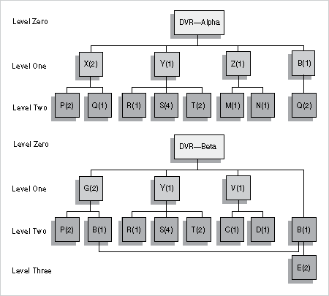
- The matrix of total costs per day for jobs 1, 2, and 3—if assigned at facilities A, B, and C of the Rivet and Nail Factory—is

Facilities
 |  | A | B | C
Jobs | 1 | $1,000 | $900 | $1,200
 | 2 | 800 | 700 | 900
 | 3 | 1,500 | 1,800 | 2,000

What relatively permanent assignments will minimize total costs per day?

- The matrix of costs per part for jobs 4, 5, and 6—if assigned at facilities A, B, and C of the Rivet and Nail Factory—is

Facilities
 |  | A | B | C
Jobs | 4 | $0.10 | $0.19 | $0.12
 | 5 | 0.16 | 0.14 | 0.18
 | 6 | 0.30 | 0.36 | 0.40

The jobs are all of the same size (5,000) and duration. What relatively permanent assignments will minimize total costs?

- The matrix of costs per part for jobs 7, 8, and 9 if assigned at facilities A, B, and C of the Rivet and Nail Factory is described by the matrix:

Facilities
 |  | A | B | C
Jobs | 7 | $0.10 | 0.09 | $0.12
 | 8 | 0.08 | 0.07 | 0.09
 | 9 | 0.30 | 0.36 | 0.40

The jobs are all of the same size (5,000 units) and duration. What relatively permanent assignments will minimize total costs?

- The Door Knob Company has four orders on hand, and each must be processed in the sequential order:
First: Department A—press shop
Second: Department B—plating and finishing
The following table lists the number of days required for each job in each department. For example, job IV requires one day in the press shop and one day in the finishing department.

 | Job I | Job II | Job III | Job IV
Department A | 8 | 6 | 5 | 1
Department B | 8 | 3 | 4 | 1

Assume that no other work is being done by the departments and that "no passing" of jobs is allowed.Use a Gantt sequencing chart (see Figure 16-7) to show the best-work schedule. (Best-work schedule means minimum time to finish all four jobs.)
Figure 16-7 Gantt Sequencing Chart for n× 2 Problem Where n = 5 Persons Being Processed by m = 2 Facilities

3. Line efficiency (A)) is a measure used to assess line balance. It is given by Equation 17-6. Determine line efficiency for The Photo Lab where n = 4, C = 1.5 minutes, and total work content is 4.8.
Equation 17-6

L = TWC/nC = S_{i}t_{i} where and i = all operations

4. Determine line efficiency (described in Problem 3) and relate it to the balance delay measure (given in Equation 17-4) for the following conditions: Total work content is 3 hours; there are 180 stations operating with a cycle time of one minute. Compare the results and meanings of d and A .
Equation 17 - 4

d = 100(nC–S_{i}t_{i}) ÷nC

For The Photo Lab, what happens if t_{max} can be reduced from 1.0 to 0.7 by improving the technology of the film development step i = 6? Refer to Figure 17-2 and Tables 17-2 and 17-3.
Figure 17-2
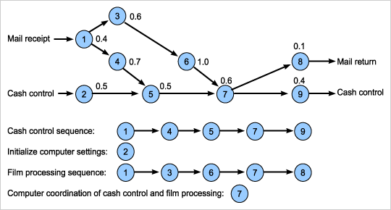

Table 17-2 Operation Times for The Photo Lab

Operation (i) | Operation Time (t_{i}) in Minutes
1 | 0.4
2 | 0.5
3 | 0.6
4 | 0.7
5 | 0.5
6 | 1.0 = t_{max}
7 | 0.6
8 | 0.1
9 | 0.4

Note: t_{max} = 1.0 minute is the longest operation time.

Table 17-3 The Photo Lab's Processing Times

Operation (i) | Operation Time (t_{i}) in Minutes
1 | 0.4
2 | 0.5
3 | 0.6
4 | 0.7
5 | 0.5
6 | 1.0 = t_{max}
7 | 0.6
8 | 0.1
9 | 0.4
TWC | 4.8 = S_{i}t_{i}

Note: TWC = total work content = S_{i}t_{i} = 4.8 minutes.

6. Using the information in Problem 5, what occurs if t_{max} is reduced from 1.0 to 0.6 by installing two photo developing units in parallel for operation (6)? Develop a table similar to Table 17-4.

Table 17-4 The Photo Lab's Chart of Possible Cycle Times, C, Also Hourly Output Rates, O = T/C, for Number of Stations, n

n | C = S_{i}t_{i}/n in Minutes | O = T/C = 60/C Orders/Hour | Total Idle Time in Minutes
1 | 4.8 | 12.5 | 0
2 | 2.4 | 25.0 | 0
3 | 1.6 | 37.5 | 0
4 | 1.2 | 50.0 | 0
*5 | 0.96 | 62.5 | 0
*6 | 0.80 | 75.0 | 0
*7 | 0.69 | 87.5 | 0
*8 | 0.60 | 100.0 | 0
*9 | 0.53 | 112.5 | 0

Note: (* = infeasible)

