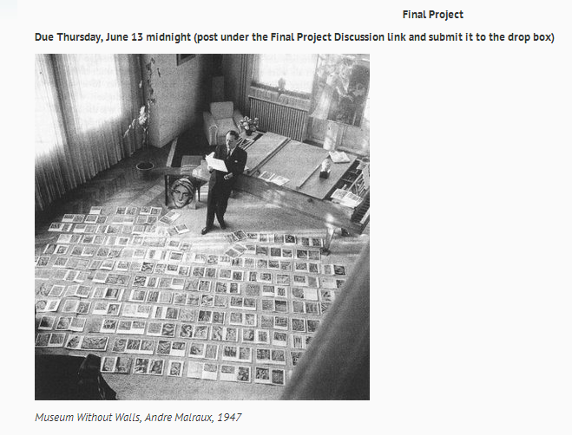

Overview
This project will allow you to explore the wealth of excellent online resources available to art history students. Since your textbook includes only an overview of major works of art and art historical issues, this assignment will allow you to focus on a work or issue in greater detail as it is presented online on a museum or other educational website. By studying a site and presenting a report on that site to your classmates, you will begin to develop a collection of free trustworthy resources at your fingertips, as well as a discriminating eye for scholarly art historical analysis.
Learning Outcomes
By the end of this assignment, you will have:
- Become familiar with a diverse selection of credible online resources in art history
- Learned how to glean useful knowledge from these websites that will aid in your understanding of art history
- Developed an in-depth report on one of these website

Task Description
Review the websites below and select ONE on which you will focus. You can select any one of the sites depending on your interest in a particular region or era. For that site, familiarize yourself with most of the links therein and concepts and artworks covered. Develop a report on this site for the benefit of your classmates in which you summarize the main ideas presented, provide an in-depth description of a couple of those ideas, apply them to the material presented in the appropriate chapter in your textbook (i.e. ancient Greece and Rome, Renaissance Art, Baroque Art, etc), and bring in relevant research to support your observations. Also, bring in a couple of these images as illustrations of these concepts, including one or more of the works considered in the website. Consider the following questions as you proceed: on what does the site focus? Is it informational, argumentative, etc?; What can we learn about the art and its culture that the textbook does not provide?; What questions do you still have? What have you discovered through further research that adds to our understanding of artist, issue, etc? You may come up with other questions and answers, but these are a good place to start.
1) The Cave of Chauvet-Pont-d'Arc
http://www.culture.gouv.fr/culture/arcnat/chauvet/en/index.html

2) The British Museum: Assyria, Babylonia, Sumer
http://www.mesopotamia.co.uk/menu.html

3) History: The Egyptians
http://www.bbc.co.uk/history/ancient/egyptians/
4) The Parthenon Marbles: The British Museum vs. The Hellenic Ministry of Culture
http://www.britishmuseum.org/the_museum/news_and_debate/debate/parthenon_sculptures.aspx
and http://odysseus.culture.gr/a/1/12/ea120.html

5) The False Door: Dissolution and Becoming in Roman Wall-Painting
http://creadm.solent.ac.uk/custom/rwpainting/cover/index.html
6) Beyond the Fingers: The Sistine Chapel Revealed
http://www.ronibennun.com/beyond/beyond.html

7) Universal Leonardo (on the Renaissance artist, Leonardo da Vinci)
http://www.universalleonardo.org/
8) Johannes Vermeer's Woman Holding a Balance (National Gallery of Art)
http://www.nga.gov/feature/vermeer/index.shtm
You might also watch the short video on this painting produced by the National Gallery. You can find it here http://www.nga.gov/podcasts/ Click on "The Collection" on the left side of the page and scroll down until you reach "Vermeer: Master of Light-Woman Holding a Balance, Part I."

Process & Requirements:
1) Thoroughly review your chosen website. Create an outline or diagram on paper as you do this so that you can better understand how the site is designed and what topics are covered. In your own words, summarize the main ideas. Note the direction or purpose of the site. Right click and save a couple of the images that you believe are good illustrations of these ideas. Or, search for these images online and import them into your report. Note any artists or works that are covered both on the website and in your textbook and compare the information given on them. If available, please make sure that you credit the artist and work by giving the name, title, date, and medium!
2) Conduct a little bit of research online on this topic. Try to determine the website's accuracy, learn more about the topic, and/or compare it with other works by the same artist or from the same period by seeking out a good, online resource on the subject. These sites are good places to start: http://arthistoryresources.net/ARTHLinks.html; http://www.besthistorysites.net/index.php/art-history; and http://smarthistory.khanacademy.org/ . Find 1 good source and integrate any information found here into your presentation, if relevant to your topic. Make sure you cite your source by author and/or site name within your presentation. Please note that sites like Wikipedia or an unverifiable source (personal blog, etc.) are NOT acceptable sources for this presentation.
3) Gather all information and create a 6+ page report using one of the following:
a) Powerpoint
b) MS Word
c) Prezi (http://prezi.com/ )
d) Any other suitable presentation software

4) Include the title and link to your site within your report
5) Post your final report under the drop box AND in the "Final Project Discussion" forum as an attachment by the due date. There, your classmates will be able to view and comment on your work.
6) You MAY NOT copy and paste the text from the website. Your writing must be your own. If you plagiarize, you will not receive credit for the assignment. Ask me if you need help with this concept. Here's a good link on the subject of plagiarism http://owl.english.purdue.edu/owl/resource/589/02/

Evaluation
This project will be worth 20 points.
You will be evaluated according to the following:
Content 5 points
5-4: Provides a thorough description of the site, including in-depth analyses of a couple of the topics covered; applies these concepts to textbook readings; integrates research found through at least 1 credible, academic source; images included and used to illustrate ideas
3-2: Provides an adequate description of site, but more overview than analysis; barely applies concepts to textbook readings; integrates some outside research, but not much; images included but not described
1 ↓: Poor description of website; no attempt to relate site to textbook readings; no evidence of research conducted; no images included

Design of Presentation/Report 5 points
5-4: Design of report is thoughtful and creative, easy to read and understand; topics arranged by subject heading; images posted alongside text and credited; website name AND link included

3-2: Design of report is of average quality, somewhat easy to read and understand; topics not arranged by subject heading; images out of order; either website name OR link are included

1 ↓: Design of report is of poor quality and difficult to follow; no images included; neither website name NOR link are included

Mechanics 5 points

5-4: Contains minor, if any, errors in spelling and grammar
3-2: Contains a handful of errors in spelling and grammar
1 ↓: Contains many errors in spelling and grammar

Timeliness 5 points

5: Posted on due date
4-3: Posted 1-2 days late

2 ↓: Posted more than 2 days late
