You will be designing a simple Sudoku Game. The rules of Sudoku can be found on web. The rules are explained:

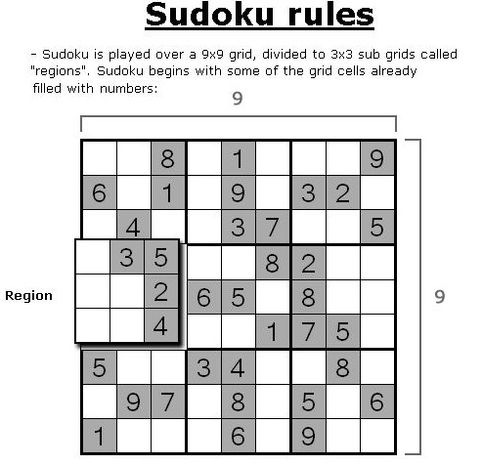

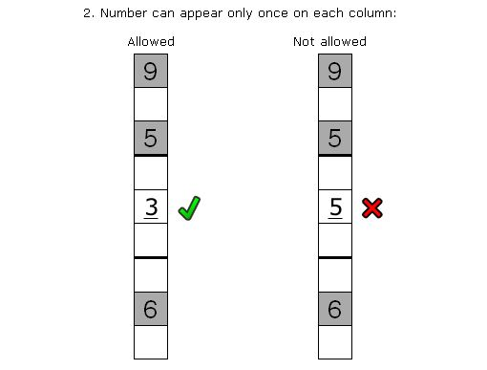

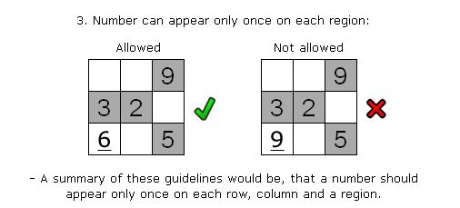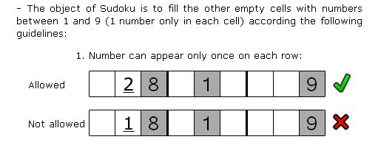

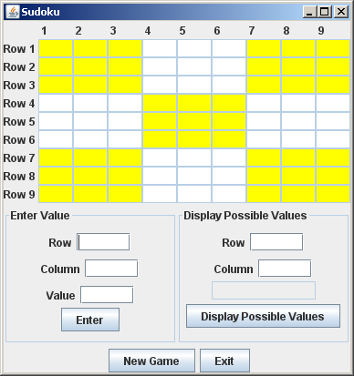

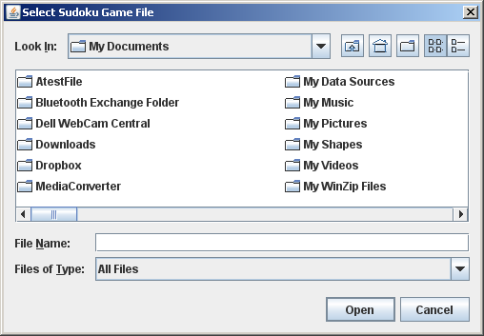

When the New Game button is selected, the user selects a file with the FileChooser

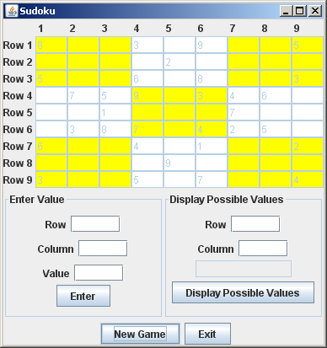

The file is then read and displayed

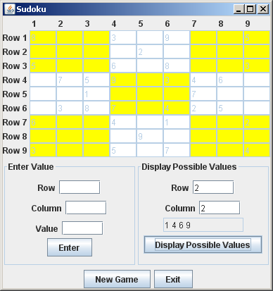

When the user selects the Display Possible Values button, all valid values for Row 2, Column 2 are displayed.

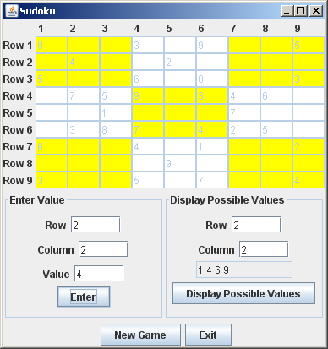

When the user selects the Enter button, the value is displayed at the row 2, column 2 if the value is valid for row 2, column 2.

Examples of Error Messages

ValueNotValidException

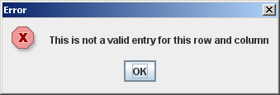

InputOutOfRangeException

