CVS – Income Statement



CVS – Balance Sheet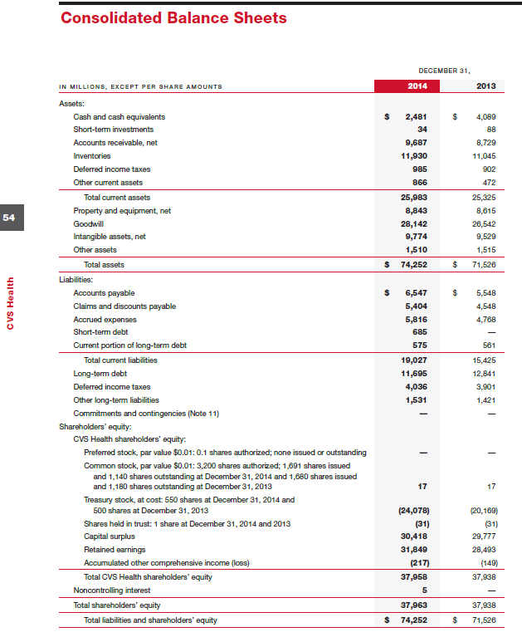

Walgreen’s – Income Statement



Walgreen’s – Balance Sheet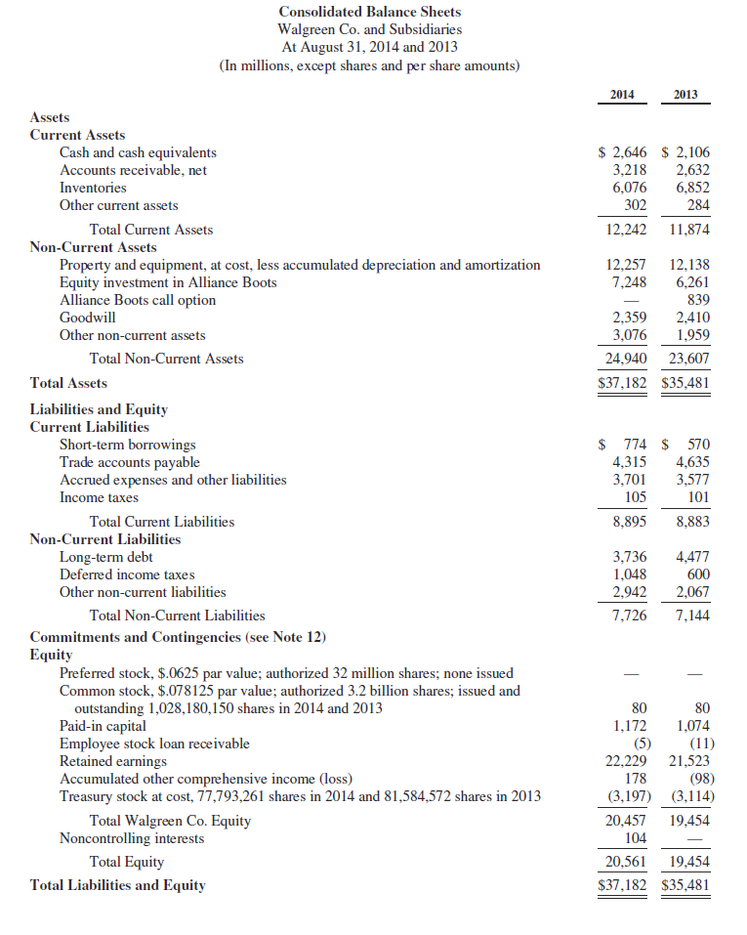

Rite Aid – Income Statement



Rite Aid – Balance Sheet+