**GRAPHING TEMPLATE –** print this document and hand draw your answers on the graphs provided. Then scan your work into a SINGLE multi-page pdf. You will be able to attach that pdf file to your homework submission on ANGEL.

**Graph 1:**

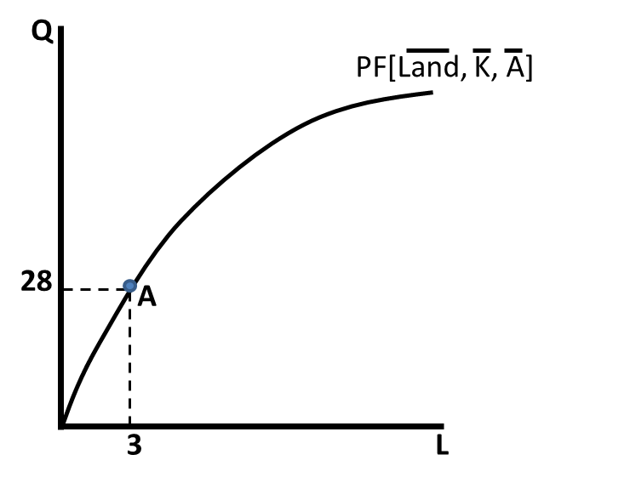

**Graph 2:**

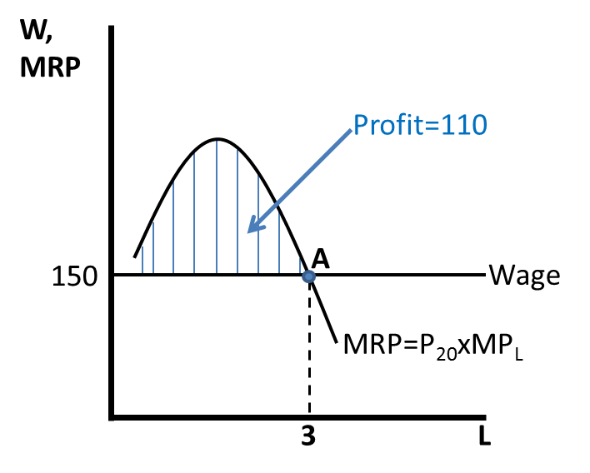

**Graph 3:**



**Graph 4:**



**Graph 5:**

