- Determine which of the following numbers could not represent the probability of an even.
0, 0.023, -0.7, 50%, 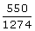,

- Identify the sample space of the probability experiment and determine the number of outcomes in the sample space.
Randomly choosing an even number between 1 and 10, inclusive

- Classify the statement as an example of classical probability, empirical probability, or subjective probability. Explain your reasoning.

A study on a college campus shows that 77% of the students like rap music.

- A family has four children. Use the tree diagram to answer each question.
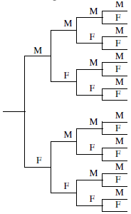
Choose the correct sample space.
- { (FFFF), (FFFM), (FFMM), (FMMM), (MMMM) }
- { (F), (M) }
- { (FFFF), (FFFM), (FFMF), (FFMM),(FMFF), (FMFM), (FMMF), (FMMM), (MFFF) , (MFFM), (MFMF), (MFMM), (MMFF), (MMFM), (MMMF), (MMMM) }
- { (FFFF), (FFFM), (FFMM), (FMMM), (MFFF), (MMFF), (MMMF), (MMMM) }

Choose the correct outcome(s) of having exactly zero girls.
- { (FFFF) }
- { (MMMM) }
- { (MMFF), (MFMF), (MFFM), (FMMF), (FMFM), (FFMM) }
- { (MMMF), (MMFM), (MFMM), (FMMM) }

- Use the bar graph below, which shows the highest level of education received by employees of a company, to find the probability that the highest level of education for an employee chosen at random is C.
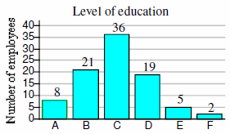

- An individual stock is selected at random from the portfolio represented by the box-and-whisker plot shown to the right. Find the probability that the stock price is (a) less than $21, (b) between $21 an $57, and (c) $34 or more.
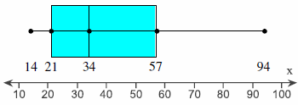

- Determine whether the events E and F are independent or dependent. Justify your answer.
- E: A person attaining a position as a professor.
F: The same person attaining a PhD.
- E: A randomly selected person having a high GPA.
F: Another randomly selected person having a low GPA.
- E: The rapid spread of a cocoa plant disease.
F: The price of chocolate.

- The table below shows the results of a survey in which 147 families were asked if they own a computer and if they will be taking a summer vacation this year.
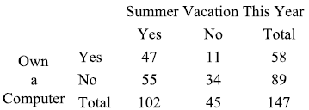

- Find the probability that a randomly selected family is not taking a summer vacation this year.
- Find the probability that a randomly selected family owns a computer.
- Find the probability a randomly selected family is taking a summer vacation this year given that they own a computer.
- Find the probability a randomly selected family is taking a summer vacation this year and owns a computer.
- Are the events of owning a computer and taking a summer vacation this year independent or dependent events?

- Suppose you just received a shipment of eight televisions. Three of the televisions are defective. If two televisions are randomly selected, compute the probability that both televisions work. What is the probability at least one of the two televisions does not work?

- By rewriting the formula for the multiplication rule, you can write a formula for finding conditional probabilities. The conditional probability of event B occurring, given that event A has occurred, is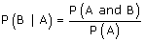. Use the information below to find the probability that a flight departed on time given that it arrives on time.

The probability that an airplane flight departs on time is 0.89.
The probability that a flight arrives on time is 0.87.
The probability that a flight departs and arrives on time is 0.81.

- Determine whether the statement is true or false. If it is false, rewrite it as a true statement.

If two events are mutually exclusive, they have no outcomes in common.

- During a 52-week period, a company paid overtime wages for 19 weeks and hired temporary help for 10 weeks. During 6 weeks, the company paid overtime and hired temporary help. Complete parts (a) and (b) below.
- Are the events “selecting a week that contained overtime wages” and “selecting a week that contained temporary help wages” mutually exclusive?
- If an auditor randomly examined the payroll records for only one week, what is the probability that the payroll for that week contained overtime wages or temporary help wages?

- The percent distribution of live multiple-delivery births (three or more babies) in a particular year for women 15 to 54 years old is shown in the pie chart. Find each probability.
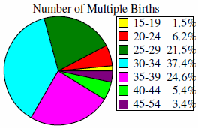

- Randomly selecting a mother 30-39 years old
- Randomly selecting a mother not 30-39 years old
- Randomly selecting a mother less than 45 years old
- Randomly selecting a mother at least 20 years old

- Find P (A or B or C) for the given probabilities.
P (A) = 0.34, P (B) = 0.27, P (C) = 0.17
P (A and B) = 0.11, P (A and C) = 0.03, P (B and C) = 0.09
P (A and B and C) = 0.01

- When you calculating the number of permutations of n distinct objects taken r at a time, what are you counting?

- Evaluate the given expression and express the result using format for writing numbers (instead of scientific notation).
₄₇P₂

- Perform the indicated calculation.
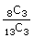

- Decide if the situation involves permutations, combinations, or neither. Explain your reasoning.

The number of ways 20 people can line up in a row for concert tickets.

- Suppose Grant is going to burn a compact disk (CD) that will contain 10 songs. In how many ways can Grant arrange the 10 songs on the CD?

- A horse race has 12 entries and one person owns 5 of those horses. Assuming that there are no ties, what is the probability that those five horses finish first, second, third, fourth, and fifth (regardless of order)?

- In how many orders can three broken computers and two broken scanners be repaired if (a) there are restrictions, (b) the scanners must be repaired first, and (c) the computers must be repaired first? (d) If the order of repairs has no restrictions and the order of repairs is done at random, what is the probability that a scanner will be repaired first?

