Kerry has a budget of $M to spend on two goods: X and Y. The price of good X is $6 per unit and that of good Y is $5 per unit. Kerry’s budget line is presented below. At the most affordable point, Kerry consumes 8 units of good X and A units of good Y.

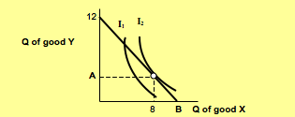

- Find the values of M, A and B.

- At the most affordable point, what is Kerry’s marginal rate of substitution (MRS) of good X for good Y? Explain briefly how you obtain the result.
- Copy the budget line and indifference curve I₂ on your answer sheet. Suppose the prices of good X decrease by $2 per unit. Sketch (as accurately as you can) the new budget line in the diagram and indicate the new equilibrium point by drawing an additional indifference curve.

- In part (c), is it possible that when the price of good X goes down, its consumption also goes down?
Food Stamps
- A country recently passed a food stamp legislation. Qualified households are given food stamps, which can be used to purchase foods, but they cannot legally re-sell the food stamps. Suppose a household receives a grant of $600 of food stamps per month. How will this household’s budget line be affected? (Hint: Consider two goods: food and other goods.)
- Show that if the food stamps could be legally re-sold, the household would be better off. Give one reason why food stamps should not be re-sold.

