Biology 106 Epistasis/Sex linked Traits

Answer each question in the space provided (in your own words of course). There is more than ample space for the answers. Don’t worry if your answer doesn’t take up the entire space!! ☺ Remember to use your name and the assignment name for the file name.

1. Marfan syndrome is a dominant disorder. In the cross Mm x mm, what percentage of the children are expected to inherit the disorder? Explain your answer.

2. How does non-disjunction cause Down syndrome? What is specifically happening in which process to cause this disorder?

3a. Labrador retrievers coat color is controlled by two genes. For the cross bbEe x BbEe, list the gametes produced by each parent.

3b. What color puppies will this cross produce?

3c. List the percentage for each color from this cross.
4a. Why are there more males with red/green colorblindness than females?

4b. If Xc denotes the colorblindness allele and X denotes the normal vision allele; From the cross XcX x XY What percentage of boys will be colorblind? What percentage of girls will be colorblind?

5. Shown below is an incomplete pedigree for color blindness within a family. Individuals
with “?” provide no information for their phenotype. For all other individuals their genotype is evident from the diagram. From the information provided determine the genotypes and phenotypes for all individuals. Using the numbers in the diagram below, fill in the table that follows. You must determine which individuals are carriers and or afflicted from the
information provided.

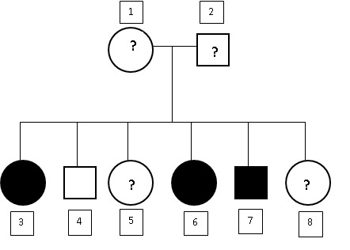

Individual | Gender | Genotype | Phenotype  (Normal/Carrier/Colorblind)
1
2
3
4
5
6
7
8

6. Explain your determination of which individuals are carriers.

Use your textbook, notes and this website to answer the pre lab questions. http://biology.clc.uc.edu/Courses/bio105/sex-link.htm http://anthro.palomar.edu/biobasis/bio_4.htm http://www.biology.arizona.edu/Mendelian_genetics/problem_sets/sex_linked_inheritanc e/sex_linked_inheritance.html

PreLab Questions:

1. Define the term sex linked in your own words.

2. List 3 common human sex linked traits.

3. What is the most common sex linked trait in fruit flies.

4. What is the genotype of a colorblind female?

5. Define the genetic usage of the term “carrier”.

6. Can a male be a carrier of an X linked sex linked trait? Why or why not?
Click on the link below to access the online lab.

http://www.mhhe.com/biosci/genbio/virtual_labs_2K8/pages/LinkedTrait.html

Download and print the instructions for reference as you work through the lab. As you work through the lab fill in the table below. Use this information to answer the questions that follow contained in this document.

Begin by clicking on the notebook on the right hand side of the lab table. Explore the genetics of eye color and wing types by crossing various flies. Once you’ve chosen your parental flies above and to the left of the punnet square, drag what you think the baby flies will be from the row below the punnet square. Do as many crosses as you like clicking on the check button to check your answers.

Getting Started Questions (2 points total)

. What is/are the genotype(s) for a red eyed female?

. What is/are the genotype(s) for a white eyed female?

. What is/are the genotype(s) for a red eyed male?

. What is/are the genotype(s) for a white eyed male?

1 . Which eye color is dominant in fruit flies?

When you are done practicing the punnet squares click on the [return] button to go back to the lab.

Click on the shelves with all the flies in jars on the center of the lab bench. This will take you to a new page where you can complete the crosses of your chosen flies. Click and drag the flies you wish to mate to the ‘empty’ jar in the center of the shelf below to begin. Click on [mate and sort] to see the results of the mating. Every time you begin a new cross you start at the top shelf. Once that mating is complete, you then choose from the third shelf (the results of your parental cross) for the F1 cross – again click on mate and sort to see the results. Once both crosses are completed click on reset to move on to the next cross of the experiment as directed by this lab document. Fill in the tables below. Each table begins with a parental pairing. Remember that only the top shelf parental generation is guaranteed to be homozygous for the allele you are studying!!
Cross 1: Parental Red Eyed Female with Parental Red Eyed Male

Number of Red eye,  Male Offspring | Number of White  eye, Male Offspring | Number of Red eye,  Female Offspring | Number of White  eye, Female  Offspring
Now that you have the F1 generation from your parental cross; Choose a red
female and a red male to continue.

F1 Cross: Red Female x Red Male

Number of Red eye,  Male Offspring | Number of White  eye, Male Offspring | Number of Red eye,  Female Offspring | Number of White  eye, Female  Offspring

1 . Why are there no white eyed offspring?|

Click on reset to prepare for the next cross
Cross 2: Parental Red Eyed Female with Parental White Eyed Male

Number of Red eye,  Male Offspring | Number of White  eye, Male Offspring | Number of Red eye,  Female Offspring | Number of White  eye, Female  Offspring

1 . Why are there no white eyed offspring?| Think about the genetics – this question will have a different answer to the previous question.
Choose a red female and a red male from your F1 flies of Cross 2. F1 Cross: Red Female x Red Male

Number of Red eye,  Male Offspring | Number of White  eye, Male Offspring | Number of Red eye,  Female Offspring | Number of White  eye, Female  Offspring

Click on reset to prepare for the next cross
Cross 3: Parental White Eyed Female with Parental Red Eyed Male

Number of Red eye,  Male Offspring | Number of White  eye, Male Offspring | Number of Red eye,  Female Offspring | Number of White  eye, Female  Offspring

1 . If white is recessive, how did you get white flies in this generation? Why are all the white flies from this cross male?

Choose a red female and a white male from your F1 flies of Cross 3.
F1 Cross: Red Female x White Male

Number of Red eye,  Male Offspring | Number of White  eye, Male Offspring | Number of Red eye,  Female Offspring | Number of White  eye, Female  Offspring

Post Lab Questions:
X-linked Sex Linked traits follow the same inheritance pattern in humans as they do in
fruit flies. From your newly acquired knowledge answer the questions below.

1 . A woman is a carrier for hemophilia, if she has children with a ‘normal’ male what is the chance they will have a daughter with hemophilia? Explain your answer

1 . If this same pair were to have a male child what is the chance that he would have hemophilia? Explain your answer.

1 . For a female to be colorblind, what are all of the possible genotypes of her parents?

1 . Can a normal (non carrier) female have a colorblind child? Why or Why not?

Complete all answers in the space provided. Remember to add your last name and first initial to the file name when you save it prior to submitting through Canvas.

Complete the “How Does DNA Work?” tutorial prior to doing this assignment. Go to the following webpage: http://www2.edc.org/weblabs/WebLabDirectory1.html Click on the How Does DNA Work button

You’ll know you’re in the right place when you see the screen below:

1. What protein (enzyme) transcribes DNA into RNA?

2. What are the structural differences between DNA and RNA?

3. Explain what complimentary base pairing is with respect to DNA synthesis, transcription and translation.
4. What is the RNA start codon for translation?

5. The table below is a segment of double stranded DNA (shown in the two center columns). Transcribe the DNA into RNA by filling in columns 1 and 4.

RNA | DNA |  | RNA
Side 1 | Side 1 | Side 2 | Side 2
 | G | C
 | A | T
 | T | A
 | A | T
 | C | G
 | A | A
 | G | C
 | T | A
 | G | C
 | G | C
 | G | C
 | C | G
 | T | A
 | G | C
 | T | A
 | A | T
 | C | G
 | T | A
 | T | A
 | T | A
 | T | A
 | A | T
 | G | C
 | G | C
 | T | A
 | A | T
 | A | T
 | T | A
 | T | A

6. Translate your transcript from question 5 into a protein (amino acid sequence). Remember the differences between DNA and RNA when transcribing. Use your codon table for the translation. Pay attention to where to start translation. Your answer should be the three letter abbreviation of each amino acid name in order from the beginning to the end of the sequence.

7. What is mRNA? Where is it made? What is its function in the cell?

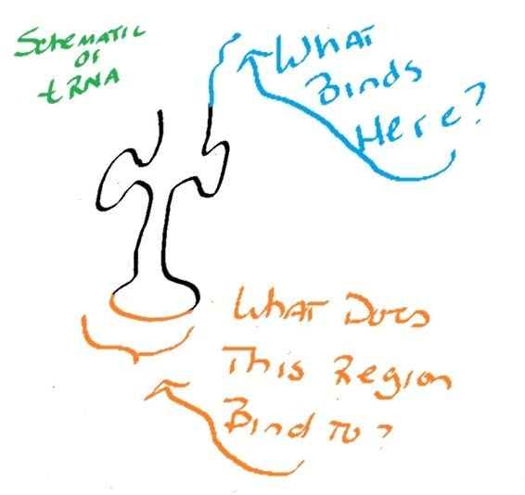
8. Using the adjacent schematic of tRNA answer the following two questions:

What binds at the blue region in the diagram?

What does the orange region at the bottom bind to?

9. Where is tRNA located in the cell?

10. What process is tRNA involved in, in a normal cell?

