**SCENARIO A** - Consider a firm that has the following relationship between labor and output, i.e., a production function. Along this production function, we hold land, capital (K) and technology (total factor productivity) fixed.

**TABLE A- The current wage is $150 and the price of output (Q) is $20.**

|  |  |  |  |  |  |
| --- | --- | --- | --- | --- | --- |
| L | Q | MPL | MRP | Marginal Profit | Total Profit |
| 0 | 0 | ------ | ------- | -------------------- | 0 |
| 1 | 8 | 8 | 160 | 10 | 10 |
| 2 | 20 | 12 | 240 | 90 | 100 |
| 3 | 28 | 8 | 160 | 10 | 110 |
| 4 | 35 | 7 | 140 | -10 | 100 |
| 5 | 41 | 6 | 120 | -30 | 70 |
| 6 | 45 | 4 | 80 | -70 | 0 |

*note that the values in the shaded part of the table are provided, but you should able to calculate all of these values. You will need to fill in similar tables in homework 3, so make sure you are comfortable with these calculations NOW.

**It should be clear from this table that the profit maximizing amount of labor is 3, the profit maximizing amount of output (Q) is 28 and maximum profit is $110.**

A sketch of this firm’s production function, including the profit maximizing Q and L combination (labeled point A) is shown below. You should be able to hand sketch this production function using the information from table A.



A sketch of this firm’s W/MRP labor market diagram is shown below. The profit maximizing point is labeled (point A) and the blue shaded area is the profit. You should be comfortable hand sketching the graph below using the information from table A.

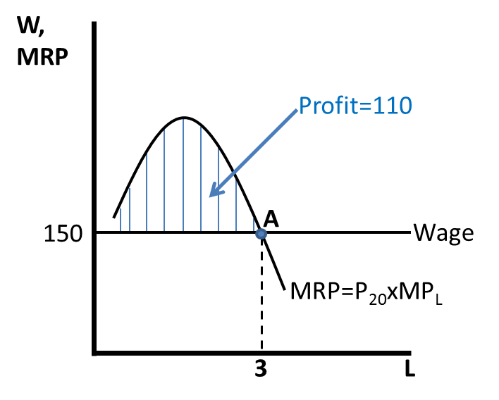

**Scenario A will be your starting point for homework 3. You will be examining several alternative scenarios for this firm (Scenario’s B, C and D), and each time you will compare the new situation to the original case in scenario A.**