INFS3380: Fall 2014: Assignment 2:
There is an opportunity to get some extra credit in this assignment. The extra credit part is discussed at the end of Assignment 2C in this document.

- All pages (including the extra credit part, if done) must be HTML5 and CSS compliant.
- All HTML and CSS files should have appropriate comments.
- Use Notepad,TextPad or Notepad++ to do all works of this assignment.
- Do not use any other HTML generating software like Dreamweaver, or any other similar software. If you use other software you will receive a grade of “zero” in your assignment.
- Read the section “General Policies for Assignments: INFS 3380” in Section 7 of our course syllabus.
- Friendly Note:Do not use align=”left” or (right) attribute to align an object. The align attribute has been deprecated. If necessary, use float:left (or right) in the CSS.
- Your folder structure for this assignment should be as shown in Figure 1 in next page.
- If you are using external style sheet, you will need to validate the CSSfile. You should validate the HTML file for HTML5 compliance. If you try to validate the CSS compliance for a HTML source code that uses external CSS, you may receive a File Not Found error. In these cases, you need to validate the external css file using the CSS validator.
- Essentially, in this assignment you will progressively improve the web site for Pacific Trails Resort as outlined in the Web Site Case Study sections of Chapter 3 (Assignment 2 Part A), Chapter 4 (Assignment 2 Part B) and Chapter 6 (Assignment 2 Part C). For each of these sites the author has given the instructions on developing the pages; however you will need to override some of the instructions to meet the instructor’s submission requirements and make necessary adjustments (such as including the “UnderConstruction” page in each of the sites in 2A, 2B and 2C. Also I have outlined certain minor changes in the names of the source documents, titles, first h1 and in the footer sections of each of these pages (shown later in this assignment).
- Please see Figure 1.0 for the sites folder structures to be implemented in this assignment.

Figure 1.0: Folder Structures for Assignment 2:
Notes:
- Create a folder named YourInitialsAsn2. Create three subfolders named YourInitialsAsn2A, YourInitialsAsn2B, YourInitialsAsn2C in the above folder. Each of these subfolders will be treated as the a web site for the case study in Chapter 3, 4 and 6, respectively.
- In the following figure, each of the resources in yellow background would be your own source code or CSS file (of course to be named with your initials as prefix (rather than my initials)
- All of the image files are available in the Assignment 2 Resources zip file.

Contents of YourInitialsAsn2 folder
Contents of YourInitialsAsn2A sub folder | Contents of YourInitialsAsn2A/Images sub folder
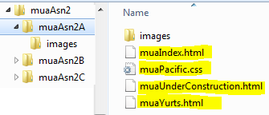 | 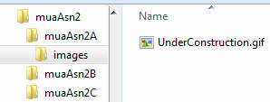
Contents of YourInitialsAsn2B sub folder | Contents of YourInitialsAsn2B/Images sub folder
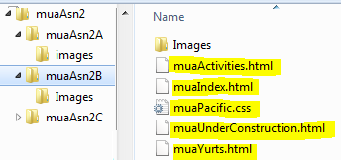 | 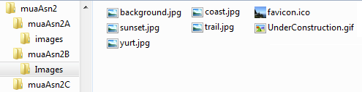
Contents of YourInitialsAsn2C sub folder | Contents of YourInitialsAsn2C/Images sub folder
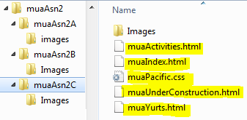 | 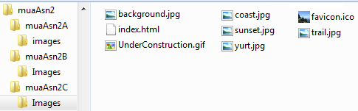

Assignment 2A

In this part of the assignment, you will need to develop an external style sheet and then employ this external style sheet to develop the pages as described in the Pacific Trails Resort case studystarting from page 127 (in Chapter 3) of the textbook with certain modifications as described by me. Obviously, you will have to override some of the step-by-step procedures specified by the author and as described below:
- If you have completed Asn1A, you may copy all resources of Asn1Aand paste those in your Asn2Asubfolder. Then you will have to modify certain parts of the pages (including the comments, title and certain contents) as described later in this assignment (and in the textbook).Please be sure to include and revise the “Under Construction” page too.
- Actually the author has not asked you to develop any new page here except that you will need to apply your external style sheet in your Index and Yurts pages done in Assignment 1A.
- As you have done in Assignment 1A, you will need to develop (or modify) the “Under Construction” page too.
- Observe my screen shots on Assignment 2A (in Figures 2A1throughFigure 2A3) and the screen shots in pages starting from page 127 of the textbook to understand the requirements of this assignment. Be sure to copy the appropriate images folder from the unzipped Asn2Resources.zipfile and save it in your Asn2A folder (as the images sub folder of your Asn2A folder).
- In the case-study, the author has given certain step-by-step procedures to develop the pages. Use your common sense to adjust some of these steps to satisfy the additional requirements for our class. Specifically, note the following adjustments.

General modifications to do in the textbook’s step-by-step instructions starting (in Page 127 chapter 3)
Page 127:
- Task 1: Ignore the author’s instructions. Follow my instructions to create an appropriate folder and subfolders as shown in Figure 1 (in page 1 of this assignment). Also name the html files and CSS files prefixed with yourInitialsas shown in Figure 1.You will find all necessary resources in the Asn2Resurces.zip file.
- Task 2: Name the CSS File as YourInitialsPacific.css (like I named mine one as muaPacific.css)

As you will observe from my screen shots in Figure 2A1 through Figure 2A3, you will see the following following:
- For each of your source documents in this assignment, you will need to change the title, and enter the first h1 as shown in the these figures (ans also as shown below).

<h2> Asn2A Home Page M. Ahmed </h2>

Of course you will need replace my name with your name. You should also adjust the titles of the pages as shown in my screen shots. For example the title of the home page would be:Asn2A Home Page by M. Ahmed.

Be sure to adjust all comments in all re-used documents (that you may have copied from your Assignment 1A folder), or subsequently from Asn2A folder to Asn2B or 2C folder.

You should also modify your Under Construction page and link it to the external revised CSS. All hyperlinks in all pages must also be adjusted appropriately.

Hints:Since some of you are new to external css, I will give you an excerpt of my code (not all though). Here it is:

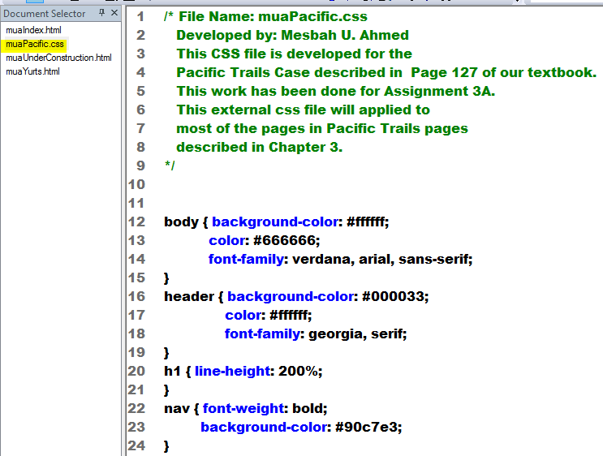

Figure 2A1: The Home Page in Firefox(for Asn2A)
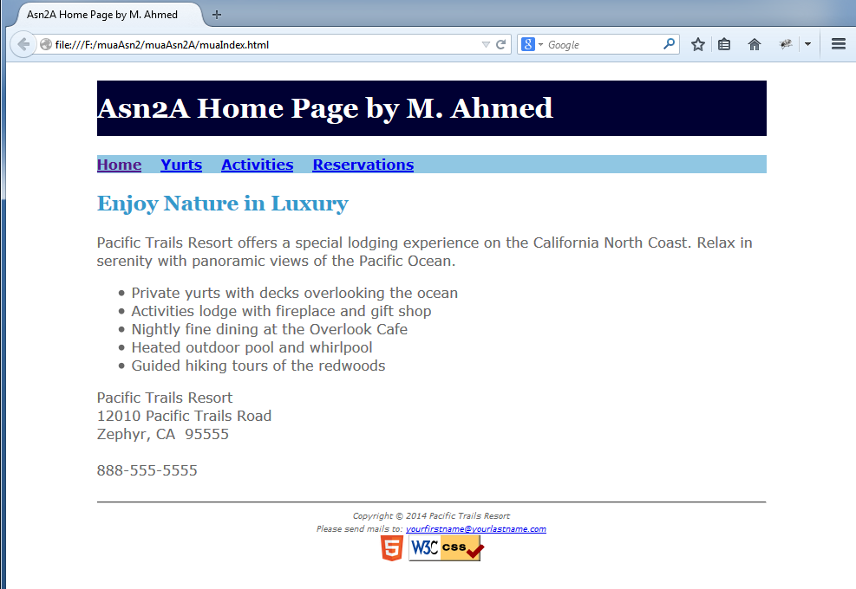
Observe the HTML5 & CSS compliance logos
This is a <hr/>
Observe the<h1>
Replace my name with your name. Keep the name adequately short please
Observe the title of the page

Note: The footer in each of these pages is slightly different from that of Assignment1A pages. Before the mail to link add a text as “Please send mails to:”

Observe that all pages in this assignment are displayed as “centered” and the pages are somewhat flexible as each page self-adjusts itself as you increase or reduce the size of the browser’s window (also known as View Port).
Figure 2A2: The Yurts Page in Firefox (for Asn2A):
Observe the title of the page
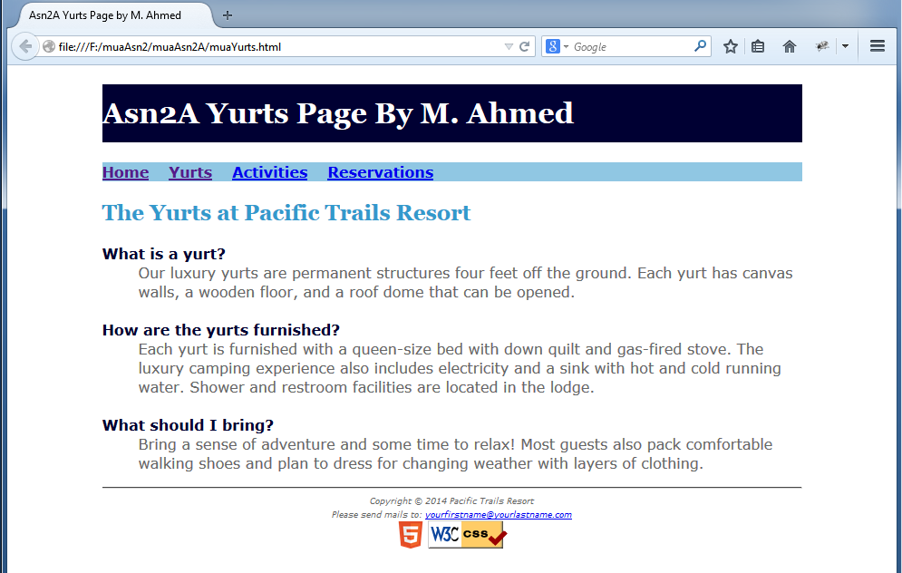
Observe the HTML5 & CSS compliance logos
This is a <hr/>
Observe the<h1>
Replace my name with your name. Keep the name adequately short please

Figure 2A3: A Recommended UnderConstructionPage:You may develop your own page, but it should employ the same external sheet (as was used in Home and Yurts pages. If the user clicks the Activities or Reservations hyperlinks, this page should be displayed.
Observe the<h1>
Replace my name with your name. Keep the name adequately short please
Observe the title of the page
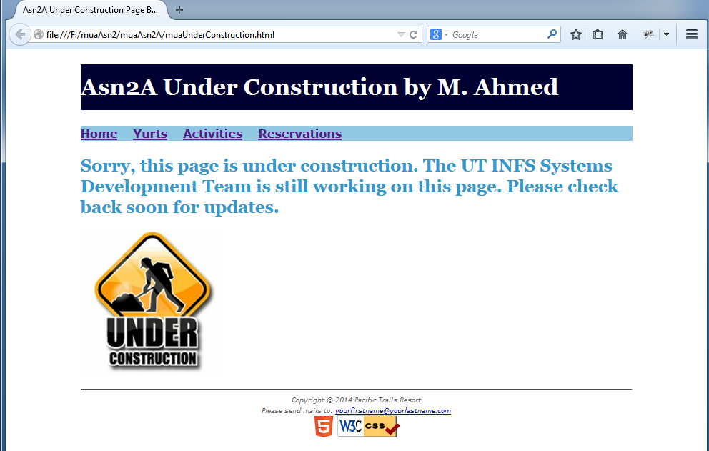
UnderConstruction.gif
This is a <hr/>
Observe the HTML5 & CSS compliance logos

Observe the HTML5 & CSS compliance logos
This is a <hr/>

Assignment 2B

In this part of the assignment, you will develop the pages for the Pacific Trails Resort case study as described in Chapter 4 pages 191 to 194 of our textbook with certain modifications to meet my expectations. I assume that you have already created a sub folder named yourInitialsAsn2B in your yourInitialsAsn2folder.

To minimize your work, you may copy all html and CSS files from yourInitialsAsn2A folder and paste these in yourInitialsAsn2B folder. Caution: Simply copying and pasting will not complete the job. Remember that you will need to adjust all comments, titles and the first <h1> accordingly. You will also need to modify and apply the matching external CSS file so the pages are displayed as shown in figures 2B1 to 2B4. Also be sure to adjust the comments in your CSS file.

Now copy the Images subfolder from Asn2B subfolder of the Asn2Resources.zip file and paste it in yourInitialsAsn2B folder. You will need to modify, and add some more rules in the CSS file for Assignment2B as described in the textbook. In this part of the assignment, the author has asked you to develop a new page named Activities.html. You must name this page as yourInitialsActivities.html.

First observe my screen shots (in figures 2B1 through 2B4) and the textbook’s figures to see the differences. Your objective would be to develop or revise the relevant pages as shown in my screen shots in this assignment.Please use your common sense to ignore some of the author’s instructions so that your work meets my expectations of your completed work.

Figure 2B1: Home Page for Asn2B
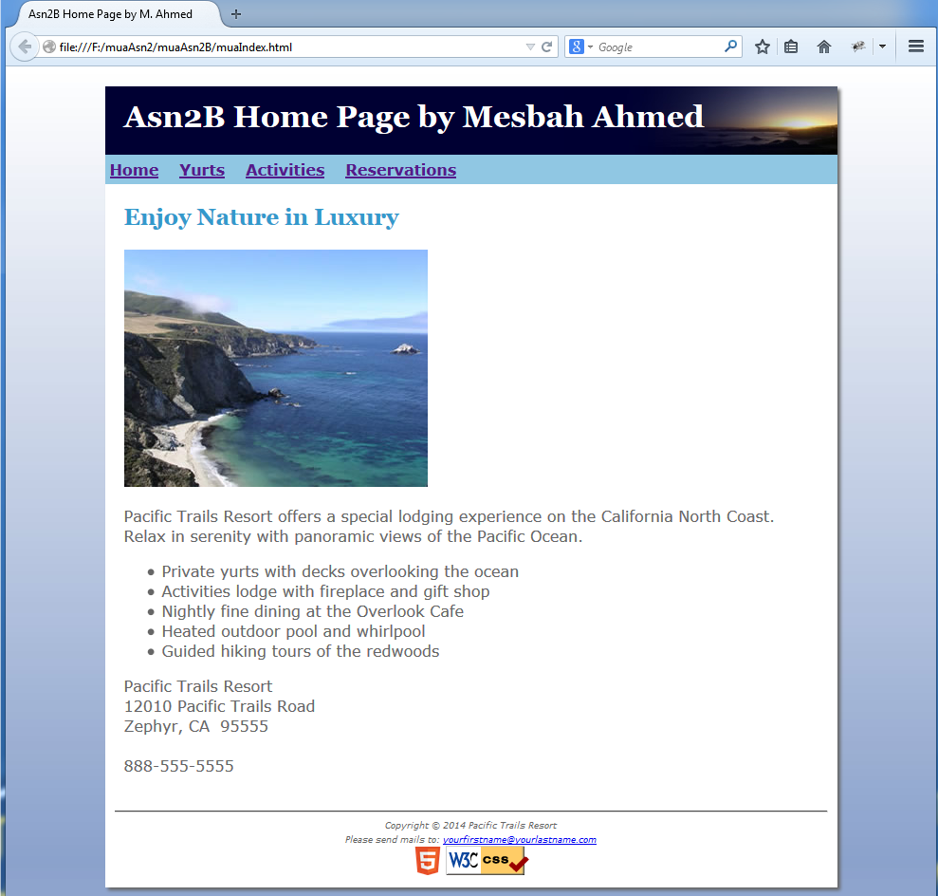
Observe the<h1>. Replace my name with your name.
Also observe that the header has the background image named sunset.jpg(the image file must be in the Images subfolder)

Observe the HTML5 & CSS compliance logos
The <body> has background.jpg. All image files must be in the Images subfolder)

Observe the title of the page

Figure 2B2: Yurts Page for Asn2B

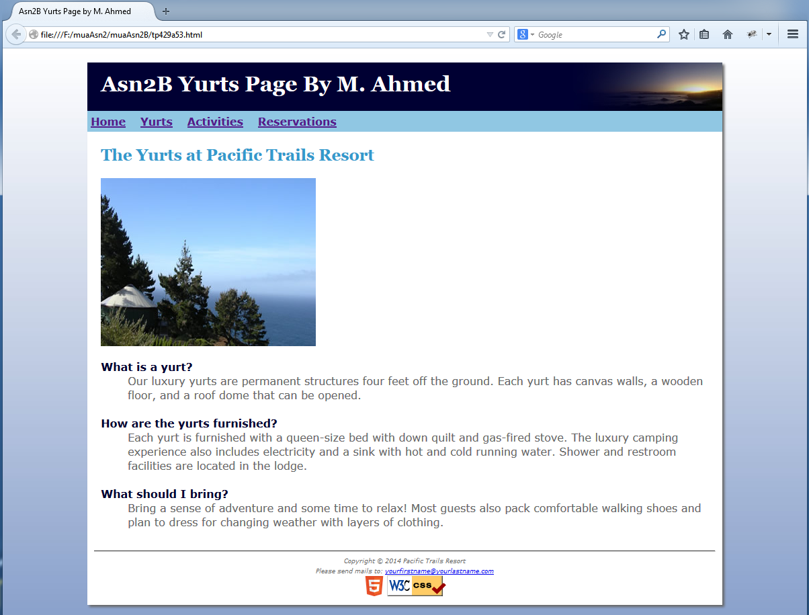
Observe the HTML5 & CSS compliance logos
The <body> has background.jpg. All image files must be in the Images subfolder)

Observe the<h1>. Replace my name with your name.
Also observe that the header has the background image named sunset.jpg(the image file must be in the Images subfolder)

Observe the title of the page

Figure 2B3: The Activities Page for Asn2B
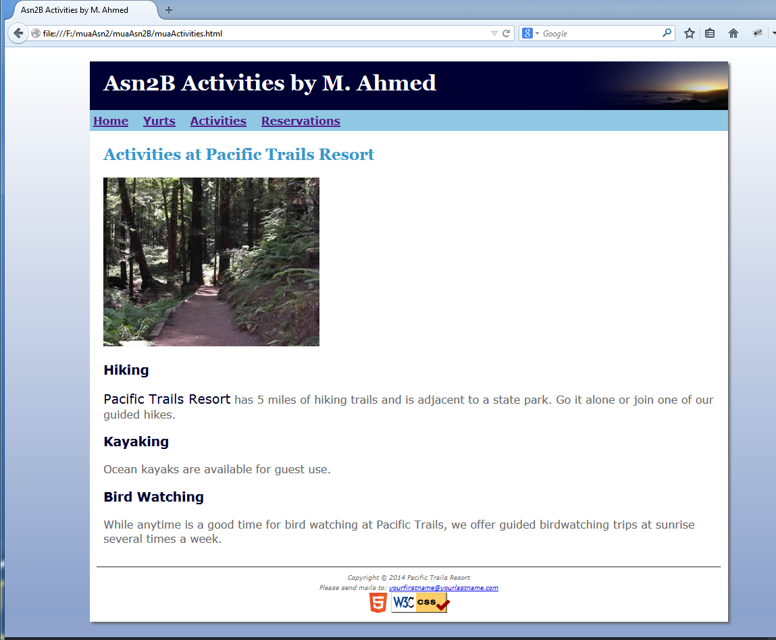
Observe the HTML5 & CSS compliance logos
Observe the<h1>. Replace my name with your name.
Also observe that the header has the background image named sunset.jpg(the image file must be in the Images subfolder)

Observe the title of the page

Figure 2B4: A Recommended UnderConstructionPage(for Asn2B especially for the Reservations hyperlink):You may develop your own page with your own image, but it should employ the same external sheet.
Observe the title of the page
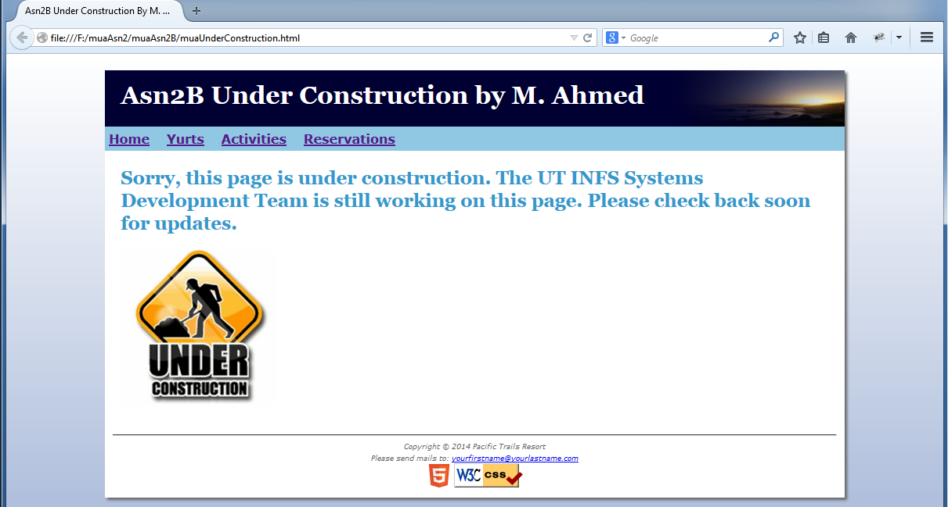

Assignment 2C

In this part of the assignment, you will develop the pages for the Pacific Trails Resort case study as described in Chapter 6 (287 to 290) of our textbook with certain modifications to meet my expectations. I assume that you have already created a sub folder named yourInitialsAsn2C in your yourInitialsAsn2 folder.

To minimize your work, you may copy all html and CSS files from yourInitialsAsn2B folder and paste these in yourInitialsAsn2C folder. Caution: Simply copying and pasting will not complete the job. Remember that for a good grade, you will need to adjust all comments, titles and the first <h1> accordingly. You will also need to modify and apply the matching external CSS file so the pages are displayed as shown in figures 2C1 to 2C4. Also be sure to adjust the comments in your CSS file.

Now copy the Images subfolder from Asn2C subfolder of the Asn2Resources.zip file and paste it in yourInitialsAsn2C’s Images folder. You will need to modify, and add some more rules in the CSS file for Assignment2C as described in the textbook. In this part of the assignment, the author has not asked you to develop any new page, however you need to make minor adjustments. Further you will need revise the “Under Construction” page to add a new block of code shown in Figure 2C3.

First observe my screen shots (in figures 2B1 through 2B4) and the textbook’s figures to see the differences. Your objective would be to develop or revise the relevant pages as shown in my screen shots in this assignment. Please use your common sense to ignore some of the author’s instructions so that your work meets my expectations of your completed work.

Figure 2C1: Home Page for Asn2C
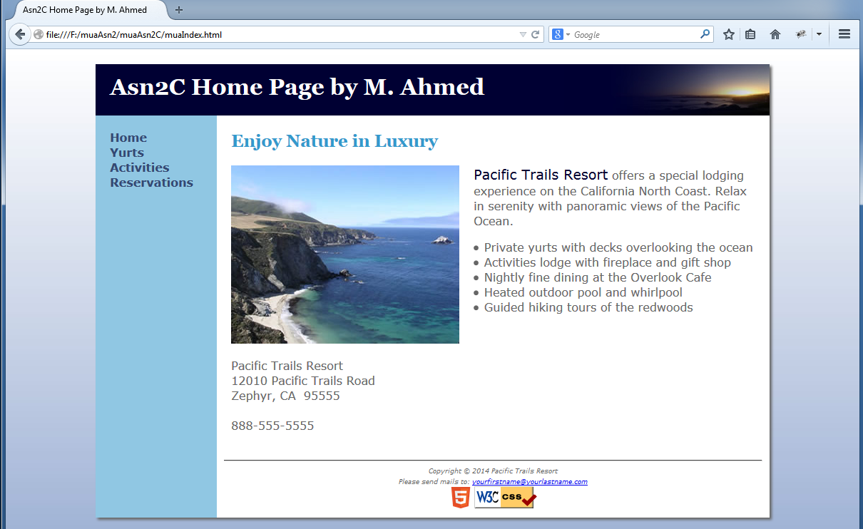
Observe the HTML5 & CSS compliance logos
The <body> has background.jpg. All image files must be in the Images subfolder)

Observe the title of the page
Observe the<h1>. Replace my name with your name.
Also observe that the header has the background image named sunset.jpg(the image file must be in the Images subfolder)

Note: In each of the pages for your Assignment 2C site, the menu items (at left) should change the font color to white when the mouse hovers over it as shown below:

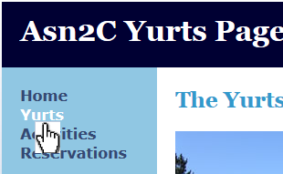

Figure 2C2: Yurts Page for Asn2C

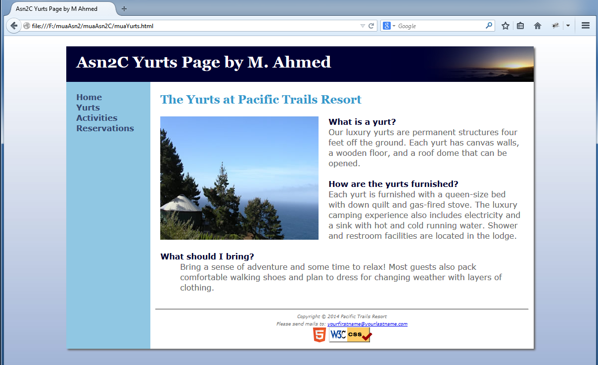
The <body> has background.jpg. All image files must be in the Images subfolder)

Observe the HTML5 & CSS compliance logos
Observe the<h1>. Replace my name with your name.
Also observe that the header has the background image named sunset.jpg(the image file must be in the Images subfolder)

Observe the title of the page

Figure 2C3: The Activities Page for Asn2C
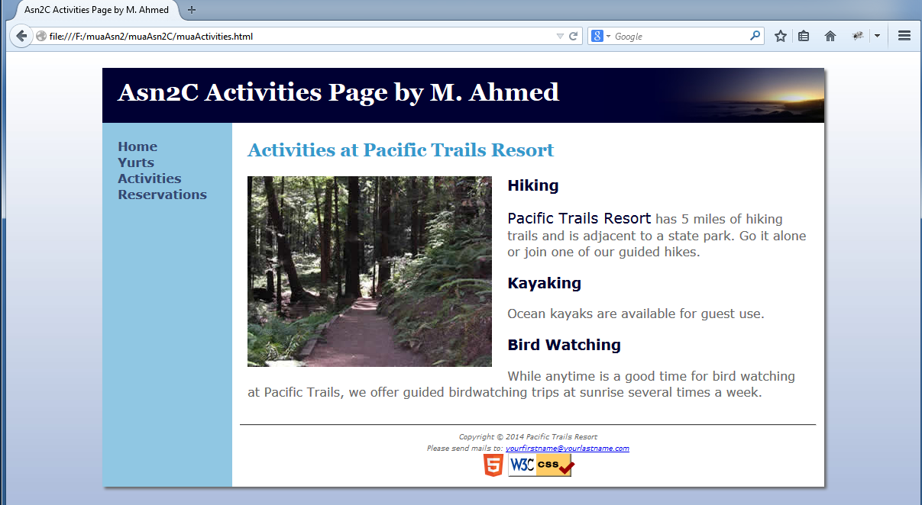
Observe the HTML5 & CSS compliance logos
Observe the title of the page
Observe the<h1>. Replace my name with your name.
Also observe that the header has the background image named sunset.jpg(the image file must be in the Images subfolder)

Figure 2C4: A Recommended UnderConstructionPage (for Asn2C especially for the Reservations hyperlink):You may develop your own page with your own image, but it should employ the same external sheet.
Observe the title of the page
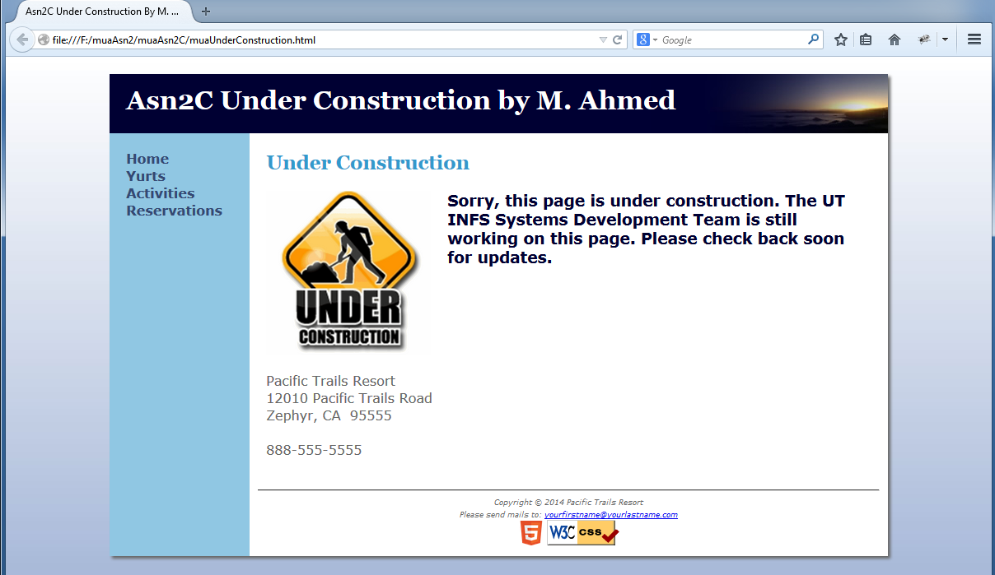
Observe the new text block in the Under Construction page below the image in the Asn2C site

Note: Follow the textbook’s instructions, however override some of the instructions to conform my expectations and conform to the screen shots I provided in this assignment’s doc file.

Opportunity to receive an extra credit of 5 points.

You will receive maximum 5 points extra credit if you can implement an HTML5 video (the Dare-Desktop skating video) in the yourInitialsIndex page of Assignment2C. The revised Asn2C Home page should be as shown below:

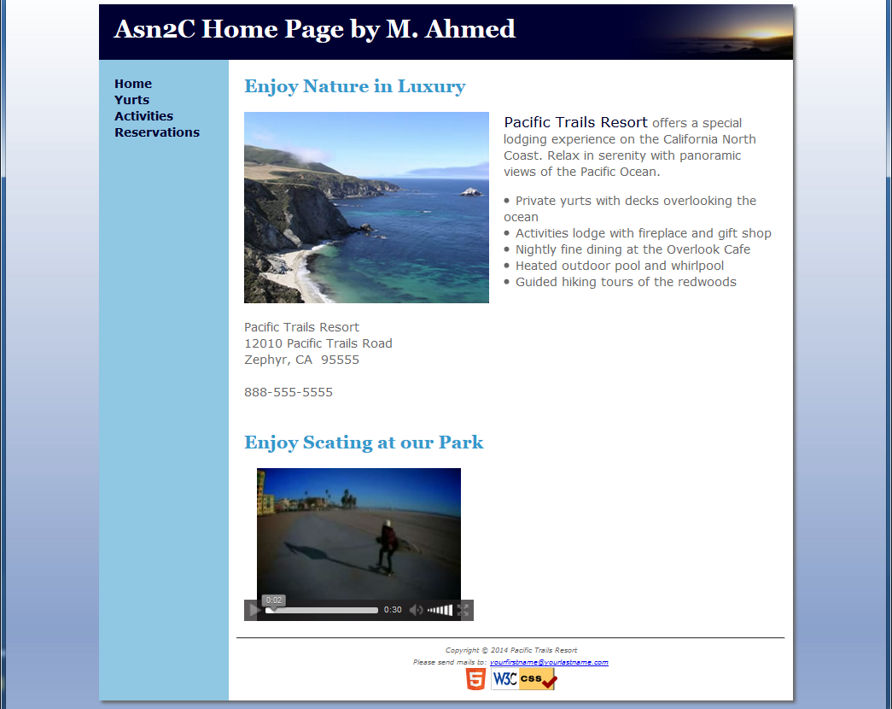
Here is the video in the Asn2CHome page (for extra credit)

- The video screen size should be 300px by 200px (put in the style sheet).
- It should display most video controls (in all browsers).
- The page must be HTML5 compliant.
- The video should run fine in the latest versions of IE, FF, and Chrome.
- You will find the Dare-Desktop.m4v and its ogv version in the HTML5VideoSite.zip posted in Item#17 entry of the Lecture Materials > Slides&Handout folder of Blackboard. You may also look into the handout named HTML5Video.docx available in this folder.

Keep a copy of your Asn3C folder before you try for the extra credit. In case you cannot implement the video, you can replace it with your copy.

Submit:

Finally zip the yourInitialsAsn2 folder (that would contain all of your subfolders and source documents and appropriate image files).

Submit the zip file using the Blackboard’s Assignment2 node.

