Group Project
Part 1: Select one of the Innovator’s Notebook case. Answer the questions based on the textbook material and logic.
Part 2: Compare the entrepreneur and innovative strategies/decisions of the company analyzed in Innovator’s Notebook with its close global competitor (or a similar organization in the UAE). A comparison table is highly desired. Make a judgment on the efficacy and success of the global competitor’s entrepreneur and innovative strategies/decisions. You may also want to analyze the impact of these two companies in the UAE.
Word length: 2,500 to 3,000
Note we are using bellow Text book
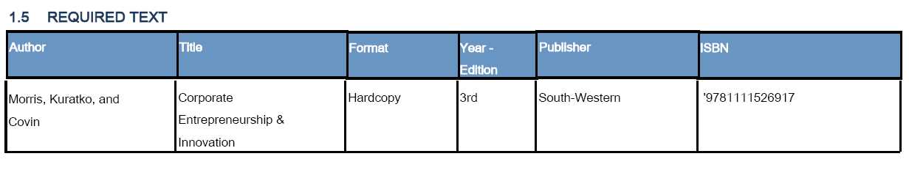

Rubric for Group Project Assessments- Guidelines
Learner Name: -------------------------------------------Learner ID:-------------------- Date
Innovation in the selected business organization.
Marking Criteria
Grade | Response to question | Knowledge and understanding of course material | Approach to alternative explanations and arguments | Construction of argument | Clear expression and use of academic conventions | Approach to  Language and data  (where appropriate)
A  (Excellent) | Demonstrates originality and critical thinking | Demonstrates solid knowledge and understanding | Demonstrates logical criticism | Original, demonstrates creative thinking and coherence | Very well organized and based on evidence and appropriately referenced | Logical and Complete  Interpretation and analysis
B  (Very good) | Polished and utilizes a wide range of relevant and contemporary material to produce a cogent and insightful argument | Comprehensive use of relevant body of knowledge | Objective discussion of competing explanations and arguments | Conclusions are drawn evaluated evidence, all sections contributing | Very good structure, expression and ability to employ sources appropriately | Very good Analysis,  judicious interpretations
C  (Good) | Clear evidence of understanding question and overall address the main issues of answer | Effective inferences from evidence/ideas/concepts and arguments central to the course | Recognition and limited discussion of competing explanations | Clear, sustained argument | Good structure/ expression/referencing | Analysis barely appropriate  and related to course
D-F  (Poor-Fail) | Irrelevant, unacceptable | Very poor comprehension of material | Very poor explanation and argument | Demonstrating errors of judgment and understanding | Very poor, many errors, not based on references | Serious deficiencies
Remarks: _________________________________________________________________________________

