STATISTICAL PROCESS CONTROL PROJECT

**Introduction**

In this project, the objective is to study the statistic data for the distance of the ball away from the target. The team will prepare a simple golf playing device and shoot the ball to a target. The data will be collected as the distance of the ball away from the target. The positive value is obtained when the ball is to the right of the target and the negative value is obtained when the ball is to the left of the target. The team will also learn how to apply the box plot, histogram as well as normal probability distribution plot to study the results.

Schematics

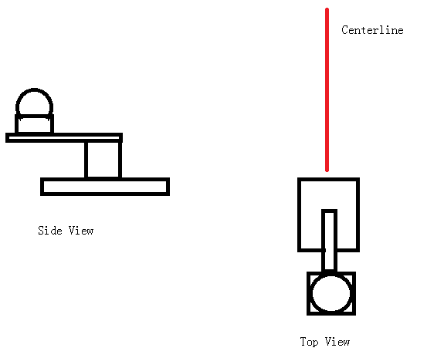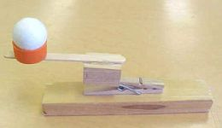

**Procedure**

1. Place the simple golf playing device
2. Place a centerline sticker on the ground
3. Load the golf ball and shoot
4. Record the distance of the ball away from the centerline

**Data**

Raw Data



**Analysis**

**Calculation for Box Plot**



**Figure 1: Box Plot**

**Figure 2: Histogram Chart**

**Calculation for Normal Distribution**



**Figure 3: Normal Distribution**

**Calculation for moving average**

**Sample calculation**

$$average=\frac{-0.1+0.2+0.22}{3}=0.11$$

**Upper limit control:**

$$Upper=0.109+3*0.296=0.997$$

**Lower limit control:**

$$Lower=0.109-3*0.296=-0.77851$$

**Figure 4: Moving Average Chart**

Figure 3 shows the moving average chart with red curve being the upper limit control and green curve being lower limit control

**Figure 5 Moving Range Chart**

Figure 5 shows the moving range chart with red curve being the upper limit control.

**Conclusion**

The method that students used in this project is quantitative data collection method. Students measure the distance of the ball away from the target and record the positive value when the ball is to the right of the target and record the negative value when the ball is to the left of the target. The control in this project is the golf ball. We use the same golf ball throughout the whole process.

However, there are some factors that may affect the variability. The first is the device that we build for launching the golf ball. We used a simple device that is shown in schematics part. Because the basket that holds the golf ball is not stable when the golf ball leaves, it will cause some systematic error that the ball tends to go either side from the centerline. This error is also shown in the plots above where most of data tends to gather on one side of the centerline.

According to the plots shown in the analysis part, students can learn that the data has relative high standard deviation which means that most of data is far away from the centerline where distance is 0

For future improvement, students should be able to build better golf ball launcher so that the ball is stable when it is launched.