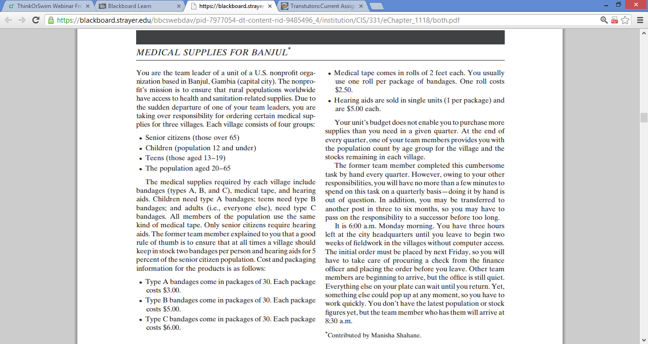
Complete the following assignment from page 134, Chapter 6, of your textbook:
Using ‘Medical Supplies for Banjul’ as your case, complete questions 2a, 2b, and 2c.
You will use either Excel 2007 or Excel 2010 to complete this assignment.
2. Refer to the medical supplies for Banjul case. Design a spreadsheet that will enable you to request the required funds from your team’s finance officer, order supplies from the home office, and ensure dissemination of appropriate quantities to each village. Your final order to the home office should specify the number of packages required of each item.
a. The population figures will show that there are 3000 children, 2500 teenagers, 500 seniors, and 9000 other adults in the population. If there were no stock on hand, what amount would be required for ordering supplies?
b. using the parameters in (a), construct a graph showing how the amount required for the order would vary if the unit cost of a package of bandages rose by $0.25, $0.50, and so on, up to $3.00 per package.
c. Following up on (a), a check on stock shows an inventory of 124 packages of A-bandages, 16 packages of B-bandages, 82 packages of C-bandages, 72 rolls of tape, and 4 hearing aids. What amounts will be require for ordering supplies?

