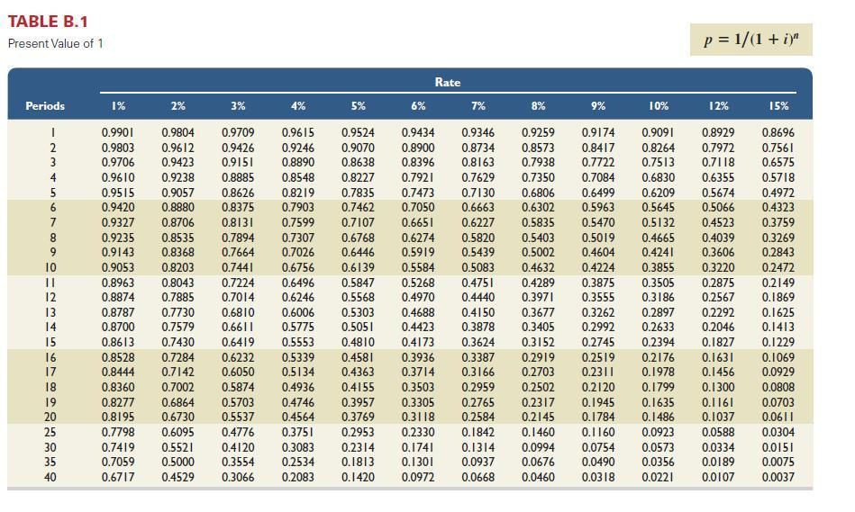
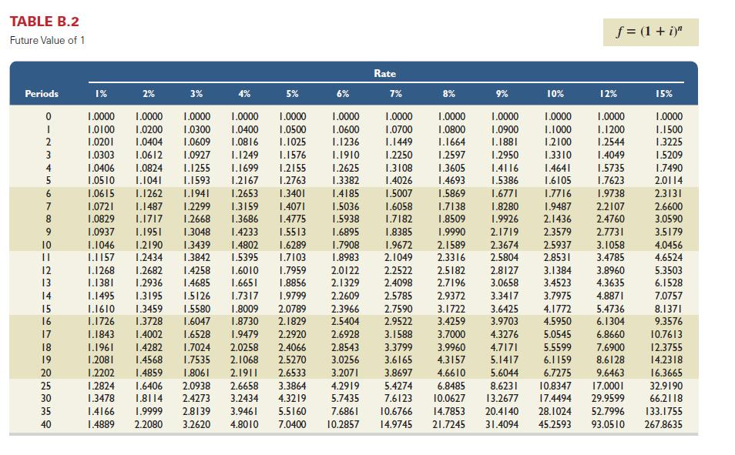
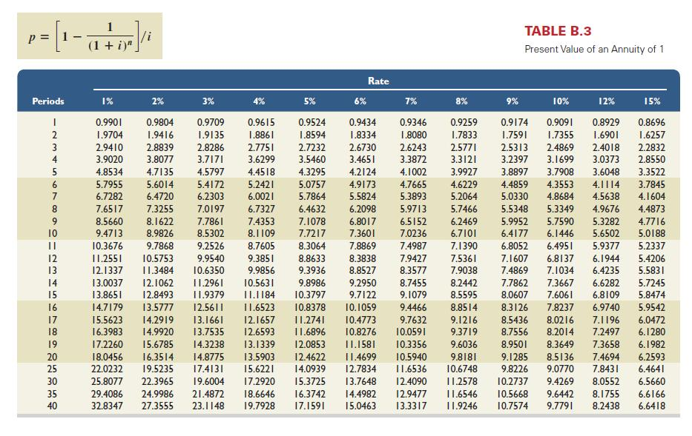
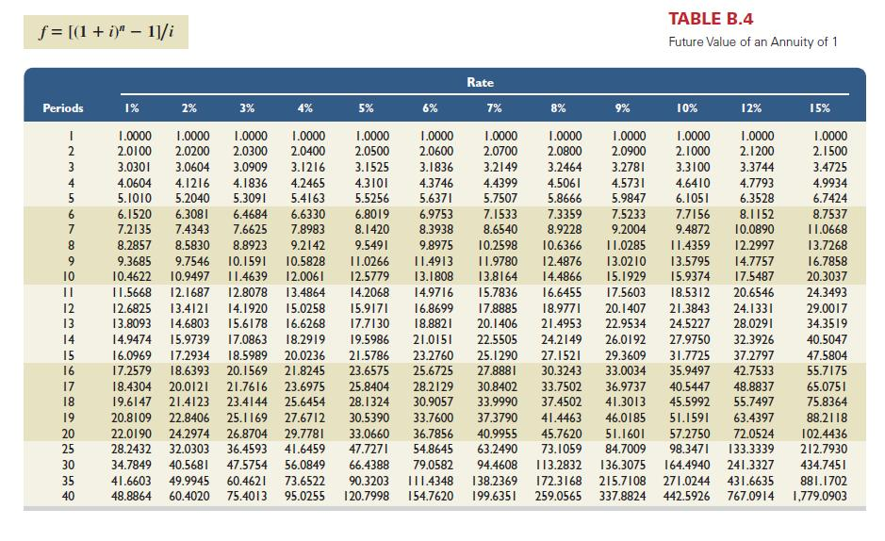

Most Company has an opportunity to invest in one of two new projects. Project Y requires a $350,000 investment for new machinery with a four-year life and no salvage value. Project Z requires a $350,000 investment for new machinery with a three-year life and no salvage value. The two projects yield the following predicted annual results. The company uses straight-line depreciation, and cash flows occur evenly throughout each year
Project Y Project Z
Sales |  |  | $ | 395,000 |  |  |  | $ | 325,000
Expenses
Direct materials |  |  |  | 55,300 |  |  |  |  | 40,625
Direct labor |  |  |  | 79,000 |  |  |  |  | 48,750
Overhead including depreciation |  |  |  | 142,200 |  |  |  |  | 146,250
Selling and administrative expenses |  |  |  | 28,000 |  |  |  |  | 29,000
Total expenses |  |  |  | 304,500 |  |  |  |  | 264,625
Pretax income |  |  |  | 90,500 |  |  |  |  | 60,375
Income taxes (26%) |  |  |  | 23,530 |  |  |  |  | 15,698
Net income |  |  | $ | 66,970 |  |  |  | $ | 44,677
1. | Compute each project’s annual expected net cash flows.  Project Y Project Z  Net income $66,970 $44,677  Depreciation expense  Expected net cash flows

2. | Determine each project’s payback period

Payback period
 | Choose Numerator: | / | Choose Denominator: | = | Payback period
 | ? | / | ? | = | Payback period
Project Y |  |  |  | = | 0
Project Z |  |  |  | = | 0

3. | Compute each project’s accounting rate of return.

Accounting rate of return
 | Choose Numerator: | / | Choose Denominator: | = | Accounting rate of return
 | ? | / | ? | = | Accounting rate of return
Project Y |  |  |  |  | 0
Project Z

4. | Determine each project’s net present value using 9% as the discount rate. Assume that cash flows occur at each year-end

Project Y
Chart values are based on:
n =
i =
Select chart | Amount | x | Table factor | = | Present Value
? |  |  |  | = | $0
Net present value
Project Z
Chart values are based on:
n =
i =
Select chart | Amount | x | Table factor | = | Present Value
 |  |  |  | = | $0
Net present value

Part 2:

Manning Corporation is considering a new project requiring a $96,500 investment in test equipment with no salvage value. The project would produce $75,000 of pretax income before depreciation at the end of each of the next six years. The company’s income tax rate is 36%. In compiling its tax return and computing its income tax payments, the company can choose between the two alternative depreciation schedules shown in the table.
Straight-Line  Depreciation |  |  |  | MACRS  Depreciation
Year 1 |  | $ | 9,650 |  |  | $ | 19,300
Year 2 |  |  | 19,300 |  |  |  | 30,880
Year 3 |  |  | 19,300 |  |  |  | 18,528
Year 4 |  |  | 19,300 |  |  |  | 11,117
Year 5 |  |  | 19,300 |  |  |  | 11,117
Year 6 |  |  | 9,650 |  |  |  | 5,558
Totals |  | $ | 96,500 |  |  | $ | 96,500

1. | Complete the following table assuming use of straight-line depreciation. Net cash flow equals the amount of income before depreciation minus the income taxes.

 | Income Before Depreciation | Straight-Line Depreciation | Taxable Income | Income Taxes | Net Cash Flows
Year 1
Year 2
Year 3
Year 4
Year 5
Year 6

2. | Complete the following table assuming use of MACRS depreciation. Net cash flow equals the income amount before depreciation minus the income taxes.

 | Income Before Depreciation | MACRS Depreciation | Taxable Income | Income Taxes | Net Cash Flows
Year 1
Year 2
Year 3
Year 4
Year 5
Year 6

3. |  | Compute the net present value of the investment if straight-line depreciation is used. Use 8% as the discount rate.

Chart values are based on:
i =
Year | Net cash inflow | x | Table factor | = | Present Value
1 |  |  |  | =
2 |  |  |  | =
3 |  |  |  | =
4 |  |  |  | =
5 |  |  |  | =
6 |  |  |  | =
Net present value

4. | Compute the net present value of the investment if MACRS depreciation is used. Use 8% as the discount rate.

Chart values are based on:
i =
Year | Net cash inflow | x | Table factor | = | Present Value
1 |  |  |  | =
2 |  |  |  | =
3 |  |  |  | =
4 |  |  |  | =
5 |  |  |  | =
6 |  |  |  | =
Net present value

