Develop an Incident Action Plan based on the three job hazards you identified.

Reference the Sample Command Procedures for Emergency Response Operations, beginning on the bottom of page 412 in your textbook. Use this guideline to create an Incident Action Plan for your place of employment (or home). Tailor the Incident Action Plan to address your unique situation. In addition, address the seven common mistakes made by incident commanders on page 416.
Must be seven double-spaced pages in length, and formatted according to APA style.
- Must include a title page with the following:
  - Title of paper
  - Student’s name
  - Course name and number
  - Instructor’s name
  - Date submitted
- Must begin with an introductory paragraph that has a succinct thesis statement.
- Must address the topic of the paper with critical thought.
- Must end with a conclusion that reaffirms your thesis.
- Must use at least six scholarly sources.
- Must document all sources in APA style.
- Must include a separate reference page, formatted according to APA style.

PLEASE SEE BELOW PAGES FOR INCIDENT ACTION REPORT ON THREE HAZARDS!!!

Risk Assessment
The purpose of this assignment is to carry out the risk assessment on three different activities that are performed at my workplace which are relating to materials management. The tasks relate to vehicle fueling, various cleaning tasks, storing materials, replacing the oil of the car, and others. According to Gantt (2009), the risk assessment has fewer objectives as well as it requires the certain degree of the judgment on behalf of the ones that are involved. It primarily refers to the processes that are utilized for determining the methods wherein these hazards would potentially be causing harm towards the ones that are involved in the operation.

Risk Assessment Plan
Considering my actual workplace currently there are minimal situations where any form of hazards or the risky situations could occur. However, I can primarily relate to different situations at other workplaces wherein I had worked in past. This part of the paper refers to various situations from these workplaces. Various risk assessment plans have different probability levels as well as consequences for each of the levels.
So, for level 1 it would mean the hazards are occurring frequently as well as its consequences refers to severe trauma and even death. The level two of probability means that the hazard is very likely to occur in near future and the anticipated consequences could lead to high level trauma as well as severe injuries. The third level of the probability can be considered as highly infrequent as well as the consequences resulting in moderate trauma.
The first hazard that I would to underpin is when I had been working for the company that was into manufacturing the certain material by the combination of gas with various other materials. In this process, these materials that I and other employees used to handle were highly flammable. So working on it required a high level of caution while working with all of these materials. I had been personally involved in moving move various gas tanks from the company’s storing place towards the point where in the operations required then for using it for creation of the new material. I used to carry each of these materials with the help of piler. So there were tremendous risks that were involved within this operation as well as there had been some possible hazards that could have been occurred.
Marcotte, Mercier, Savard, and Verter (2009) consider that the explosives, flammable liquids, gasses, different infectious substances including poisonous substances, as well as various radioactive materials had been the hazmats that are being transported in the large volumes. Thus, while moving these gas tanks, I could have dropped any of these tanks and if while touching a spark was created; the entire tank could be exploded. For making sure that this risk has been reduced to a minimum level, I used to carry this task at a highly slower speed thereby making no quick moves towards creating any imbalance that could lead the tank to fall from the piler.
Many other operations that had included various hazardous materials had been conducted at the same workplace. For E.g. one of my colleagues in the same company used to handle another process that required combining of two chemicals. The materials that were required to be combined as the part of their process had been included within the class of the poisonous as well as poison inhalation hazards. Most of these materials fall into acids category and as it is a safety standard that while working with the acids, each of the worker is required to wear the face mask as well as gloves. In such a case the type of the mask that is required to be used has to be an air-purifying system which can filter in excess of the 99% percent of the air so that all of the workers are safe while handling such substances.
There are several other regulations that have been the part of the risk assessment plan as well as the instructions for the safe operations of each of these materials.
The third hazard that I would like to refer towards is the respiratory hazard and I had been dealing with such a hazard while working for the constructions company that had been dealing with the demolishing several old constructions. The respiratory hazard in such case had been referring towards the particulates. According to Gantt (2009), dusts can be considered as the solid particles within the air that are created through the operations like sanding, grinding, drilling, as well as the demolition. In the current situation, I was required to be at the firm’s working site wherein the demolitions used to occur and was required to protect myself against the dust. I had to take assistance of an air-purifying system for this so that the dust need not get into my lungs and respiratory system. The masks that were used were full faced masks which stopped the dust from entering in the eyes, nose, ears, as well as mouth.

Conclusion
Managing risks as well as creating the risk assessment plans has been imperative while working with the hazardous materials. The assignment presented three different activities within the workplace that primarily involved dealing with the hazardous materials. It related to various risks that had been associated towards the manipulation of each of these materials as well as describing various ways wherein these risks needs to be mitigated so that nothing unanticipated happens to the company’s employees, staff, society as well as the environment

References
Gantt, Paul W. (2009). Hazardous materials, regulations, response, and site operations. Delmar: Cengage Learning.
Marcotte, P., Mercier, A., Savard, G., & Verter, V. (2009). Toll Policies for Mitigating Hazardous Materials Transport Risk. Transportation Science, 43(2), 228-243.
NCNR (2012). How to Worak with Acids. Retrieved from http://www.ncnr.nist.gov/safety/acid.html
Si, H., Ji, H., & Zeng, X. (2012). Quantitative risk assessment model of hazardous chemicals leakage and application. Safety Science, 50(7), 1452-1461.

PLEASE SEE BELOW PAGES FOR Procedures for Emergency Response Operations
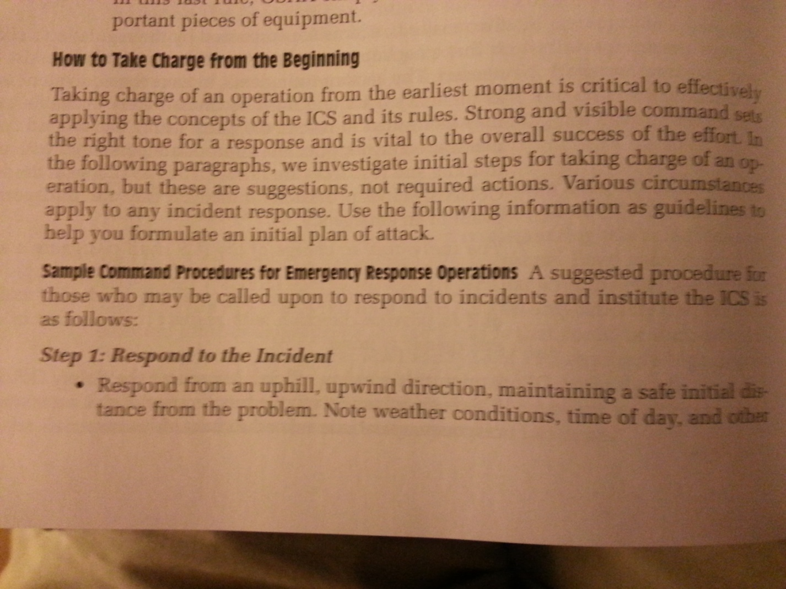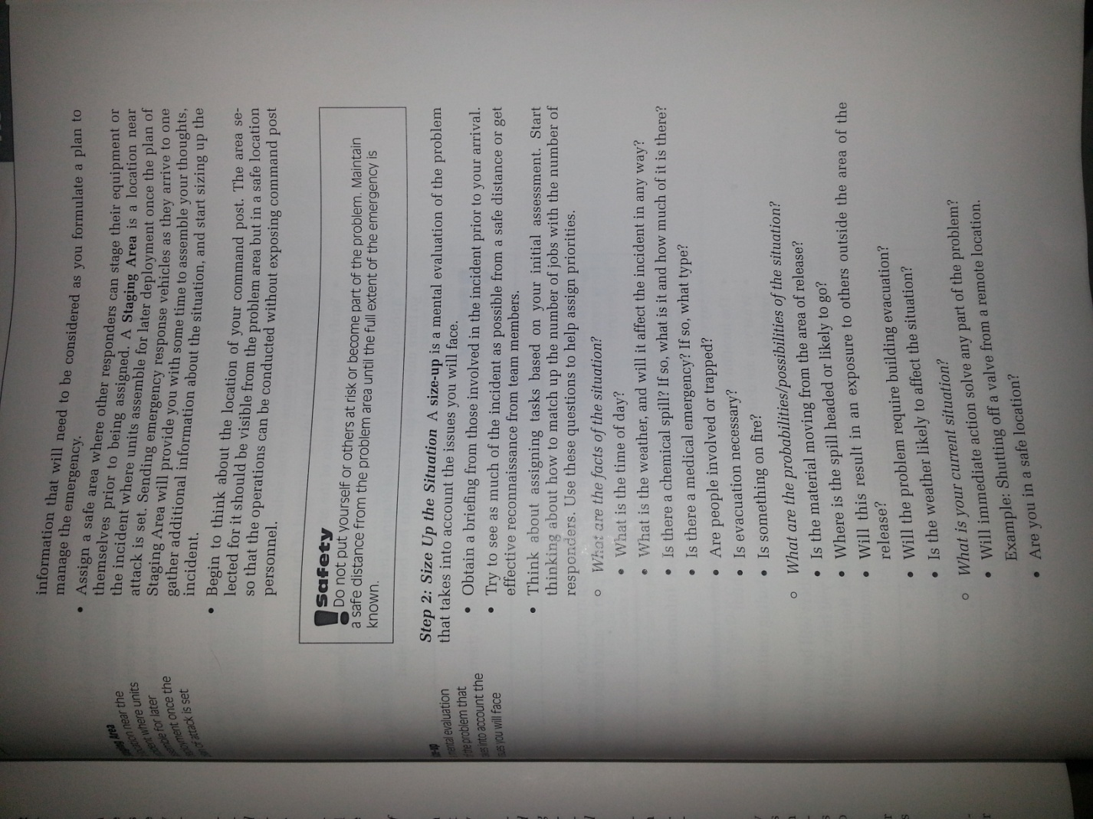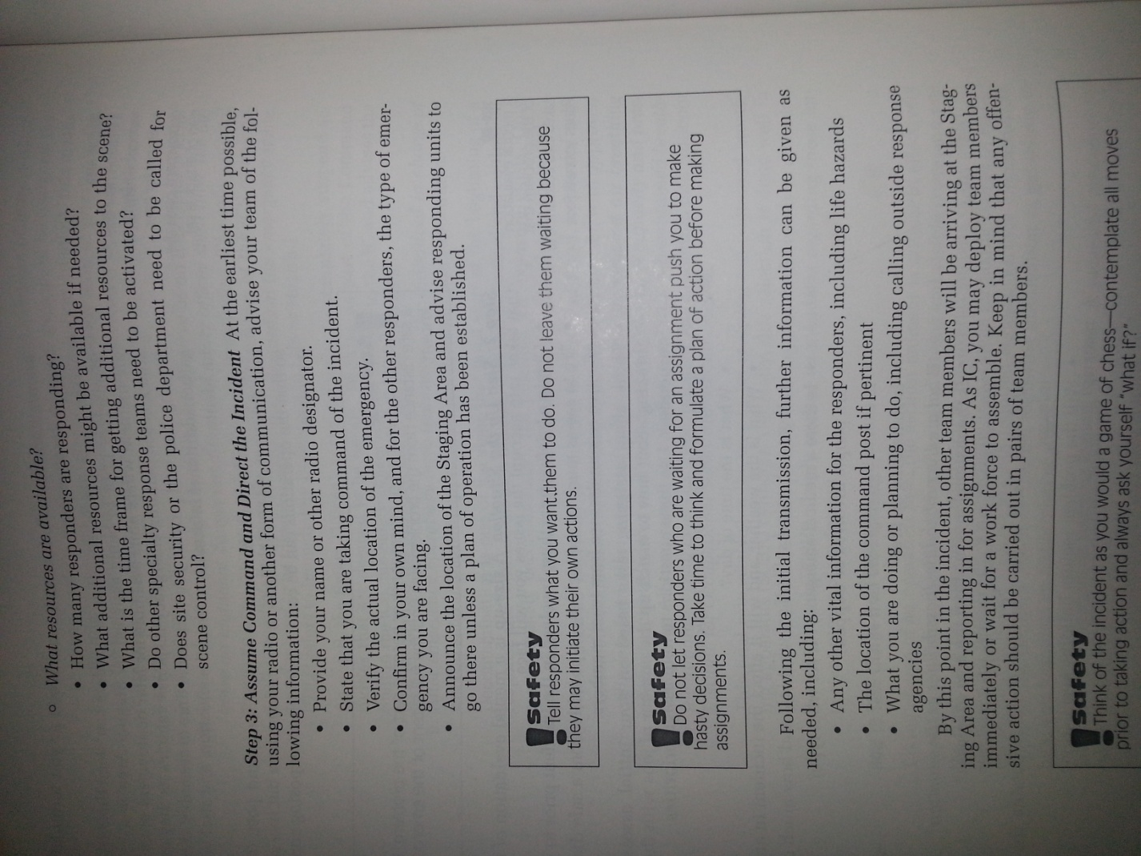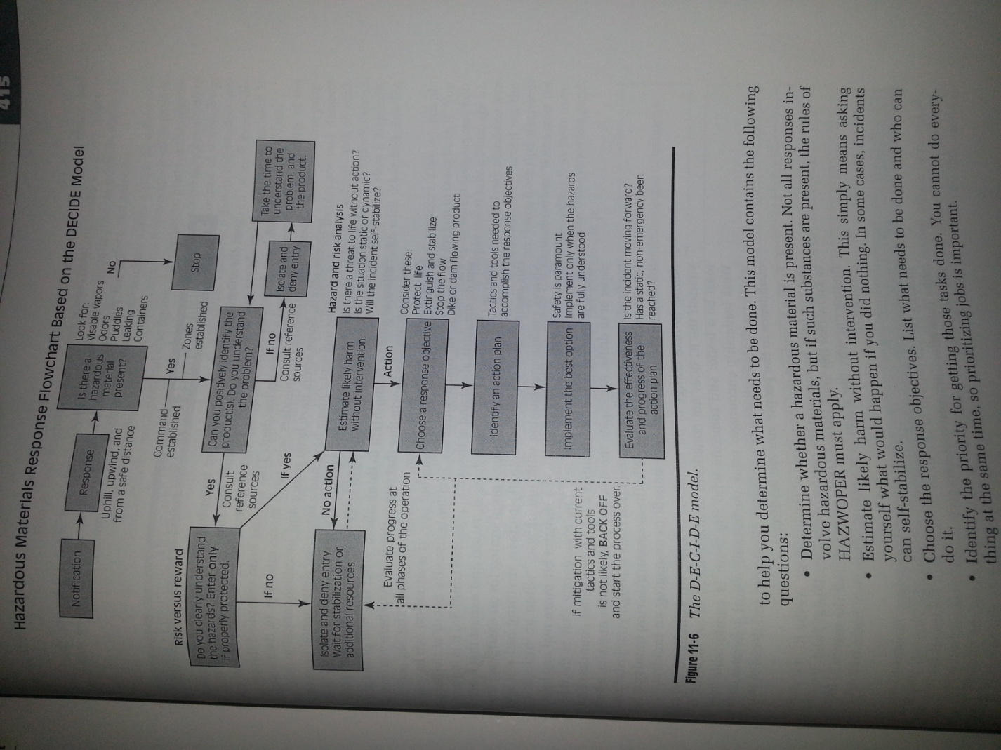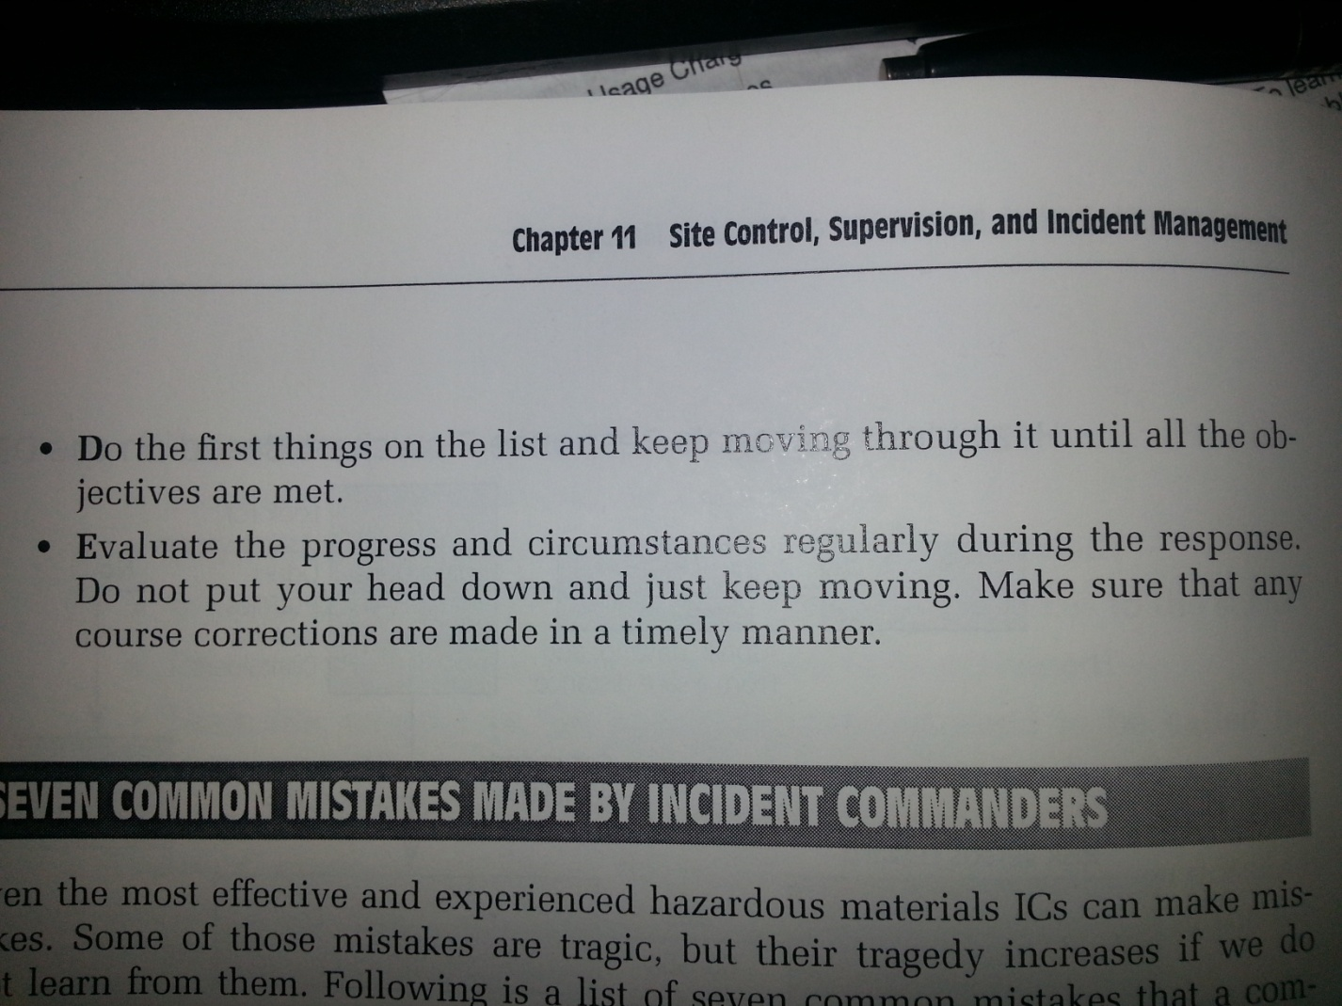

PLEASE SEE BELOW FOR 7 COMMON MISTAKES!!!!

