Carlos Roa
Strayer University
CIS-331
Prof. Eve Yeates
4/26/13
Lab Assignment 1

1. Explore the mess by answering the following questions:
(a) What do we know?
We do know that the client has an advertising plan and budget in place where in he is presently spending 5% on creation of ad and 95% on airing of the commercial. It has been seen that the quality of advertise designing is falling and not up to the mark. So it has been decided to increase the budget or percentage of funds allocated to the designing of the advertisement.
(b) What can we assume?
We can assume that there is a direct influence of ad design and storyboard on the audiences. We can assume that if there is better advertising then it leads to effective influence on the audiences.
(c) What could the results look like?
The results would look like, there being better influence on the audiences and there being better remembrance.
(d) What information can be brought to bear?
The information that can he brought to bear is that the audiences would remember an ad that is different and catchy.
(e) What can we ask the client?
We can ask the client as to what is their target message that they wish to convey to the audiences and as to how they wish to position their product.
(f) Are there any similar situations or problems?
There are similar situations which include the focus on target audiences and the target message to be conveyed to the audiences.
2. Formulate one or more problem statements.
The problem statement is, "To improve the advertising design in order to ensure better remembrance and impact on the audiences" Advertising is an essential element in the present day organizations. But graffiti is a very different form of image formation. It explains a lot more than what is written or shown. Moreover exaggerations and humor are a very common element of these graffiti representations. This can be used in order to increase the remembrance value in advertising.
3. What are the decisions, outcomes, and relationships in the problem?
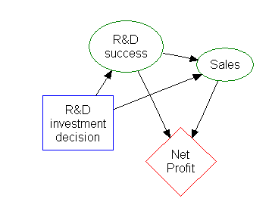
The decision is to increase the budget for advertising design. The outcomes include better remembrance value and better impact on the audiences. The relationships include R & D in advertising and net profit. In this way better advertising design leads to appropriate increase in impact and remembrance in audiences. Television is a popular media all around the world and it seconds the internet as a source of getting information about the activities and changes in society that are taking place.
4. Draw an influence chart for the problem.

Advertising creation

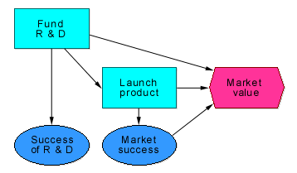

5. In what ways could we simplify the problem?
We could simplify the problem through ensuring that there be analysis of the issues and then use the various options including research and finding alternative solutions to the problem. Then the problem will be simplified.
6. What modules will we need to build?
The modules that we need to build include analyzing weaknesses in the present advertising design and then ensure that based on the required message to be conveyed, the ad design needs to be improved.
8. What are the parameters of the problem?
The parameters of the problem include the following:
a. Impact created on audiences not meeting the required levels
b. Remembrance value created by the advertisement
c. Budget and influence or impact on the audiences

