Q1 . Adding to Table 11.1, if real GDP in 2002 were &10,048.8 billion and nominal GDP in 2002 were $10,469.6 billion, calculate the percentage change from 2011 to 2002 in nominal GDP, real GDP, and price level. What is the value of the GDP deflator in 2002?
Nominal versus Real GDP
Variable | 2000 | 2001
Nominal GDP | $9,817.0 billion
Percentage change |  | 3.17
Real GDP | $9,817.0 billion
Percentage change |  | 0.76
GDP deflator (price changes) | 100
Percentage change |  | 2.4

Q2. From the Bureau of Economic Analysis Web page (www.bea.gov), construct a table showing the annual percentage in real GDP, gross private domestic investment (I), non-residential fixed investment from 2000 to 2008. Discuss how the changes in these variables show the difference between the recession of 2001 and the recession in 2007 and 2008 that is discussed in the news article that opened this chapter.
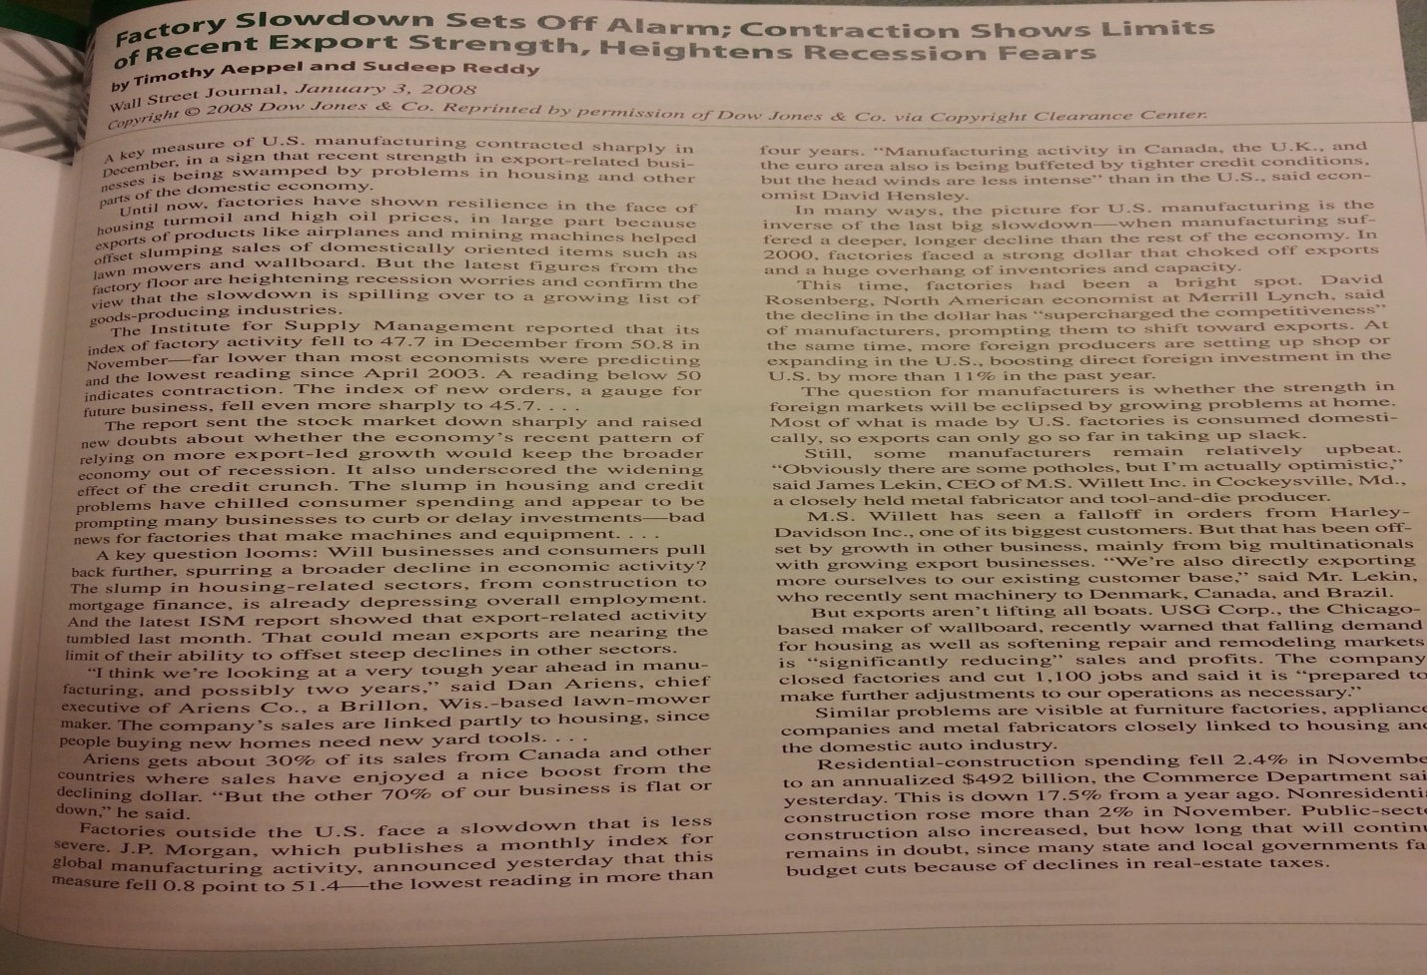
Q3. Explain how the aggregate expenditure function shifts in response to changes in each of the following variables:
- The real interest rate increase
- Consumer confidence decrease
- Higher taxes are imposed on business profits.
- The economies of many countries in the rest of the world go into recession.
Q4. What were the key provisions of the economic stimulus bill passed by the Congress in February 2008? What further changes in fiscal policy have occurred since this time?

