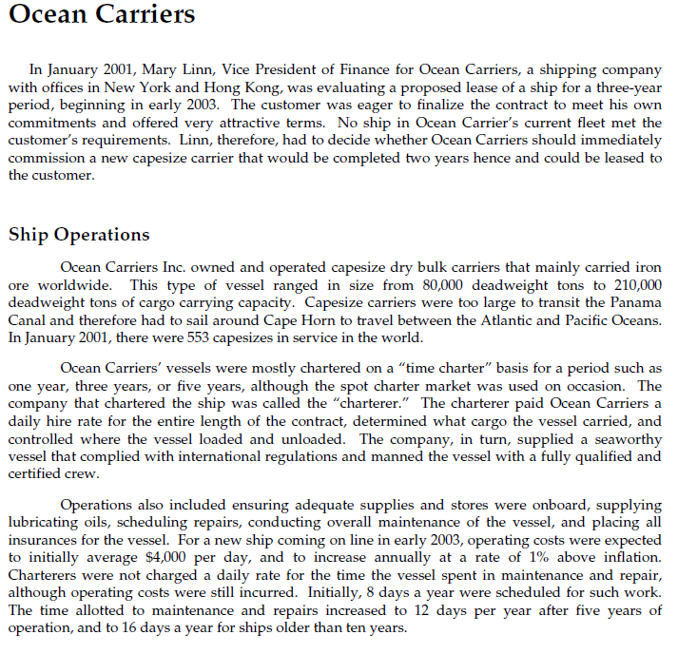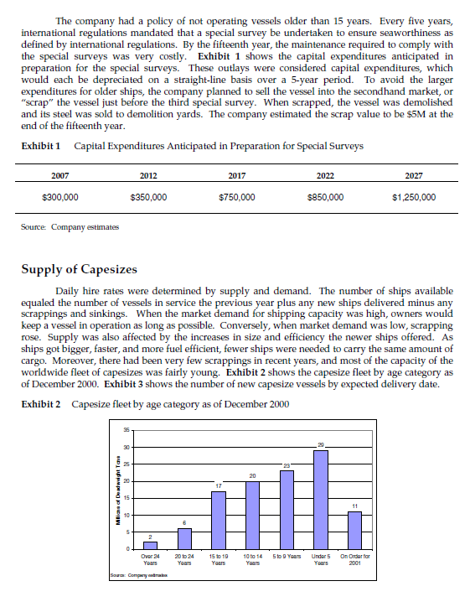
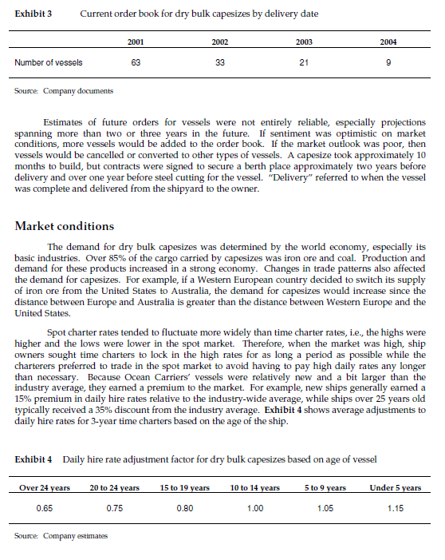
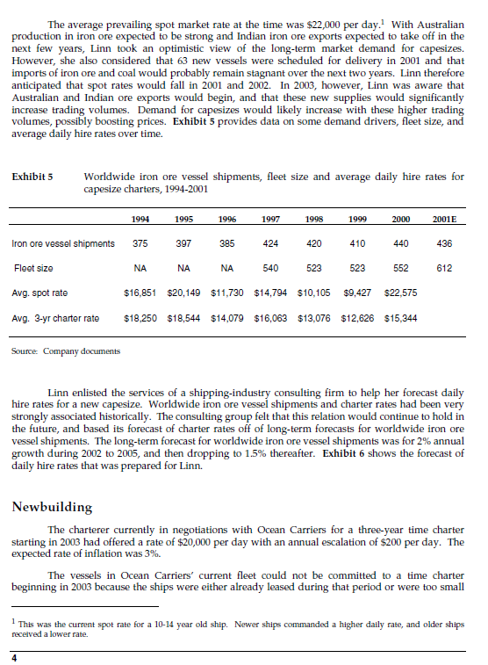
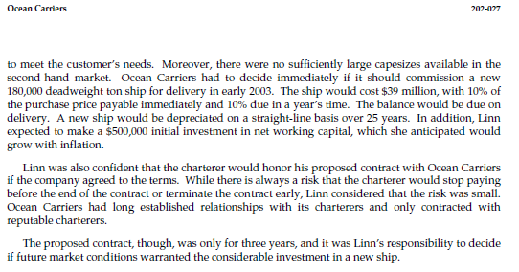

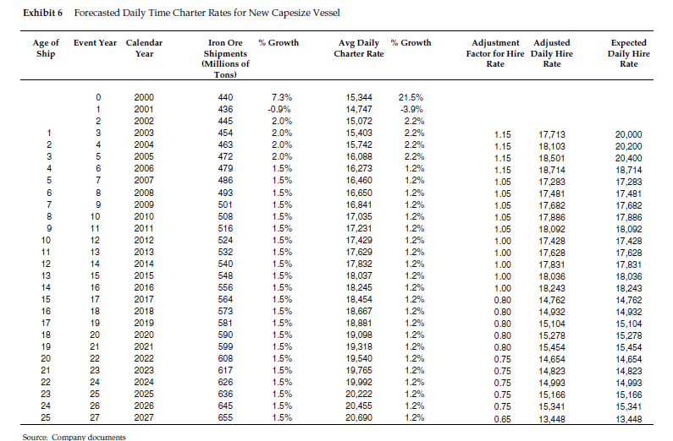

Hints and Assumptions
• Ocean Carriers uses a (nominal) 9% discount rate. • I recommend doing the case using nominal cash flows and nominal interest rates. • Assume that operating costs will grow annually at 1% in real terms.
• Given this assumption, work out what the nominal growth rate is using the information given about the inflation rate. • Then use this nominal growth rate to work out the operating costs in each year.
• Assume that Ocean Carriers pays all operating revenues and operating costs at the end of the year – the case gives you daily values, just multiply by the appropriate number of days to get the annual values. • Assume that there are 365 days/year in all years.
• To make the timing of the large capital expenditures for the carrier and working capital easier to work with, it is easiest to shift the expenditures backwards in time by one day and assume that time 0 is December 31, 2000, and not January 1, 2001, time 1 is December 31, 2001, etc.
• In other words, assume that Ocean Carriers makes the decision and spends the initial expenditures to purchase the ship on December 31, 2000, not on January 1, 2001, and so on.
• Assume that Ocean Carriers has sufficiently high taxable income in each year such that they can utilize any tax shields.
• Remember that when you increase working capital, it implies a cash outflow, and when you decrease working capital, it implies a cash inflow.
• If Ocean Carriers purchases the carrier then working capital will increase (from previously zero) to $500,000 at the end of 2002.
• The case is not clear about exactly what the working capital is. It does not matter, but let us think of it as supplies on board, such as food and oil that must be purchased a year in advance of their use. When the case states that working capital will grow with inflation, this implies that Ocean Carriers will invest a little more in working capital (supplies) each subsequent year.
• Please assume that if Ocean Carriers is going to sell the ship in the next year, they do not purchasing working capital in advance of that year.
• Furthermore assume that if Ocean Carriers sells the carrier, then from that time onwards the buyer will have the same working capital requirements that Ocean Carriers would have had, as if Ocean Carriers had not sold the carrier (that implies that the buyer will have to resupply the vessel after buying it). The case only gives an estimated scrap value for the carrier of $5M when it is 15 years old. Assume that the scrap value increases over time at the rate of inflation, so the scrap value is lower than $5M in earlier years and higher than $5M in later years.
• If Ocean Carriers sells the ship in the second-hand market before the ship is 25 years old, you can assume that the buyer can depreciate the carrier straight-line for the remaining years before it is 25 years old.
• For example, if Ocean Carriers sells the ship after 15 years, then the new owner can depreciate the ship over 10 years. The new owner will use the second hand sale price as the starting book value of the asset.

