First Name, Last Name
Course Title:
Professor/Tutor:
Date of Submission
Neo Classical Art versus Contemporary Art
Neo classism may be defined as a category or classification of arts, literature and music by western movements such as the age of enlightenment and romanticism in the in the 18th and 19th century that originated from Rome. Contemporary art on the other hand is forms of art that have been produced in the 21st century, in other words modern art.
Below is an art from both the neo classical and contemporary era;
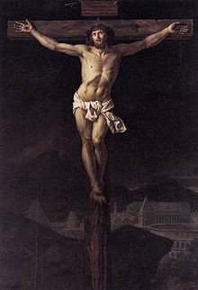

The first painting is called the, The Christ on the cross. The Christ on the cross was a religious painting that was painted by Jacques-Louis David out of oil and canvas in 1782 to be commissioned and hang in a chapel. It symbolises the trials and crucifixion of Jesus as narrated in the Bible after the last supper.
The latter painting belongs to one Maria Lassnig and symbolises woman power and advances the notion of a country of strong women being United States of America. It advances the idea that it is a country where women toil and work hard towards success, progressively without fear or intimidation to be themselves in a bid to grasp and look for opportunities all over this country to leave a mark or legacy as beautiful as the one she left. It portrays a naked woman, confidently towering above a mammoth of a modern city made up of buildings, apartments and skyscrapers. It is created using pencil drawings and a variety of water colours.
Both classical and contemporary art share a number of ideals and values the major one being that they are intended to pass a message and or symbolize some values or virtues or to tell and advance a story. Both have beautiful and aesthetic elements that are appealing to the eyes and evoke aesthetic emotion to its beholders that is lovers of art. Lastly and contrary to public stereo types and perceptions both forms of art require talent and creativity as well as using your mind to create something unique, deep and beautiful to its intended audience.

Conclusion
In conclusion therefore it can be said that though the differences between contemporary and neo classical art are numerous, the common characteristics can neither be overlooked nor under estimated. It is the classical arts that guide many modern artists in creating beautiful contemporary art in ways that we may never understand.

