COVENTRY UNIVERSITY
Faculty of Engineering and Computing

Stress and Dynamic Analysis (326MAE)

Stress Assignment – For hand-in on or before Friday 22nd November 2013

Question 1
a) A hollow shaft is subjected to a bending moment of 10 kNm and a torque of 5 kNm. The internal diameter is 0.75 times the outer diameter. If the yield stress is 300 MPa and a safety factor of 1.5 is required, determine the minimum inner and outer diameters required according to the Maximum Shear Stress theory (Tresca).
(10 marks)

b) Figure Q1a on the next page shows a jib crane. When a load is lifted by the crane a force is reacted through the support frame on the left of Figure Q1a.

The support frame basically consists of two 50 mm x 50 mm square columns made from plates 5 mm thick, joined by a 6 mm thin web as shown in the X – X cross-section in Figure Q1b. A force of 100 kN is applied to the top of the support frame at an angle that creates a 3-4-5 triangle with the vertical and horizontal directions.

There is a point A identified on the support frame. It is 350 mm from the top, on the web adjacent to the right hand column.

(i) Calculate the axial stress at A. (4 marks)

(ii) Calculate the bending stress at A. (4 marks)

(iii) Calculate the shear stress at A. (4 marks)

(iv) Show the state of stress on an infinitesimal aligned to the vertical and horizontal directions.
(3 marks)

Question 2
The stress tensor for a three-dimensional system for some x, y z axis system is

$\left[σ\right]=\left[\begin{matrix}100 & 30 & -60 \\ 30 & 50 & 40 \\ -60 & 40 & 35\end{matrix}\right]$ MPa

a) Find the normal and shear stress on a plane whose normal makes an angle of 50° with x-axis and 70° with y-axis. Also give the direction cosines for the shear stress on the plane.
(8 marks)

b) Find the principal stresses for the stress tensor. (5 marks)

c) What angles does the y-axis make with the second principal direction? (3 marks)

d) Carry out an analysis to determine if this stress tensor fails the von Mises criterion when the yield stress of the material is 250 MPa? If not, what is the factor of safety?
(4 marks)

(You may use MATLAB for this problem if you wish.)

Question 3
A steel cylinder with closed ends has an internal diameter of 160 mm and external diameter of 320 mm OD. It is subject to an internal pressure of 150 MPa.

a) Determine the radial and tangential stress distributions and plot the results in EXCEL.
(10 marks)

b) Also determine the maximum shear stress in the cylinder. (5 marks)

(You may use Lame’s equations without proof.)

Question 4

A cantilever beam with length L and flexural rigidity EI has a rectangular cross-section. The height in the y-direction is 2c. It has an end load P as shown in Figure Q4.
The deflection, including shear effects, can be written as:
$u\left(x,y\right)= \frac{P}{6EI}\left[3xy\left(2L-x\right)- 3\left(1+ ν\right)c^{2}y+\left(2+ν\right)y^{3}\right]$
$v\left(x,y\right)= -\frac{P}{6EI}\left[3νy^{2}\left(L-x\right)+ x^{2}\left(3L-x\right)+ 3(1+ ν)c^{2}x\right]$
a) Determine σ_{x}, σ_{y}, and τ_{xy} throughout the beam from the displacement field and verify that these results agree with the basic strength of materials theory for beams.
(This means that you have to work out normal and shear stresses from $σ_{x}= \frac{y M}{I}$ and $τ_{xy}= \frac{Q A \overline{y}}{Ib}$ and show the answers are the same as from the displacement functions.)
(12 marks)
b) Find the vertical displacement of the centre line $v\left(x,0\right)$ and the slope of the beam along the centreline Ф(x,0). Compare your answers with the displacement and slope obtained from Macaulay’s method and discuss any differences.
(8 marks)

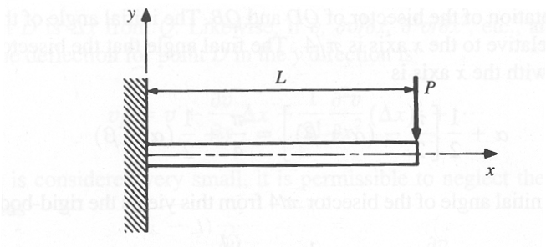
Figure Q4

Question 5
a) Show that $ϕ(r,θ)=Cr^{2}\left(α-θ+sinθ cosθ-tanα \cos^{2}θ\right)$ is a permissible Airy stress function. (4 marks)
b) Derive expressions for the stresses from this Airy function. (5 marks)
c) These general stresses may be used to solve the problem of a taped cantilever beam of unit thickness carrying a uniformly distributed load q per unit length as shown in Figure Q5. Show that the derived stresses in b) satisfy all the boundary conditions along the edges θ = 0◦ and θ = α. (6 marks)
d) Hence obtain a value for the constant C in terms of q and α and therefore that
$σ_{r}= \frac{qα}{tanα-α}$ , when θ = 0◦.
(2 marks)
e) Compare the value obtained from this formula with the bending stress obtained from simple bending theory $σ=\frac{yM}{I}$ when α = 30◦. Give the percentage difference between the stress given by the formula and that from simple bending. Identify clearly which is the bigger. (3 marks)

α
θ
r
q per unit length

Figure Q5

