- What is the total area under the normal curve?

- A study was conducted that resulted in the following relative frequency histogram. Determine whether or not the histogram indicates that a normal distribution could be used as a model for the variable.
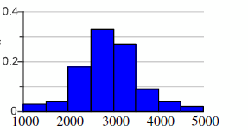

- Find the area of the indicated region under the standard normal curve.
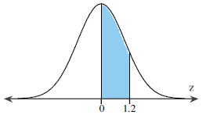

The area between z = 0 and z = 1.2 under the standard normal curve is.
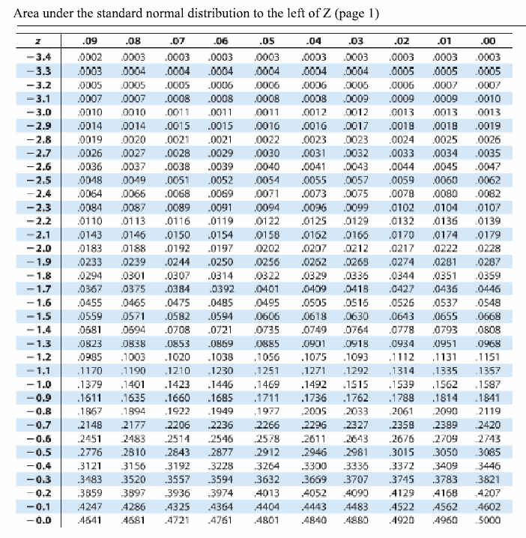
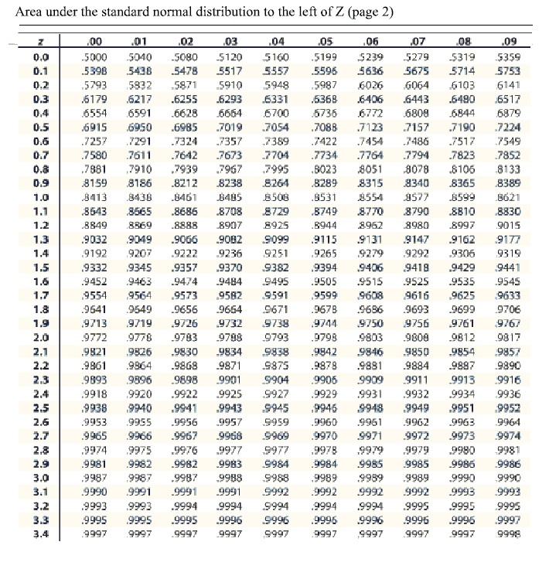

- Find the area of the indicated region under the standard normal curve.
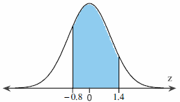

The area between z = 0 and z = 1.2 under the standard normal curve is.

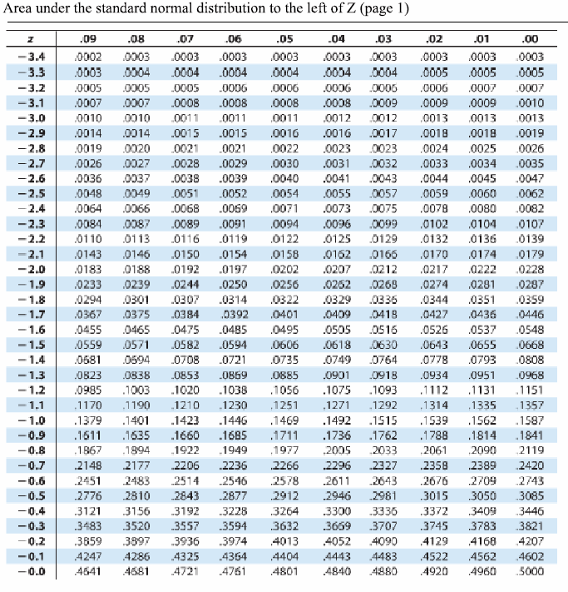
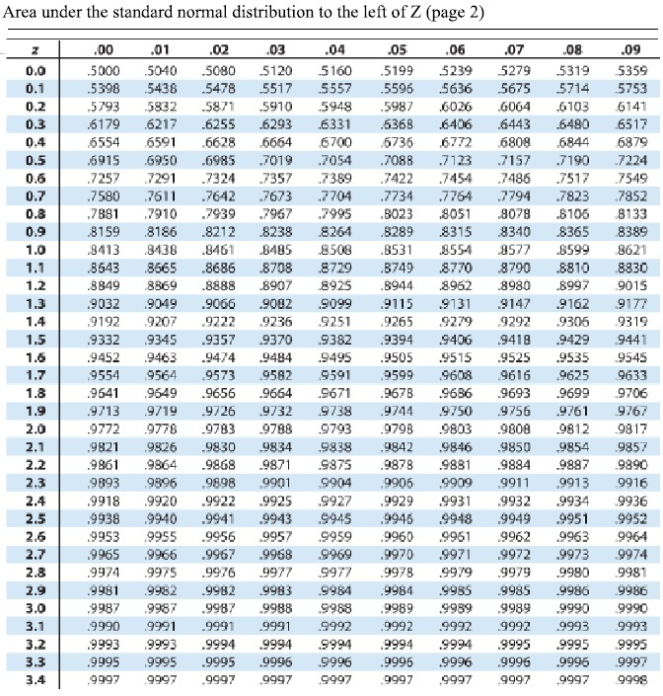

- Assume the random variable x is normally distributed with mean μ = 88 and standard deviation
σ = 5. Find the indicated probability.

- Assume a member is selected at random from the population represented by the graph. Find the probability that the member selected at random is from the shaded area of the graph. Assume the variable x is normally distributed.
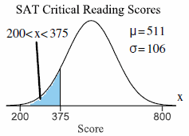

- Assume a member is selected at random from the population represented by the graph. Find the probability that the member selected at random is from the shaded area of the graph. Assume the variable x is normally distributed.
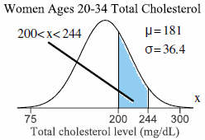

- The mean incubation time for a type of fertilized egg kept at 100.6ºF is 23 days. Suppose that the incubation times are approximately normally distributed with a standard deviation of 1 day.
- What is the probability that a randomly selected fertilized egg hatches in less than 22 days?
- What is the probability that a randomly selected fertilized egg hatches between 21 to 23 days?
- What is the probability that a randomly selected fertilized egg takes over 24 days to hatch?

- The life span of a battery is normally distributed, with a mean of 2500 hours and a standard deviation of 50 hours. What percent of batteries have a life span that is more than 2575 hours? Would it be unusual for a battery to have a life span that is more than 2575 hours? Explain yours reasoning.

- Use the standard normal table to find the z-score that corresponds to the cumulative area 0.7517. If the area is not in the table, use the entry closest to the area. If the area is halfway between two entries, use the z-score halfway between the corresponding z-scores.
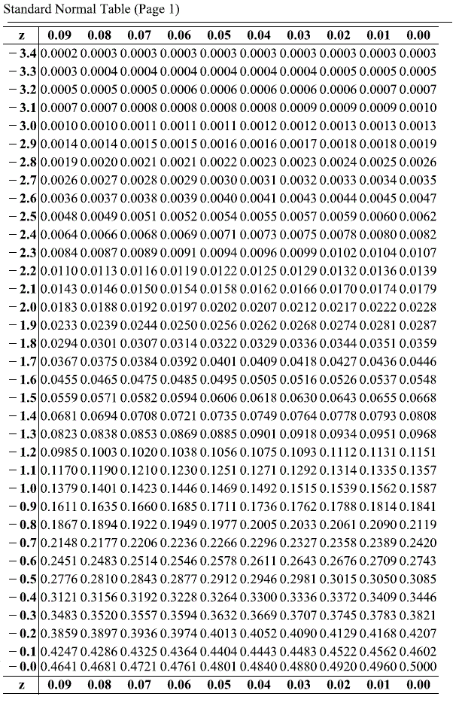
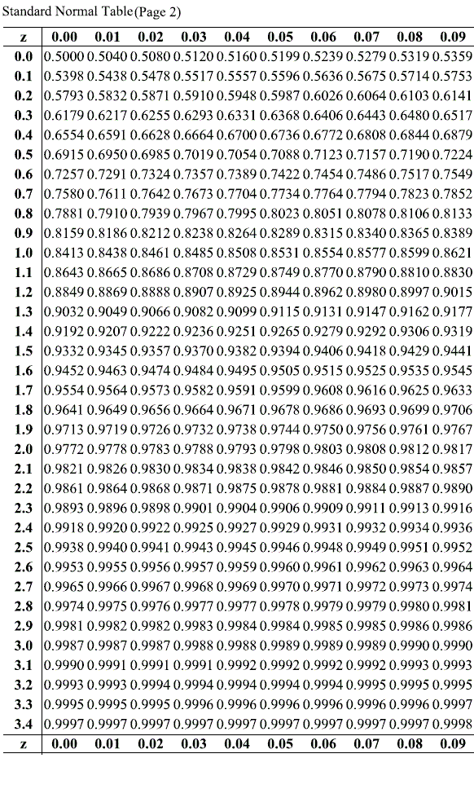

- Find the indicated z-score shown in the graph to the right.
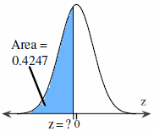
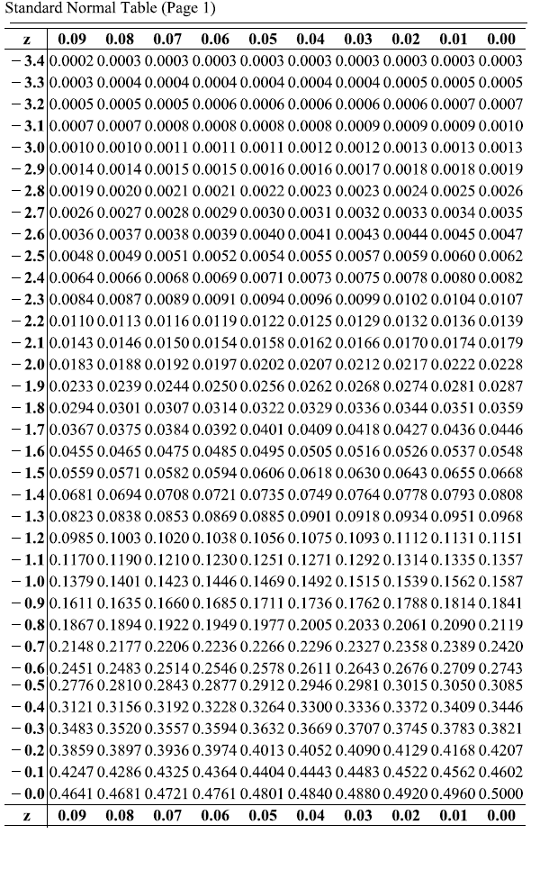
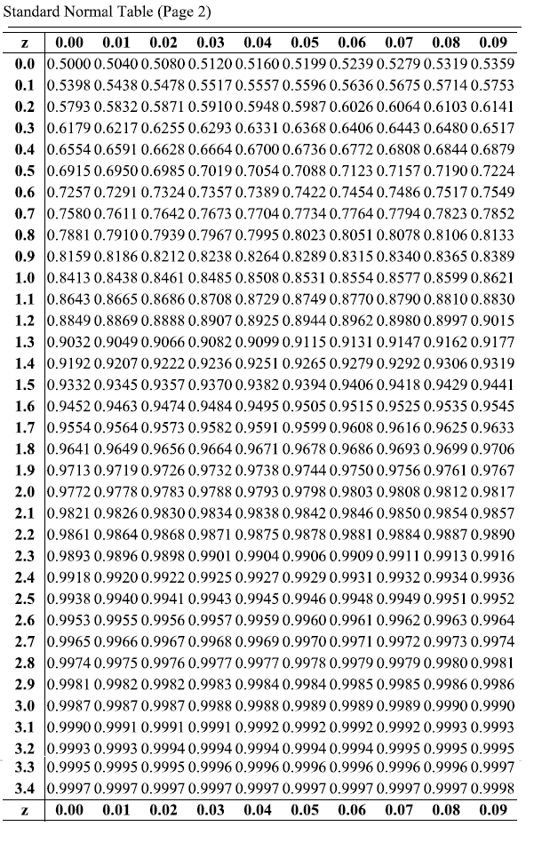
- Find the indicated z-score shown in the graph.
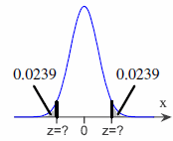
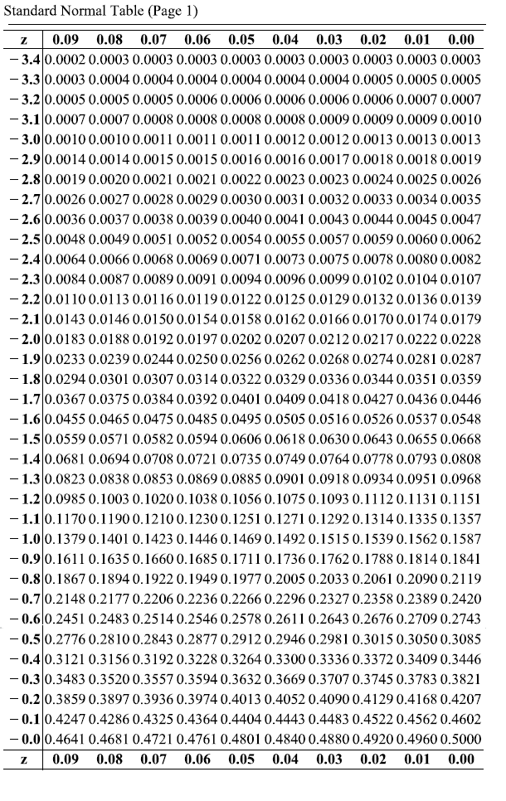
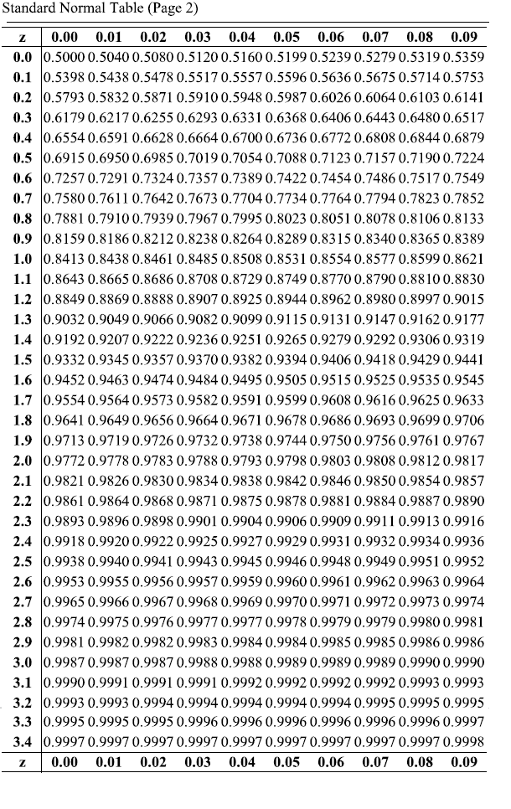
- Find the z-scores for which 97% of the distribution’s area lies between –z and z.
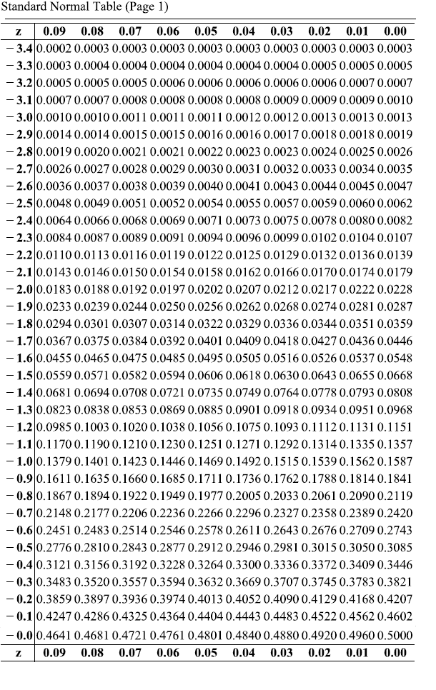
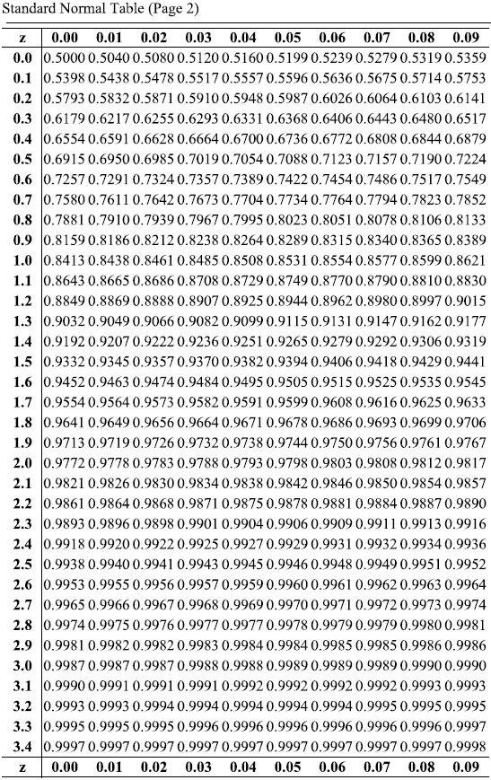
- The time spent(in days) waiting for a heart transplant in two states for a patients with type A⁺ blood can be approximated by a normal distribution, as shown in the graph to the right. Complete parts (a) and (b) below.
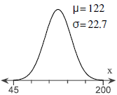

- What is the shortest time spent waiting for a heart that would still place in the top 15% of waiting times?
- What is the longest time spent waiting for a heart that would still place in the bottom 15% of waiting times?
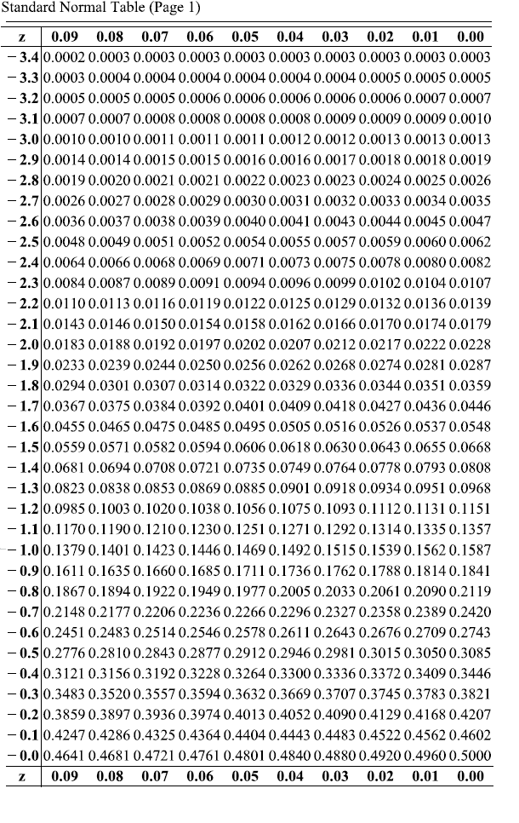
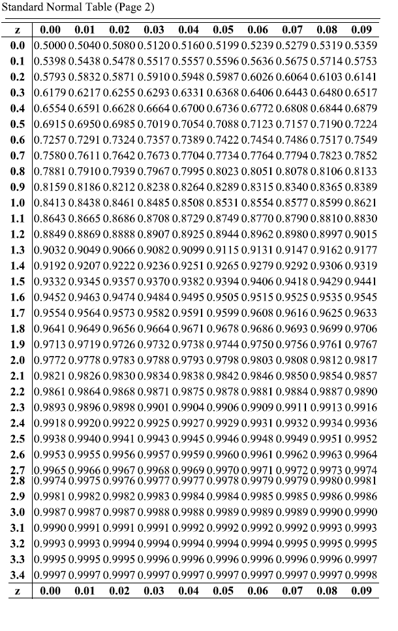
- A population has a mean μ = 90 and a standard deviation σ = 27. Find the mean and standard deviation of a sampling distribution of sample means with sample means with sample size n=81

- Determine whether the statement is true or false. If it is false, rewrite it as a true statement.
As the size of a sample increases, the mean of the distribution of sample means increases.

- The population mean and standard deviation are given below. Find the required probability and determine whether the given sample mean would be considered unusual.
For a sample of n = 75, find the probability of a sample mean being greater than 213 if μ = 212 and
σ = 6.1.

- Use the central limit theorem to find the mean and standard error of the means of the indicated sampling distribution. Then sketch a graph of the sampling distribution.
The per capita consumption of red meat by people in a country in a recent year was normally distributed, with a mean of 115 pounds and a standard deviation of 37.2 pounds. Random samples of size 20 are drawn from this population and the mean of each sample is determined.

- A machine used to fill gallon-sized paint cans is regulated so that the amount of paint dispensed has a mean of 124 ounces and a standard deviation of 0.40 ounce. You randomly select 50 cans and carefully measure the contents. The sample mean of the cans is 123.9 ounces. Does the machine need to be reset? Explain your reasoning.

- The sample size n, probability of success p, and probability of failure q are given for a binomial experiment. Decide whether you can use the normal distribution to approximate the random variable x.
n = 17 p = 0.32 q = 0.68

- Use the correction for continuity and determine the normal probability statement that corresponds to the binomial probability statement.
Binomial Probability P(x < 113)

- Decide whether you can use the normal distribution to approximate the binomial distribution. If you can, use the normal distribution to approximate the indicated probabilities and sketch their graph. If you cannot, explain why and use the binomial distribution to find the indicated probabilities.
Five percent of workers in a city use public transportation to get to work. You randomly select 273 workers and ask them if they use public transportation to get to work. Complete parts (a) through (d).

- Find the probability that exactly 19 workers will say yes.
- Find the probability that at least 9 workers will say yes.
- Find the probability that fewer than 19 workers will say yes.
- A transit authority offers discount rates to companies that have at least 30 employees who use public transportation to get to work. There are 549 employees in a company. What is the probability that the company will not get the discount?

Can the normal distribution be used to approximate the binomial distribution?

- A drug tester claims that a drug cures a rare skin disease 81% of the time. The claim is checked by testing the drug on 100 patients. If at least 74 patients are cured, the claim will be accepted.
Find the probability that the claim will be rejected assuming that the manufacturer’s claim is true. Use the normal distribution to approximate the binomial distribution if possible.

