ROBOTIC TECHNOLOGY

QUESTION1
DEFINITION
Robotics is the branch of technology that deals with the design, construction, operation, and application of robots, well as computer systems for their control, sensory feedback, and information processing.
This technology deals with machines that are automated and can work in dangerous environments or industrial sectors and can take the place the place of humans. It includes such diverse fields as machine design, control theory, microelectronics, computer programming, artificial intelligence, human factors, and production theory. Robotics is an extremely dynamic field with thriving advancement in its technology. Robotics will contribute to increasing opportunities for economic growth and greatly affect future generations with substantial social and economic impacts.

HISTORY
The line of ancestry leads back to the mechanical dolls that inventors have devised to entertain patrons and members of the society. One of the earliest examples of such a mechanical doll is a wooden model of a pigeon made by Archytas of Tarentum around 350 BC. In the 13th century, Roger Bacon and Albertus Magnus are the people from the European world believed to have devised the so called rudimentary androids. The French were also adept at inventing these gadgets. A mechanical lion was built by Loius XII around the year 1500.
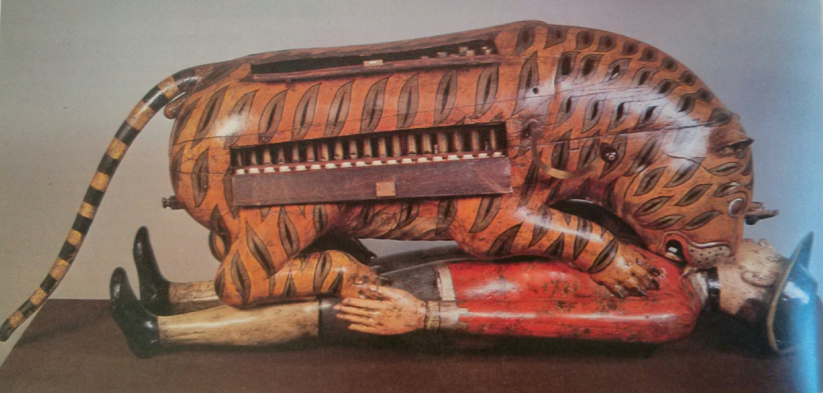
Fig1:Tippu's tiger is an example of 18th century automation

In 1739, Jacques de Voucanson created a mechanical duck that appeared to have the ability to eat kernels of grain, to metabolize and defecate them.
The 20th century brought with it more meaningful advances in the direction of today's robots. The word Robot was itself derived from the Czech word "robota" meaning self or forced labour.
In 1928, one of the first humanoid robots was exhibited at the annual exhibition of the Model Engineers Society in London. Invented by W. H. Richards, the robot Eric's frame consisted of an aluminium body of armour with eleven electromagnets and one motor powered by a twelve-volt power source. This robot was remote controlled and it could move its upper limbs and head. The humanoid robot known as Elektro as initiated at the World's Fair. This robot could walk by voice command, speak, smoke cigarettes, blow balloons and move it limbs. Gakutensoku was Japan's first robot which was designed and constructed in the year 1928 by a biologist Makoto Nishimura.
The UNIMATE was the first digitally operated and programmable robot which was invented in the year 1954 by George Devol. This invention marked the era of industrial automation. It also represents the foundation of the modern robotics industry. The Unimate was bought my General Motors in the year 1960 and was installed in 1961 in a plant in Trenton, New Jersey to lift hot pieces of metal from a die casting machine and stack them.

Robotics is part of an evolving pattern of technology that has concentrated on developing machines to do people's work for them.

for others, the new machinery may be less benign. It may, for example, supplant manual labour to such a degree that it threats the security of people's job. The introduction of new breeds of robots will surely stimulate similar questions about their sociological effects.

