Find the Laplace transform of 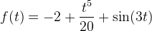.
Find the Laplace transform of .
Find the Laplace transform of .
Find the Laplace transform of 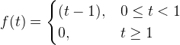

Find the Laplace transform of 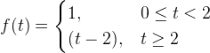

Find the inverse Laplace transform of
.
Find the inverse Laplace transform of

Find the inverse Laplace transform of
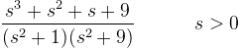

Consider the following initial value problem:
Using for the Laplace transform of , i.e., , find the equation you get by taking the Laplace transform of the differential equation and solve for

Find the Laplace transform of

Find the Laplace transform of

Find the inverse Laplace transform of
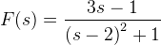

Find the Laplace transform of
.

Take the Laplace transform of the following initial value problem and solve for :
.
Now find the inverse transform to find

Find the Laplace transform of

Find the convolution of and

Let denote the Laplace transform of . Find .
Now find the inverse Laplace transform to obtain
NOTE: Your answer will require the unit step function 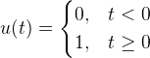 which in

Evaluate the integral (here is the Dirac delta function)
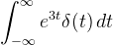
ANS:

Find the Laplace transform of the given function

