The following is the main text about the Scientific Revolution. The quiz will be based on this text as well. Study questions are at the bottom, and an accompanying Power Point presentation is available through a separate link in the Week 11 folder.

The Scientific Revolution: The Disenchanting of the Universe
by Karen Styles

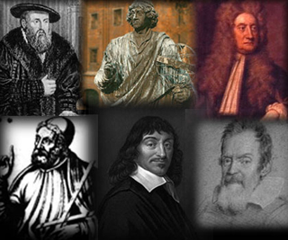

One could say that the dominant scientific worldview going into the 16th century was not all that “scientific” in the modern sense of the word. One of the essential features of ancient and medieval scientific views is the idea that the motion of an object is imparted by an accompanying “mover”, with no attempt to explain what that mover was. (a god or God, perhaps?) According to the theory of the ancient scientist and philosopher Aristotle, all heavy terrestrial bodies had a natural motion towards the center of the universe, which for medieval thinkers was at or near the center of the earth. It should be noted, however, that Aristotle had no understanding of the force of gravity. It was believed that things fell to the earth because they wanted to “go home”, and did so with the help of their movers.

The Aristotelian doctrine of inertia was a doctrine of rest--it was motion, not rest, that always required to be explained. Wherever this motion existed, and however long it existed, something had to be brought in to account for it. The view that a body would keep in movement only so long as a mover was actually in contact with it accounted for why a thing moved, although again, it never defined what the nature of the mover was. Aristotle also held that the more mass an object has, the faster its rate of acceleration. Aristotelian tradition also held that one could work out all the laws that govern the universe by pure thought (deductive method); it was not necessary to check by observation. So no one until Galileo bothered to see whether bodies of different weights did in fact fall at different speeds.

One reason why Aristotle’s theories were not overturned sooner is because no one ever questioned the knowledge gained through the method of deductive reasoning, and why no one ever made first-hand observations of phenomena for themselves in order to check the theories. There are several reasons for this lack of suspicion. First of all, it was supremely difficult to escape the Aristotelian doctrine by merely observing things more closely, especially if one had already started off on the wrong foot and were hampered beforehand with the whole system of interlocking Aristotelian ideas (Butterfield 24). In fact, the modern law of inertia is not the thing one would discover by mere photographic methods of observation. It required a different kind of thinking, for we do not actually see ordinary objects continuing their motion in that kind of empty space, which Aristotle said could not occur, and sailing away to infinity. The trick lay in the fact that it occurred to someone (Galileo) to imagine these possibilities.

Another reason why Aristotle's theories were not overturned sooner than they were is directly linked to the medieval domination of the Christian Church. Since literacy was found almost exclusively among the clergy during this period, it was left to the Church to dispense with information concerning secular as well as religious matters. An earth-centered universe was essential to Church teachings because it placed humans at the center of creation and hence at the center of God's attention. This astronomical/religious outlook was the key to the Church's maintaining heightened power and authority.

As was stated above, it takes incredible powers of the imagination to go beyond widely adhered-to scientific and religious doctrines, and imaginative powers are what characterized four key figures who contributed to disenchanting the view of the universe: Nicolas Copernicus, Galileo Galilei, Johannes Kepler, and Isaac Newton.

Copernicus

If necessity is the mother of invention, so too is discontent with the old ways of doing things. And discontent was what lay behind the willingness of Polish astronomer Nicolaus Copernicus (died 1543) to take the risk of offending the Church and daring to propose that the sun, not the earth, is fixed at the center of all things, and that the spherical earth spins on its own axis once a day while moving around the sun in a circle once a year (Hoffmann 10). This astronomical view is known as the heliocentric theory. For centuries, the Church adhered to the geocentric or Ptolemaic theory. (Ptolemy was an Alexandrian astronomer who lived in the 2nd century CE who had advanced the astronomical theories of Aristotle.) Copernicus knew that the traditional techniques of Ptolemaic astronomy had not and could not solve the problem of the strange motions that the planets make. Though their main motions were all eastward, each passed through a variety of stages during which it moved backwards before moving forward again. Ptolemy referred to these motions as “epicycles”. The inconsistencies of planetary motion were unsettling to Copernicus because he could not accept the idea that the operations of the universe lacked perfection. He therefore concluded that there must be a fundamental error in the basic concepts of traditional planetary astronomy. The significance of Copernicus' discontent is expressed by Thomas Kuhn in The Copernican Revolution:

For the first time, a technically competent astronomer had rejected the time-honored scientific tradition for reasons internal to his science, and this professional awareness of technical fallacy inaugurated the Copernican Revolution. (142)

Copernicus published his cosmological and astronomical propositions in a work entitled De Revolutionibus Orbium Caelestium (The Revolutions of the Celestial Planets). This work, published in 1543 shortly before Copernicus’ death, contains a preface in which Copernicus addresses Pope Paul III and explains why he dared to conceive such motion of the earth contrary to the opinions of the mathematicians of his day. An honest appraisal of contemporary astronomy, says Copernicus, shows that the earth-centered approach to the problem of the orbits of the planets is hopeless:

For, first, the mathematicians are so unsure of the movements of the Sun and Moon that they cannot even explain or observe the constant length of the seasonal year. Secondly, in determining the motions of these and of the other five planets, they use neither the same principles and hypotheses nor the same demonstrations of the apparent motions and revolutions. So some use only homocentric circles, while others employ eccentrics and epicycles. Yet even by these means they do not completely attain their ends. Those who have relied on homocentrics, though they have proved that some different motions can be compounded therefrom, have not thereby been able fully to establish a system which agrees with the phenomena. (Quoted in Kuhn 167)

Copernicus was not the first to propose that the earth was not motionless. In the third century BCE, the Greek mathematician Aristarchus of the island of Samos made the same proposal. However, because of his irreverent treatment of the earth, Aristarchus was attacked as impious. Additionally, Aristarchus’ proposal was contrary to what can be seen by the human eye—it appears as though the sun rises in the east, moves through the sky throughout the day, and sets in the west. Copernicus’ proposal treated the earth just as irreverently as Aristarchus’ had, but Copernicus advanced his theory with such cogency and with such a wealth of mathematical detail that at last the idea of a moving earth prevailed--though not in his lifetime (Hoffmann 8-10). It was left for the Italian astronomer Galileo Galilei to find an audience that would finally accept the Copernican theory.

Galileo

Galileo Galilei was born in Pisa in 1564. Although some of his earliest scientific contributions helped to dramatically overturn Aristotelian physics, Galileo's most celebrated discovery was in the field of astronomy. In the early 1600's this field was in a state of great ferment, for an important dispute was going on between the followers of the heliocentric theory of Copernicus and the adherents of the earlier Ptolemaic, or geocentric, theory. As early as 1604, Galileo had announced his belief that Copernicus was correct, but at that time he had no method of proving it. Galileo happened to be in Venice in June 1609, and there he heard of the "Dutch perspective glass" by means of which distant objects appeared nearer and larger. Galileo was able to secure a description of this lens, and he made his own and used it to construct a vastly improved telescope. (Galileo is commonly credited with inventing the telescope, but this is not accurate. Galileo was the first to use a telescope for the purpose of astronomy in 1609. Hans Lipperhey, a German spectacle maker, is generally credited as the inventor of the telescope, as his patent application is dated the earliest, on the 25th of September 1608.)

Within one year, Galileo made a whole series of astronomical discoveries that would make him famous. Galileo looked at the moon and saw that it was not a smooth sphere, but had numerous craters and high mountains on it. Celestial objects, he concluded, were not smooth and perfect after all, but had the same sort of irregularities that one observed on earth. He looked at the Milky Way and saw that it was not a milky, nebulous body after all, but was composed of an enormous number of individual stars, which were so far away that the naked eye tended to blur them together. He looked at the planets and saw that rings encircled Saturn; he also observed that four moons revolved around Jupiter. Here was clear evidence that an astronomical body could revolve about a planet other than Earth. Galileo’s most famous contribution to astronomy was his confirmation of the Copernican theory. Acceptance of this theory had massive repercussions for the Western worldview, as it removed humans from the center of the universe and put great distance between them and God, who must, according to medieval thinkers, exist at the center of creation. The disenchantment of the natural order that was rooted in the Copernican theory found even greater impetus in Galileo’s work in mechanics.

Although Galileo’s discoveries made him famous in the world of astronomy, he aroused opposition among important church circles for the same reason that the Greek mathematician Aristarchus was attacked as impious: the theory treated the earth irreverently. Galileo was ordered in 1616 to refrain from teaching the Copernican hypothesis, but when the Pope died in 1623, he was succeeded by a man who had been an admirer of Galileo. The following year this successor, Pope Urban VIII, hinted that the prohibition would no longer be in force. Galileo then set to work composing his most famous work, Dialogue Concerning the Two Chief World Systems. This book was a masterly exposition of the evidence in favor of the Copernican theory, and the book was published in 1632 with the authorization of the Church censors. Nevertheless, some Church authorities responded in anger when the book appeared, and Galileo was soon brought to trial before the Inquisition in Rome on charges of having violated the 1616 prohibition.

Galileo was found guilty but was given a light sentence. He was not, in fact, confined to jail at all, but merely to house arrest in his own comfortable villa on the outskirts of Florence. His only other punishment was the requirement that he publicly recant his view that the earth moves around the sun. This the sixty-nine-year-old scientist did in open court. (There is a famous and probably apocryphal story that after he finished making his retraction, Galileo looked down to the earth and whispered softly, “It still moves.”) Galileo lived out the remainder of his life under house arrest in his villa, where he died in 1642. During this time he continued to write on mechanics.

Galileo had been taught Aristotelian mechanics as a young boy. He decided to test, however, the theory that heavier objects fall faster than lighter objects, and through a series of experiments, he soon found that Aristotle had been incorrect. Galileo found that heavy and light objects fall at the same velocity except to the extent that they are retarded by the friction of the air. Having learned this, Galileo took the next step. He carefully measured the distance that objects fall in a given period of time and found that the distance traversed by a falling object is proportional to the square of the number of seconds it has been falling. This discovery, which implies a uniform rate of acceleration, is significant in itself. Even more important, Galileo was able to summarize the results of his experiments by a mathematical formula. (The extensive use of mathematical formulas and mathematical methods is an important characteristic of modern science.)

Another of Galileo’s major contributions was his discovery of the law of inertia. Previously, under the Aristotelian system, it was believed that a moving object would naturally tend to slow down and stop unless some force was exerted to keep it moving (an enchanted force which accompanied the object). But Galileo’s experiments indicated that the common belief was erroneous. If retarding forces, such as friction, could be eliminated, a moving object would naturally tend to continue moving indefinitely. Galileo’s contributions to mechanics indicated that the universe operates according to natural laws and that there is no supernatural mover, and this idea was to be greatly reinforced by the contributions of Kepler and Newton.

Johannes Kepler

By 1600 the earlier flame of excitement over Copernicanism had reached low tide. Man’s changing vision of the universe appeared as an aberration, as was evidenced by the treatment of Galileo when he published his support of the idea that the earth moves. The idea of heliocentrism would have passed into oblivion as do so many ideas built upon such little evidence, had it not been for the German mathematician Johannes Kepler (1571-1630). Kepler was an eccentric genius whose work left an indelible mark that decisively ended the uncertainty and established Copernicanism in its place as the origin of modern astronomy.

Kepler dedicated his life to clarifying the theory of heliocentrism, a theory which attracted him while he was still a theology student. One of the reasons he was so attracted to this view was perhaps due to his mystical belief that the sun, being the source of all light and heat, so necessary for life, must be at the center of the action, symbolic of God the Father.

Furthermore, Kepler held the opinion that geometry existed before the Creation and was co-external with the mind of God himself. Geometry provided God with a model for Creation and was implanted into the mind of every man. Thus, young Kepler felt that if God had created the universe from a geometrical model and had given man an understanding of geometry, then it seemed reasonable that perhaps the nature of all things might be deduced from pure reasoning. In his book Mysterium, Kepler had tried to build his universe around the five Pythagorean solids (tetrahedron, cube, octahedron, doderahedron, icosahedron). He reasoned that the intervals between the five planets known to exist were such that the five solids fitted into the intervals. Since the theory did not quite fit the facts, he then tried to build his universe around the musical harmonies of the Pythagorean scale. The combination of these two ideas led, twenty years later, to his great work Harmonice Mundi (Harmony of the World). But as he began to compute the details of his cosmic musical box, he ran into increasing difficulties. He was never short of an excuse for ascribing to any pair of planets the musical interval which approximately happened to fit it; he managed to construct a system of sort, but its inadequacies were obvious to himself. The principle trouble was that a planet does not move at uniform speed, but faster when it is close to the sun, slower when away from it. Accordingly it does not “hum” on a steady pitch, but alternates between a lower and a higher note. The interval between the two notes depends on a lopsidedness of “eccentricity” of the planet's orbit. But the eccentricities were only inaccurately known. How could you build a series of crystals, or a musical instrument, without knowing the measurements? There was only one man alive in the world who possessed the exact data which Kepler needed: Tycho Brahe.

Tycho Brahe (1546-1601) was a Danish astronomer who was among those who did not accept the Copernican system. What he objected to in this system was not its structure but its moving earth. He proposed an alternative that was essentially identical to the Copernican system, except that the earth--instead of the sun--was regarded as being at rest.

With the lavish support of royalty Brahe built and operated an astronomical observatory in Prague the likes of which the world had never seen. It lacked telescopes, which did not exist at the time, but his observatory was a marvel of precision.

The great event of Tycho’s years of observation, an event that was discussed all over the world and that established, at a single stroke, Tycho’s fame as the leading astronomer of his time, was the new star of 1572. The world had never seen or heard the likes since the year 125 BCE, when Hipparchus had seen a new star. The significance of such a sighting was certainly upsetting to the established doctrines which held that the number of stars outside the sphere of the known planets was fixed and immutable.

The sighting of the new star drew much attention to Brahe’s observatory, including the attention of Kepler. Tycho refused to publish any of his observations until he had completed his own theory concerning the structure of the universe. He jealously guarded his treasure--volumes of figures--the result of a lifetime of work. Kepler had to settle with being invited by Tycho to join his staff at the observatory near Prague in 1600. Kepler also had to stick out numerous arguments with the loud, often violent-tempered Brahe before his patience earned him any reward. When Brahe died, Kepler inherited all his astronomical data which contained information on the regular and continuous sightings made by Brahe.

One of the astronomical problems that had puzzled Kepler for some time which was worked out with Tycho’s data was the problem of the orbit of Mars. Tycho’s data showed that Mars at times made such an orbit that it appeared to actually be going backwards in its orbit for a while before going forward again. Concentrating on Mars, Kepler assumed that its orbit was a circle with its center somewhat displaced from the sun and tried to deduce from Tycho's data the size of the orbit and the position of its center. He spent years of arduous computational labor on the task, and after more than seventy trials found a circular orbit that agreed with the data to be within eight minutes of arc--about a quarter of the apparent width of the moon. In those pre-telescope days, most astronomers would have brushed this small discrepancy aside as being simply due to errors of observation. After his laborious calculations Kepler must have been sorely tempted to do just that. But he could not. He had seen Tycho at work and knew the quality of his observations. Other observers might make errors of such magnitude, but not Tycho. So Kepler accepted the eight minutes of arc as a sign from God and continued his search (Hoffmann 14).

With Tycho’s data Kepler finally worked out the orbit of Mars and to his own surprise found its orbit not to be a circle but an ellipse. In 1609 Kepler published On the Motion of Mars, setting forth his solution to the problem of what kept the planets in their orbits. His findings were expressed in two scientific laws that were elegant in their simplicity:

Law 1 Planets describe elliptical orbits
about the sun, with the sun located
at one of the foci of the ellipse.

Law 2 The radius vector sweeps out equal
areas in equal intervals of time.

His second law accounted for each planet’s observed variable speed within its respective orbit by showing that nearness to the sun affected its behavior--the closer to the sun, the faster the speed, and the farther from the sun, the slower the speed. Together, these two laws validated sun-centered astronomy, enabling Kepler to abolish the orbital deviations and the tangled calculations that had cluttered the Copernican system (Matthews & Platt 385).

Kepler continued to manipulate Tycho’s raw data, convinced that other mathematical laws could be derived from observations of the heavens. Kepler noticed in Tycho's data that the farther away a planet is from the sun, the longer it takes for it to complete a revolution. He published this observation about planetary motion in 1619:

Law 3 The square of the period of revolution
of a planet is proportional to the cube
of its semimajor axis.

This law explains that the squares of the length of time for each planet’s orbit are in the same ratios as the cubes of their respective mean distances from the sun. This means that if one divides the square of the time by the cube of the average distance from the sun, the number obtained is the same for all the planets (Hoffmann 19). Through his third law, Kepler affirmed that the solar system itself was regular and organized by mathematically determined relationships. The universe is also predictable; using Kepler’s laws, one can determine where any planet is going to be at any moment. (It is because of Kepler’s law that NASA scientists are able to determine where a distant planet is going to be located months, or even years, after a spacecraft was launched.) This was the first expression of the notion that the universe is mechanized--it operates with clocklike regularity; it is predictable and orderly, and its underlying order can be discovered through scientific theorizing. This is an idea which became the focus of the worldviews of many prominent thinkers of the Enlightenment Period of the 18th century.

Isaac Newton

Kepler’s significant contribution to the Scientific Revolution was his description of the actual paths the planets take in their orbits around the sun. Kepler was unable, however, to define the force which held the planets in their respective paths. All he knew was that as the planets orbit the sun, they speed up as they approach the sun and slow down as they move away from it; he had no answer for the question of why they vary in their speeds. This riddle was left to the brilliant mind of Isaac Newton (1642-1727) to solve. Building on the research of the heirs to Copernicus, including Kepler's laws of planetary motion and Galileo’s law of inertia, Newton, an English mathematician, conceived a model of the universe that decisively overturned the Ptolemaic scheme and finished the revolution in astronomy that was initiated by Copernicus (Matthews & Platt 386). In a letter to a scientific colleague, Newton applied an old aphorism to himself: “If I have seen farther, it is by standing on the shoulders of giants.” He was speaking of his work in optics, but the words apply more broadly
(Hoffmann 23).

In school, young Newton’s early record was hardly auspicious. Indeed, for a while he was at the bottom of his class. There is a story that claims that Newton got into a fist-fight with the boy who was at the head of his class, and after winning the fight, Newton decided to better his opponent intellectually as well as physically. He succeeded strikingly, ending his school days as head boy in the class.

Newton entered Cambridge in 1661, and in 1665 he fled the Black Death which struck London and soon spread to his school. The plague caused Newton to spend two years in the safety and quiet of Woolsthorpe, far away from the big city. During these two years, Newton laid the basis for almost everything of note that he was ever to accomplish in his life. He began the construction of the calculus, laid bare to himself the nature of color, and discovered the mathematical law governing the amount of gravitational attraction between objects (Hoffmann 23-24).

Like Brahe, Newton was almost obsessive about his work and he did not hasten to publish his results. In 1684, Edmund Halley, who is best known for the comet that bears his name, journeyed to Cambridge, where Newton had been appointed to a professorship of mathematics at the age of 26. Halley, recognizing the extraordinary strides that Newton had made in the study of dynamics and planetary motion, persuaded him to publish his results. In 18 months, Newton completed the main part of the greatest book in the history of science: Philosophiae naturalis principia mathematica (Mathematical Principles of Natural Science), known more familiarly as the Principia. This book quickly gained an authority that made Newton the modern world's equivalent of Aristotle. By the eighteenth century the English poet Alexander Pope could justifiably write in his “Essay on Man”:

Nature and Nature’s Laws lay hid in Night;
God said. Let Newton be! and All was Light.

In the Principia, Newton laid down the necessary proofs for the long discovered propositions concerning planetary movements, and demonstrated finally the primacy of the mathematical method in treating natural philosophy (science) in all its mechanical branches. He built upon the work of his predecessors not only in utilizing their discoveries of the workings of nature, but also by utilizing their respective methodologies. Galileo had shown that observation is an essential step toward scientific truth, and Kepler had revealed that the solar system was organized by relationships that could be understood through scientific reasoning and communicated in mathematical language. Newton combined these two methodologies into what we now refer to as "Scientific Method"—the fusion of observation and theorizing. Newton described this method in the Preface to the first edition of his Principia by arguing that the natural philosopher should perceive the motions which instigate the forces of nature, and then from these forces the philosopher should demonstrate the phenomena of the universe (Redwood 63).

Newton’s Science

The story goes that during the plague years 1665-1666, as young Newton sat in the quiet of his garden, he watched an apple fall to the ground, and this set him to wondering: The force of gravity that drew the apple to the earth certainly extended to heights far greater than the height of the apple tree. It was present even atop high mountains, and surely it did not suddenly cease there. What if it reached as far as the moon? Then it might make the circling moon and the falling apple fellow captives of the earth. And a similar gravitational force from the sun might hold its planetary flock in thrall.

How could Newton test his idea? By comparing apple and moon. For if both were tied to the earth by its gravity, their accelerations toward it should be linked. First he must know if gravitation weakened with distance, for the pull of the earth might be much enfeebled at a place as remote as the moon.

Here Kepler’s third law was the key. From it, assuming a circular orbit for simplicity, Newton found that the gravitational force falls off as the inverse square of the distance. This means that if the distance is doubled, the force is reduced to 1/2² , or 1/4, of what it was; if the original distance is tripled, the force is 1/3² , or 1/9, of what it was; at four times the distance, the force is 1/4² , or 1/16, of what it was; and so on. Armed with his inverse-square law, Newton could now make the crucial test by which his whole speculative structure would stand or fall. Knowing the acceleration with which an apple fell and knowing the law by which the pull of gravity was enfeebled by distance, he could calculate the acceleration with which the moon should be falling if it were being held by earth's gravity. But he could also calculate that acceleration directly from the distance of the moon from the earth, and from the fact that it circled the earth once a month. The calculations had their shaky aspect. For example, young Newton had to guess that the distances of the apple and the moon should be those from the center of the earth--a theorem that he was able to prove only much later. How did the two numerical values for the acceleration compare? According to Newton, he found them to “answer pretty nearly,” this phrase coming from a recollection that he set down some fifty years later (Hoffmann 34).

From Newton’s results, he generalized that the earth’s attractive pull on the moon was fundamentally the same as the sun's attractive pull on the planet. Going one step further, he envisioned the whole universe to be held by a similar force. He thus proposed his law of universal gravitation:

Every body attracts every other body with a gravitational force, which varies directly as the product of the masses and inversely as the square of the distance between them.

From Newton’s universal law of gravitation he was able to calculate the 28-day period of revolution for the moon, and he was able to explain the elliptical orbits of the planets as well as the orbits of other astronomical objects such as comets.

In Newton’s Principia, he enunciated three laws of motion in five short sentences, and with those laws and his law of universal gravitation he revealed a breathtaking unity of the heavens and the earth: The same physical laws hold sway throughout the universe.

His first law of motion, often called the “law of inertia,” says that every body continues in a state of rest or of uniform motion in a straight line unless it is compelled to change that state by forces acting on it. This law is far more than a mere restatement of Galileo's discovery--not in its wording, but in its setting. For Galileo tended to be earthbound, but Newton sought a grand synthesis of the heavens and the earth and dared to give his laws cosmic validity.

Newton’s second law tells the effect of force on the motion of a particle. It is often summed up in the phrase, “force equals mass times acceleration” (F = ma). From this law it follows that, for any given force, the larger the mass of the body on which it acts, the smaller the acceleration that the force gives rise to, and vice versa. This consequence of the law accords with everyday experience: the more massive an object, the harder it is to budge it or, if it is already in motion, to slow it down or speed it up. Thus the mass of a body is a measure of its “reluctance” to be accelerated by forces. The technical term for this reluctance is inertia.

Newton’s third law of motion says that if one body exerts a force on another, the second exerts an equal but opposite force on the first. This law can seem quite incredible, since, according to it, the gravitational pull of the earth on the apple and the gravitational pull of the apple on the earth are of equal magnitude. But Newton had made typically neat experiments attesting to the law's validity {Hoffmann 35).

World as a Clockwork Mechanism

With the universal laws revealed by Galileo, Kepler, and Newton, all of astronomy could seemingly be explained; they once and for all took the mysterious organismic concepts out of the sky--through their discoveries the universe became disenchanted. It appeared that once the universe was set into motion and the laws were fixed, it would simply go its predetermined way, just as a clock, once wound, will run on and on.

Two of the results of this mechanistic view of the universe were its impact on theology and ethics. The effect on theology was primarily to remove God from the running of the universe and to reserve for Him instead the act of creation. This, of course, runs totally counter to the belief in Divine Intervention. Yet the theology derived from Newton's mechanics had a very strong belief in God the Creator. We may remember Newton for his scientific accomplishments, but he himself felt his science had intrinsic worth only insofar as it demonstrated the power of God to produce a perfect creation. God's truth was now to be found in nature as well as in the Bible. And we must also remember that although Kepler believed that the universe was created according to mathematic principles, he felt that those principles were evidence of the perfection of God and all God's creation as well.

Another impact the mechanistic view of the universe had was an impact on ethics, in particular, the ethical aspect of free will. Once the universe is wound up, then it must run its course, and all that a person does is predetermined at the beginning by the clockmaker. Accordingly, there can be no real free will, and no one is responsible for what he does. From the configuration of the universe, the laws of Galileo, Kepler and Newton allow a complete prediction of the future. God is certainly capable of such predictions. And even though we may not have the capacity to duplicate this prediction, we certainly cannot hope to ever change the future. So there is no good, no evil, and man has no soul.

Summary

The astronomical and scientific contributions of Copernicus, Galileo, Kepler, Brahe, and Newton helped to solve the puzzle of nature so well that the world never was the same after them. The mechanics of Galileo, Kepler, and Newton led to the clockwork model of the universe, and there were attempts in other disciplines, like philosophy and politics, to use the notion of a clockwork mechanism to place those disciplines into a scientific form aiming toward universal agreement. These attempts at a scientific consensus outside science were magnificent, and they certainly characterize the period we refer to as the Enlightenment. However, in most cases the philosophers and political thinkers failed to come to universal agreement in several critical areas.

Kepler’s Science

Law 1. Planets describe elliptical orbits about the sun,
with the sun located at one of the foci of the ellipse.

Law 2. The radius vector sweeps out equal areas in equal
intervals of time.

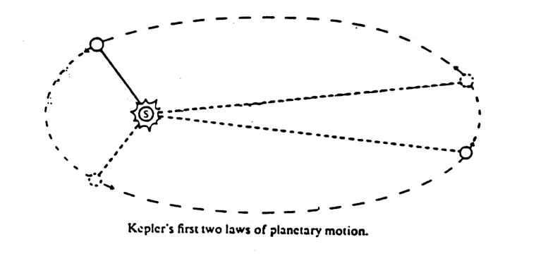
Law 3. The square of the period of revolution of a planet
is proportional to the cube of its semimajor axis.

Newton’s Science

First Law of Every body continues in its state of rest, or of uniform motion in a
Motion: straight line, unless it is compelled to change that state by forces impressed on it.

Second Law Force equals mass times acceleration (F = ma) (or alternately, force
of Motion: equals the time rate of change of momentum).

Third Law of To every action there is always an equal and opposite reaction.
Motion: (Force = Mass x Acceleration)

Newton’s Law Every body attracts every other body with a gravitational force, which
of Gravity: varies directly as the product of the masses and inversely as the square of the distance between them.

STUDY QUESTIONS

1 - What does the deductive method, which was in the base of the Aristotelian tradition, suggest?

2 - What was the major work by Polish astronomer Nicolaus Copernicus titled?

3 - What did Copernicus propose at the risk of offending the Church?

4 - What six important observations/discoveries did Galileo make with his telescope?

5 - What did Galileo find by testing the fall of heavy and light objects?

6 - Discovery of which law is another of Galileo’s major contributions to science?

7 - What did Kepler dedicate his life to?

8 - Whose observational data did Kepler use?

9 - What event drew much attention to Brahe’s observatory?

10 - What did Kepler conclude about the orbit of Mars?

11 - What are Kepler’s three scientific laws?

12 - What is the title of Newton’s most important book?

13 - What does Newton’s universal law of gravitation state?

14 - What do Newton’s three laws of motion state?

15 - What was the impact that the new mechanistic view of the world had on theology?

INSTRUCTIONS:

The Scientific Revolution brought a new comprehension of our universe. It is a single physical universe - there are no two domains, the imperfect Earthly and perfect heavenly domains. And we can understand how it works, why planets in the sky and objects here on Earth move the way they do - everything in this universe follows mathematical rules, rules of physics. It is like a clockwork mechanism, and we can calculate and predict how physical objects even planets and stars will behave. There is no more mystery.
This change had huge philosophical consequences.

INITIAL POST INSTRUCTIONS:

1 - Explain the effect that the Scientific Revolution (and its above mentioned consequences) had on theology. How did people see God before, and how after the Scientific revolution?

2 - Major topic of the post: Give me your opinion about the relationship of science and religion today. Can one "believe" in both? Do they exclude each other or not? Why? Give me your opinions, thoughts, and support all of them with solid arguments.

Figures of the Scientific Revolution
- Nicolas Copernicus (1473-1543) – Polish astronomer who dared to risk offending the Church by proposing that the sun, not the earth, is fixed at the center of all things (heliocentrism). He published this proposition in 1543 in a work entitled “The Revolutions of the Celestial Planets”.
- Tycho Brahe (1546-1601) – Danish astronomer who rejected heliocentrism but nevertheless made a major contribution to the ultimate triumph of heliocentrism because of his copious observations of planetary movement.
- Johannes Kepler (1571–1630) – German mathematician who sought to clarify heliocentrism by describing the shapes of the planetary orbits in his work “On the Motion of Mars”, published on 1609. Kepler devised his laws of planetary motion from the observational data of Tycho Brahe.
- Galileo Galilei (1564-1642) – Italian scientist/astronomer who confirmed the heliocentric theory by building a telescope and observing four moons revolving around Jupiter. This was evidence that an astronomical body could revolve about a planet other than earth. He published his findings in 1632 in a work entitled “Dialogue Concerning the Two Chief World Systems.” He also did work in mechanics; he discovered uniform rate of acceleration and the law of inertia.
- Isaac Newton (1642–1727) – English mathematician who presented a satisfactory explanation for what held the planets in their orbits—gravity—and computed the law of universal gravitation in a precise mathematical formula. He published his laws in his work entitled "Mathematical Principles of Natural Philosphy".

Events of the Scientific Revolution
- 1543 – Copernicus publishes “On the Revolutions of the Heavenly Bodies”
- 1571-1601 – Tycho Brahe makes his planetary observations
- C. 1600 – Dutch lens grinders develop the telescope
- 1609 – Kepler publishes his first and second laws of planetary motion in “On the Motion of Mars”
- 1609 – Galileo perfects his own telescope
- 1610 – Galileo sights the four moons around Jupiter
- 1619 – Kepler publishes his third planetary law in “The Harmonies of the World”
- 1632 – Galileo publishes “The Dialogue Concerning the Two Chief World Systems”
- 1633 – Galileo humiliated by the Inquisition
- 1637 – Descartes publishes his “Discourse on Method”
- 1687 - Newton publishes “Mathematical Principles of Natural Philosophy”
- 1690 - Locke publishes “Essay Concerning Human Understanding”

The geocentric model, with the earth in the center
(Also known as the Ptolemaic model, after the ancient astronomer Ptolemy)

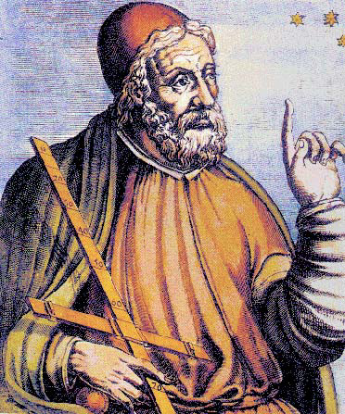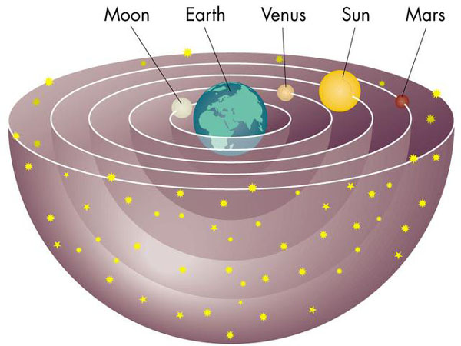

Though the main motions of the planets are all eastward, each passes through a variety of stages during which they move backwards before moving forward again. Ptolemy referred to this retrograde motion as epicycles. This appears to our eyes as a loop-to-loop motion. (This illustration shows the orbit of Mars over a period of several months
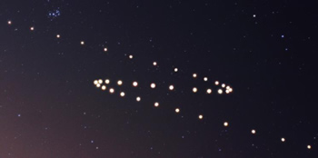

Nicolaus Copernicus (1473-1543)
Copernicus, a Polish astronomer, was the first modern astronomer to propose the heliocentric model of the universe. He did so in 1543, when he published his book, De revolutionibus orbium coelestium (On the Revolutions of the Heavenly Bodies). The publication of this book is considered to be the beginning of the Scientific Revolution.

Even though Copernicus included in his publication a letter to the Pope which explained why he felt that he had to go against the Church’s teachings on geocentrism—because geocentrism did not reconcile with the loop-to-loop motions of the planets—his book was banned by the Church. This means it was included on the “Index of Forbidden Books” that the Church published between 1559-1948.
(Click on this link to be taken to a website where you can read the entire “Index.”)
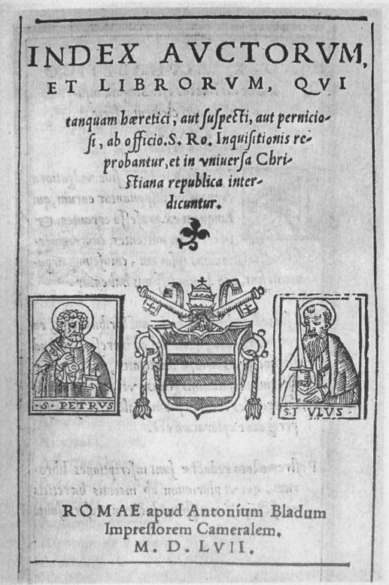

Tycho Brahe (1546-1601)
- Brahe was a Danish astronomer who rejected heliocentrism, but nevertheless made a major contribution to the ultimate triumph of heliocentrism because of his pinpoint-accurate observations of planetary movement.
- In 1601 Kepler accepted Brahe’s invitation to work with him at his observatory in Prague. As a mathematician it was his job to make sense of Brahe's extremely accurate observational data for the orbit for Mars.
- Kepler’s work on the motion of Mars resulted in his discovery of three laws of planetary motion.
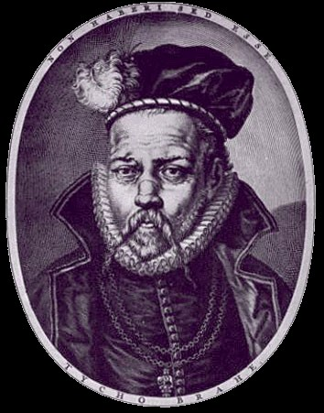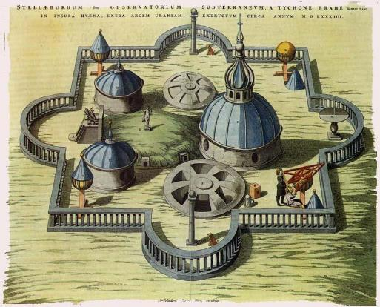

Galileo Galilei (1564-1642)\
- Galileo used the newly invented telescope to support the Copernican model of the universe. (Contrary to popular belief, he did not invent the telescope. He just made it more powerful.)
- He saw near Jupiter what he first thought to be stars. When he looked through the telescope, he realized that the stars were actually moons going around Jupiter.
- This observation proved that a body (planet) could be in motion while another body moved around it, and therefore, the earth could be in motion while the moon moves around it. This knocked a hole in the argument of the supporters of the Ptolemaic model, who argued that if the Earth were moving through space, the Moon would be left behind.
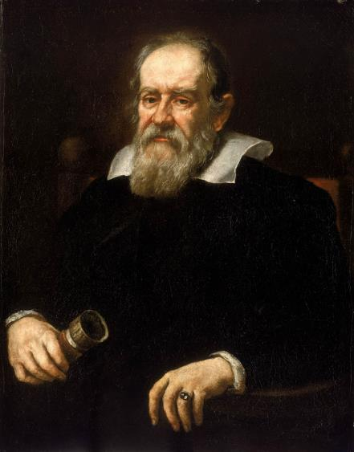

Galileo's support of the heliocentric model of the universe brought him into conflict with the Church. In 1616, the theologians of the Holy Office declared Copernicanism 'false and erroneous' and the Pope admonished Galileo for not defending official Church doctrine.
Galileo was asked to publish a book which was supposed to support the geocentric view; however, when the Dialogue Concerning the Two Chief World Systems was published, it was an outright argument for the Copernican view. The book is an imaginary conversation between three people. The geocentric position is argued for by a dogmatic, arrogant character named Simplicio. The Copernican view is supported by an intelligent and wise character named Salvanti, representing Galileo. The third character, Sagredo, is open to either position but eventually comes to accept heliocentrism.
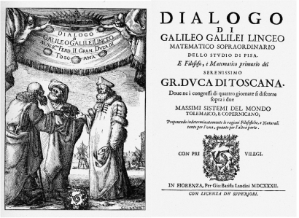

The Church banned the book and ordered Galileo to appear before the Inquisition for heresy. Threatened with torture, Galileo confessed that he was wrong. By this time, Galileo was an old man of 68 years. A death sentence would certainly not have been an unusual punishment for heresy; however, Galileo was lucky and was sentenced to life imprisonment, which was latter commuted to being held under house arrest at his home outside Florence. He died in 1642. But he was also excommunicated by the Church (which means he was denied the Sacraments of the Church, and consequently was denied entrance into Heaven).
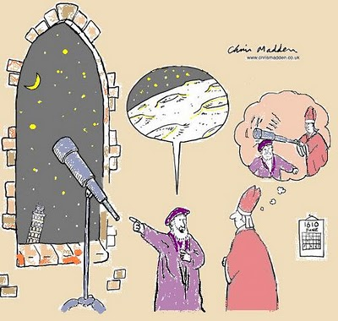

In 1992, 359 years after Galileo’s death, the Vatican cleared him of any
wrongdoing. Here is an excerpt from an “Orlando Sentinel” article from
October 31, 1992, regarding the Church’s rehabilitation of Galileo:
Galileo’s condemnation resulted from a “tragic mutual incomprehension” and became a symbol for the church's
“supposed rejection of scientific progress,” the pope said in
a speech to the Pontifical Academy of Sciences.
The speech was the Vatican's final word on the matter nearly
four centuries after the astronomer was found guilty of violating church doctrine by contending Earth revolved around the sun –
and not vice versa. Vatican experts appointed by John Paul had studied the case for 13 years.

Johannes Kepler (1571-1630)
- Originally, Kepler had planned to be ordained as a Lutheran minister. He saw it as his Christian duty to understand the universe in terms of mathematical rules and thus understand the works of God. His first attempt at explaining the cosmos was in the work, Mysterium Cosmographicum (Mystery of the Sacred Cosmos).
- He devised a model of the solar system in which the orbits of the planets fit inside spheres with radii that could accommodate each of the Platonic solids. This idea is wrong.
- Kepler's model of the Solar System had the planets orbit in spheres of the same radius that could accommodate each of the Platonic solids.
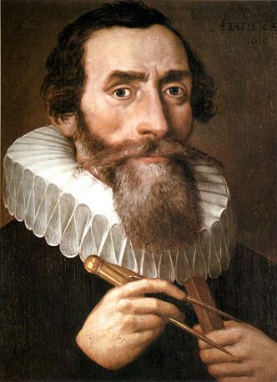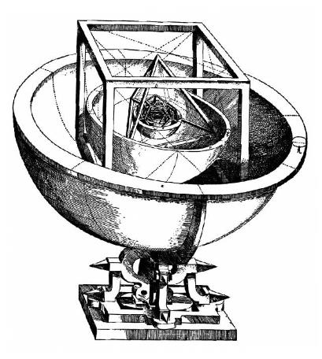

Kepler’s Three Laws of Planetary Motion
First Law: Planets describe elliptical orbits
about the sun, with the sun located
at one of the foci of the ellipse.
Second Law: The radius vector sweeps equal areas in equal times.
Third Law: The square of the period of revolution of a planet is proportional to the cube of its semimajor axis.

Isaac Newton (1642-1727)
It was Sir Isaac Newton who was able to show that Kepler's laws of planetary motion are a natural consequence of simpler and more general descriptions of motion in nature. This brought into one theory both our observations of how things move on Earth and how the planets move in the heavens. These motions are described formally as Newton's laws of motion and gravity.

- Newton applied this idea to the Sun and planets and took Kepler’s laws and calculated that the force falls off with the square of the distance from the Sun.
- Newton's law of universal gravitation states that there is a force acting between objects that pulls them together. This force is proportional to the mass of the objects and inversely proportional to the square of their distance apart.
- F = (GMmr^)/r2
- Newton looked at the motion of the moon around Earth and reasoned that the force responsible for gravity on Earth might be responsible for keeping the moon in orbit around the Earth. It turned out to be so.

