Operational Plan
Overview
Healthy Heart for Everyone is a vehicle based program that will operate out of a central base and travel to event sited throughout the service area for the program. With the exception of multi-day events the unit will return to the base each evening. Healthy Heart for Everyone will participate in two types of events. One is recurring events that will take place either monthly or quarterly in the same location on a regular schedule. The second is individual events which will be booked by the program coordinator three to six months in advance. The goal for the program is to hold 150 events during the first 12 months of operation and 200 during the second year and 300 annually thereafter.
Events:
Each event will have a community co-sponsor (sponsor). Sponsors can be other AHA affiliated programs such as Check Change and Control, Hospitals or health care agencies, local government agencies, community organizations, or companies. that will be responsible for obtaining the space on which the vehicle will set up and operate. Most events will be based from the vehicle with the screening being conducted within the unit. During events held during mild weather screening can be set up to take place outside, adjacent to the unit. During the cold months portable screening equipment will be used to conduct the screening at an indoor location. The minimum duration of an event will be four hours and generally events will run not more than eight hours on any day. Assuming that 10% of people passing by the unit will want to be screened anticipated traffic past the screening unit will need to be a minimum of 50 people per hour.
The local sponsor will be responsible for obtaining any permits needed to hold the event. For events that anticipate the need to screen more than 10 people per hour the sponsor will also recruit additional volunteer staff, to assist the program staff conduct the anticipated number of screens at the event and perform non-screening roles. Health Hearts for Everyone will provide a marketing kit to the sponsor that can be used to promote the event in the local community. The sponsor will rope off the minimum 60 ft x 20 ft area required to set up and operate the unit so it will be immediately available on the unit’s arrival..
Event Staffing
Recurring Events: The unit will be booked for up to 12 recurring events each month. Six of these will be in the Washington DC and six will be in the rural areas of the These will be booked in same location on the same day each month in a high pedestrian traffic locations identified as being under served and having a high need for increasing the awareness of the dangers of untreated hypertension. This event will generally run from 9 AM – 4 PM with a goal of 50 – 75 screenings each day. The typical location will outside a grocery store, drug store, or library or center. Screening at these events will mostly take place inside the vehicle with a volunteer provided by the sponsor greeting passersby and encouraging them to get screened during weather that is amenable to doing so.
Staffing 1 RN / health educator who will do the screenings,
- qualified volunteer supplied by sponsoring agency or AHA volunteer
- driver operator (with additional responsibilities to the unit during the event)
Individual events will mostly occur on weekends hours will vary to fit event. May be multi day event and may run into the evening. The typical event will be an outdoor market, street festival, county fair, home show or others events that will draw large numbers of people from across the community. The goal for these events would be to 100 - 200 screenings each day. For the largest groups with cooperative weather the additional screening stations will be set up outside the vehicle under the awning that extends out from the vehicle but with the
Staffing 1 Staff RN,
1 Staff qualified to do screenings
6-8 volunteers qualified to do screenings recruited by sponsoring agency or AHA volunteers
2-4 volunteers recruited by the sponsor to do non-screening tasks.
1 driver operator (with additional responsibilities to the unit during the event)
The Screening Unit
A custom mobile health screening unit will be purchased or leased according to AHA policy on large capital expenditures. A service contract will be arrange with a charter bus operator or other qualified vendor located centrally within the service area. Under the contract the vendor will provide a qualified driver for the unit, overnight parking, cleaning maintenance, and fuel for the vehicle. The contract will be for one year with the option to renew for up to four additional years. In additional to driving the unit the driver will be responsible for unit set up and take down at each location and will complete other non-screening tasks during the event.
The 45 feet long unit will have a front entrance and rear exit doors to provide efficient traffic flow. The unit will be equipped with lifts or ramps to accommodate people who have difficulty navigating stairs. The unit will have with extensions down each side to expand the interior width from 8 to 12 feet. The floor plan (see diagram) will accommodate the driver cockpit, an area for screening, an office/consultation area, and a staff support area containing a restroom, and refreshment area. There will be large under unit storage compartments. The unit shall be powered by compressed natural gas (CNG) to provide economical environmental propulsion. The CNG will also power a low emission electric generator that will provide full electric needs for the unit when a electric plug in power is not available. In cool weather heat will be provided by a CNG furnace.
The screening area of the unit will contain 4 chairs in which blood pressure will be taken, 4 computer stations where the risk assessment information will be entered by those being screened and a scale. The unit will be equipped with portable BP monitors and computers along with the necessary tables and chairs to duplicate screening area outside the unit for either extra capacity or for screening remotely from the unit.

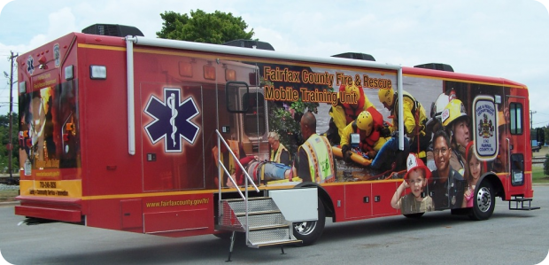
Description: MSV-H-4000-102-45-B (school bus size)
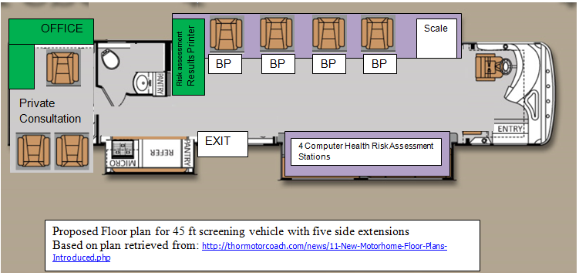
Source: http://www.msvehicles.com/articles/mobile-healthcare-1

Screening Process
Details of screening Process: Entire process done inside the unit
- Enter at front of unit – Receive a computerized Screening card (cost 10cents each)
- Obtain weight that will be used in risk assessment (expected time 1 minute)
  - Place Screening card in slot on the scale
  - Client is presented with three choices
    - Display my weight and include it in my risk assessment
    - Use my weight in my risk assessment weight but do not display it
        - This option will keep the patient’s weight from displaying on the scale or on the printed assessment provided at the end of the screening.
- Move to risk assessment questionnaire.
  - Patient will place screening card into a slot on the touch screen computer – This will enter the client’s weight into the computer.
  - Touch screen computer will ask approximate 10 questions about the patient’s age, height, health hx, family hx related to heart disease and stroke and about life style habits that either increase or reduce the risk of heart disease and stroke. Expected time to complete 5 minutes
  - Client is also presented with a research consent question that an affirmative answer would allow the anonymous data to be utilized for research purposes. Client would also be presented with the option of participating in heart AHA research studies by entering an e-mail address. E-mail would not be used for any other purpose. By providing their e-mail address the client could also receive and e-mail containing the data from the screening in an encrypted format and a separate e-mail with a computer/phone heart attack/stroke risk reduction application that would let them utilize the information collected in the screening as their baseline data.
- Have blood pressure taken utilizing hospital grade automatic Welch Allyn BP device.
Screening card is placed into a card reader connected to the BP machine which records results of the BP along with the health risk information and weight and generates and prints out a 1 – 2 page heart attack/stroke risk assessment with tip specific to the client on measures that can reduce risks; or to congratulate the patient on having a healthy life style if their risk is low.
If the client requested that the information be e-mailed to them the computer generated the e-mail and sends it along with a second message containing the health app for their phone or computer.
5. If the patient had special concerns or the blood pressure or risk of heart attack or stroke were seriously high the client could be taken to the consultation room for a brief private discussion and referral to local resources that might be able to help.
Screening done outside, adjacent to the unit or remotely from the unit or inside a building. The necessary tables, chairs portable scales, BP machines, and computers and other equipment would be carried in the under vehicle storage area to facilitate these alternative set ups. Staffing would be based on the size of the crowd expected at the event. At a very large event screening could be done both inside and outside the vehicle
Program management
A program coordinator will be employed by Health Hearts for Everyone to recruit event sponsors in the communities being served and will schedule the events. The coordinator will also manage the back office aspects of the program including timekeeping for the staff, manage the financer ledgers for the program, and coordinating with the AHA finance office to be sure all program bills are paid when due. During the first six months to year this position will require a full time effort to get the program up and running. In subsequent, unless the program is expanded the hours for the position could be reduced to approximately ½ time. Ideally the Health Hearts for Everyone coordinator work work out of an existing AHA office or in close proximity to the AHA office serving the Healthly Heart for Everyone service area. The cost of renting and setting up an independent office space for an individual employee is prohibitive. The other option would be to have the project coordinator work out the office area of the mobile unit. This would allow the coordinator continue to work with the program full time after the need for a full time coordinator no longer is needed. As the number of hours required coordinating the program decrease the coordinator could assume responsibilities assisting with the program itself. While from a financial viewpoint this arrangement could be a big cost saver, the cramped working space on the mobile unit and frequent interferences might offset the financial gaind of the arrangement.
Equipment and Supplies
10 - Welch Allyn Connex ProBP 3400 Digital Blood Pressure Device ($644.38 each) – 10 for use with 2 back up From Calfin Medical Equipment http://www.claflinequip.com/catalogsearch/result/?q=Welch+Allyn+Connex+ProBP+3400+Digital+Blood+Pressure+Device
20 cases assorted sizes - Welch Allyn FlexiPort Disposable Blood Pressure Cuff Only [20/cs] ($156.13/cs). Will be sanitized after each use with expected life 50 screenings/per cuff. From Calfin Medical Equipment http://www.claflinequip.com/welch-allyn-flexiport-disposable-blood-pressure-cuff-only-20-cs.html
10 -Tablet heavy duty tablet computers (8 to use 2 backup) Estimated cost $800.00 each (source not identified)
2 - Brecknell MS140-300 electronic scale with computer interface cost $527.19 each from Barcodes Inc http://www.barcodesinc.com/salter-brecknell/ms140-300.htm
5,000 - CR80.30 Low Coercivity Mag Stripe PVC Cards - Qty. 500 for confidential information transfer between stations in the screening process. Reusable several times. $66.30 from ID wholesaler. Com http://www.idwholesaler.com/CR8030LO.html

Appendix:
Cost of owning and operating the vehicle
Fuel – CNG Annual use 50 weeks x 5 days = 250 days x 100 miles/day = 25,000 miles /8 MPG = 3125 gallons per year x $2.68/gallon in MD (11/21/13) = $8,375.00 Annual fuel cost
Source for Fuel cost: CNG NOW http://www.cngnow.com/average-cng-prices/pages/default.aspx
Annual Vehicle parking, and Cleaning (estimated) $12,000.00/year (need source)
Bus Driver Salary with benefits ($52,000/annum) Bureau of labor statistics http://www.bls.gov/oes/current/oes533021.htm
Estimated annual maintenance, based on Class A motor homes $2,400.00. Source The RV Forum Community. Retreived from http://www.rvforum.net/SMF_forum/index.php?topic=39789.0

