Name:_________________________________________________________________________________________
Title: “Oil and Water” p.139

Before you read:
Who is your best friend and how did you meet? What are your similarities and differences?

During Reading:

- What kind of hook is used, and what background information does the author give?

- Fill in the Venn diagram illustrating the similarities or differences between the two friends, Gayla and Valerie?

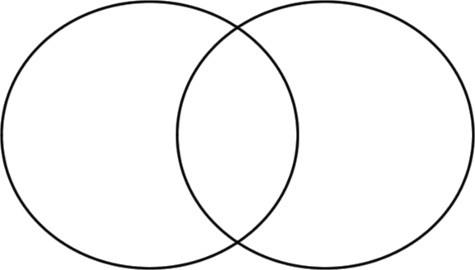

- What sentence most clearly states the author’s thesis or her opinion about her friendship with Galya?

- How does the essay explain the main ideas in the introduction and conclusion paragraphs?

After reading:
What happens when you pour oil and water together? How might two friends be like oil and water?

