**Lesson 12: Suicide**

***Required Readings:***

Katz, I.R., Kemp. J.E., Blow, F.C, McCarthy, J.F. & Bossarte, R.M. (2013). Changes in suicide rates and in mental health staffing in the Veterans Health Administration, 2005-2009. *Psychiatric Services, 64*(7), 620-625.

<http://ps.psychiatryonline.org/data/Journals/PSS/927180/620.pdf>

Mustanski, B., & Liu, R. (2013). A Longitudinal Study of Predictors of Suicide Attempts Among Lesbian, Gay, Bisexual, and Transgender Youth. *Archives of Sexual Behavior, 42*(3), 437-448.

U.S. Department of Health and Human Services (HHS) Office of the Surgeon General and National Action Alliance for Suicide Prevention (2012). 2012 National Strategy for Suicide Prevention: Goals and Objectives for Action. Washington, DC: HHS, September 2012. <http://www.surgeongeneral.gov/library/reports/national-strategy-suicide-prevention/full_report-rev.pdf>,,

Read pp. 10-28, Appendix C, skim rest of document.

*Required Training*

Ask Listen Refer (<http://www.asklistenrefer.org/>); an on-line suicide prevention gatekeeper training program for college students.

**Prevalence**

Nationally, suicide is the tenth leading cause of death among adults and the second leading cause of death among 15-34 year olds. The number of deaths by suicide in 2013 (41,149) far exceeded the number of deaths by motor vehicle accidents (35,369) and homicides (16,121) (Center for Disease Control and Prevention (CDC), 2015). Moreover, suicide rates have been growing over time, increasing from 10.46 per 100,000 in 1999 to 13.02 in 2013. The figure below displays the suicide rates nationally and in Missouri between 2003 and 2013.



Disturbingly, while suicide rates in the United States have been climbing, rates in comparable countries have been declining (National Academy of Sciences, 2015) (USW = United States, Whites, USH = United States, Hispanics).

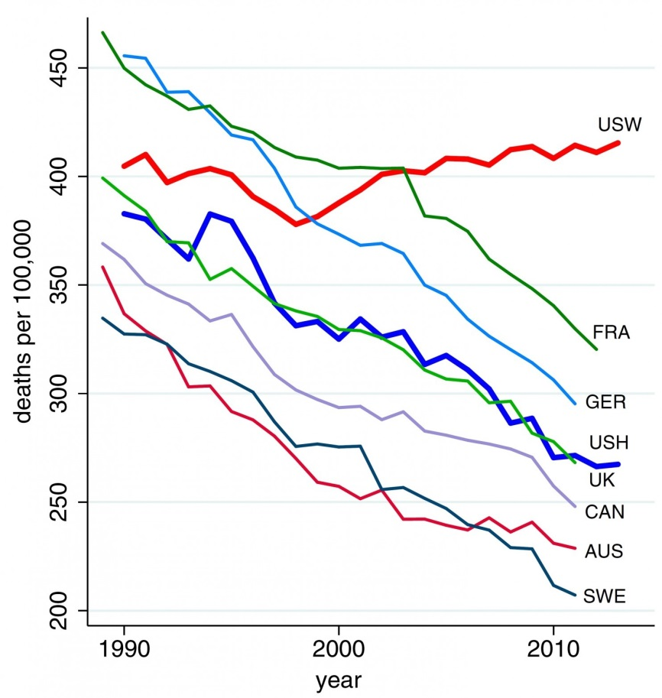

Higher rates are present among certain subpopulations, most notably adult males, whose rates of suicide nationally are almost four times those of adult women (26.41 per 100,000 compared to 7.01) (CDC, 2015). Patterns are similar among Missourians, where the highest rates of suicide are among white men 75 and older, followed by white men 45-54 (CDC, 2013).



**Means**

Firearms are the primary means of suicide among both adults and youth in Missouri and nationally. Slightly more than half (51.5%) of suicides involve the use of firearms, followed by suffocation and poisoning. While males are more likely to use firearms to kill themselves than females, firearm use is the primary means of suicide for both sexes. Among youth and young adults 15-24, suffocation is more common (38%), but firearms are still the leading cause of suicide (45%) (CDC, 2013).

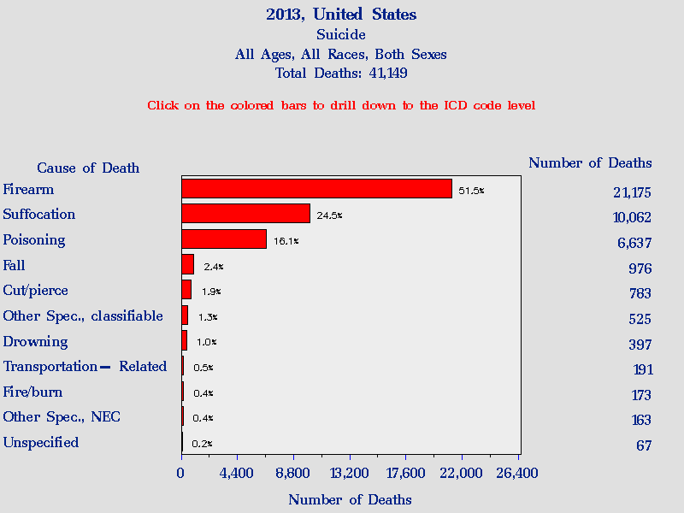

**Suicide and Mental Illness**

Suicide rates are particularly high among individuals with mental health disorders. Approximately 90% of individuals who take their lives by suicide have been diagnosed with some type of mental illness, most frequently related to substance use or mood disorders (Arsenault-Lapierre, Kim & Turecki, 2004). Studies have shown that 40%-53% of people with schizophrenia have had [suicidal ideation](http://www.stopasuicide.org/glossary.aspx#Suicidalideation) at some point in their lives, and 23%-55% reported previous suicide attempts. Research has also demonstrated that people with an anxiety disorder are 6 to 10 times more likely than the general population to complete a suicide (see Brent, 1993; Moscicki, E.K. (2001). According to the Epidemiologic Catchment Area survey, 29.2% of person with bipolar disorder have attempted suicide, compared to 15.9% of those with unipolar depression and 13.5% of the general population (Chen & Dilsaver, 1996: Kessler, Borges & Walters, 1999).

**Suicide among Youth and Young Adults**

While the number of suicides is higher among middle-age and older adults, it is the 2nd leading cause of death among youth 10-24. Nationally, rates have remained relatively stable; in Missouri, rates have increased between 2003 and 2013 (CDC, 2013).



According to the Youth Risk Behavioral Surveillance System (YRBS) survey of high school youth, almost 1 in 6 (14.2%) reported seriously considering suicide within the past 12 months and 6.9% attempted suicide during this same time interval, equating to approximately 1.5 million suicide attempts per year based on 2013 U.S. Census population estimates.

According to the 2014 Missouri Student Survey, a survey of middle and high school students, 12% of middle and high school students reported seriously considering suicide in the year prior to the survey, 9% said they had made a suicide plan and 5% said they attempted suicide. Of those who attempted suicide, 3% were male and 7% were female. Suicidal ideation is highest among 8th – 10th grade students.



Around one in six (15%) Missouri college students experienced suicidal thoughts within the 12 months prior to the 2014 Missouri College Health Behavior Survey (MCHBS, 2014). It is estimated that 79% of college students who complete a suicide have not received counseling services (Kisch, Leino, & Silverman, 2005) though a large percentage of those who receive mental health services have reductions in suicidal ideation (Drum et al., 2009). The University of Missouri-Columbia has suicide prevention services for college students including the Ask, Listen, Refer on-line training   
(<http://wellness.missouri.edu/Suicide/>) that we are requiring you to complete as part of this lesson.

***Suicide among LGBT Youth***

Suicide is a significant concern for LGBT youth. The 2013 Missouri Student Climate Survey of LGBTQ high school and college students found that more than half (54.5%) had considered suicide sometime in their lives (Gay, Lesbian and Straight Education Network (GLSEN), 2013). This percentage is more than *four* times than the rates for high school students statewide (MSS, 2014). According to the 2013 MCHBS, LGBTQ students in colleges throughout the state were more than twice as likely to have had suicidal thoughts during the previous year (33%) than non-LGBTQ youth (14%) and three times as likely to have made a suicide attempt. Furthermore, LGBTQ youth are less likely to seek mental health treatment due to stigma (Wilson & Yoshikawa, 2007).

***Veterans***

Nationally and in Missouri, around one-fifth of people who kill themselves are veterans. In Missouri, suicide rates are more than twice as high among veterans compared to the civilian population (35 per 100,000 vs. 16 per 100,000) (Department of Health and Senior Services, 2013). Risk factors leading to suicide among veterans include mental illness, sexual and physical abuse, post-traumatic stress disorder, access to lethal means, traumatic brain injury, addiction, failed relationships and financial problems (Haney & O’Neil, 2012). The Department of Veterans Affairs has developed an extensive array of programs and services for veterans, including a crisis line (**800-273-8255**) and a comprehensive website designed to provide information to veterans and their families in need of assistance <http://www.mentalhealth.va.gov/suicide_prevention/>. The Missouri Institute of Mental Health has produced a flyer for veterans and their families and friends with Missouri resources. <https://www.mimh.edu/content/uploads/2015/09/MIMH-Vets-Final-7-16-15.pdf>.

**Effective Approaches to Preventing Suicide**

In 2012, the Office of the U.S. Surgeon General and the National Action Alliance for Suicide Prevention (Action Alliance) released the *National Strategy for Suicide Prevention: Goals and Objectives for Action*. The *National* *Strategy* is the most comprehensive document to date and includes effective approaches to addressing suicide and specific goals and objectives toward meeting the goal of “Zero Suicide”. Some of these approaches include 1) gatekeeper training programs; 2) reduction of access to lethal means; 3) intensive training of health professionals, clergy, correctional facility employees, mental health providers, etc.; and 4) use of mental health treatments that have been shown to be effective in reducing suicides.

The Suicide Prevention Resource Center (SPRC) is the repository for an extensive array of resources for individuals interested in suicide prevention. Similar to NREPP, they have a registry of suicide prevention programs, with distinctions made between “evidence-based”, “expert/consensus statements” and “adherence to standards” programs. There are currently 23 programs listed as “best practices” on the SPRC website. Programs include gatekeeper training programs for youth adults, most notably Question, Persuade and Refer (QPR) which has been extensively implemented both in the U.S. and internationally. Other programs include on-line avatar training programs, emergency room programs that divert those who have attempted suicide to community mental health services, and mental health treatment programs such as Multi-systemic Therapy.

***Suicide Prevention Policies***

A commitment to reducing suicides by states and the federal government is essential to effectively address suicide prevention but to date there have been limited resources dedicated to suicide prevention. At the national level, there have been ongoing grants to states and tribal communities to address youth suicide and suicides on college campuses but federal grants addressing adult suicides are uncommon. From 2005-2015, Missouri was the recipient of three youth suicide prevention grants that trained approximately 75,000 Missourians. This year these funds are no longer available, and the state does not have funds earmarked to suicide prevention. With respect to veterans, in February 2015, President Obama signed the Clay Hunt Suicide Prevention for American Veterans Act in response to increases in veteran suicide over the past two decades. This act requires that veterans have access to a website with veteran-specific mental health resources and that VA programs be assessed annually to assure that veterans receive mental health care in a timely manner.

These efforts only begin to address suicide prevention. With the continual rise in suicide rates in the United States, commitment and dedicated funding for suicide prevention is a critical need.

**Assignment and Group Discussion**

**Your response to the question below and your participation in the group discussion will be worth points**

Referring specifically to the National Strategy for Suicide Prevention, pick a subpopulation (individuals with major depressive disorder, substance use disorders, traumatic brain injury, etc.). Which approaches to suicide prevention outlined in the *National Strategy* would be most effective for addressing that population and why? Are there any approaches that you feel would not be helpful?

Again, please try to have your initial answers to the question on the Discussion Board by Friday so that you can respond to others in the class by Sunday night.

**References**

Bozigar, J. A., Brent, D. A., Hindmarsh, K., Kerr, M. M., McQuiston, L., & Turich, C (1993). *Postvention standards manual: A guide for a school's response in the aftermath of a suicide.* Pittsburgh, PA: University of Pittsburgh Medical Center, Western Psychiatric Institute and Clinic, Services for Teenagers at Risk (STAR Center).

Case, A. & Deaton, A. (2015). **Rising morbidity and mortality in midlife among white non-Hispanic Americans in the 21st century. *Proceedings of the National Academy of Sciences,*** 1518393112v1-201518393.

Centers for Disease Control and Prevention (CDC). WISQARS (Web-Based Injury Statistics Query and Reporting System). Atlanta, GA: U.S. Department of Health and Human Services, CDC; 2014. Available at http://www.cdc.gov/injury/wisqars.

Centers for Disease Control and Prevention (CDC) (2013). Youth Risk Behavior Survey. Available at [www.cdc.gov/yrbs](http://www.cdc.gov/yrbs). Accessed on 10/31/2015.

Cerel, J., Jordan, J. R., & Duberstein, P. R. (2008). The impact of suicide on the family. *Crisis, 29*(1), 38-44.

Chen, Y. W., & Dilsaver, S. C. (1996). Lifetime rates of suicide attempts among subjects with bipolar and unipolar disorders relative to subjects with other Axis I disorders. *Biological Psychiatry*, *39*(10), 896-899.

Kessler, R.C., Borges, G., Walters, E.E. (1999). Prevalence of and Risk Factors for Lifetime Suicide Attempts in the National Comorbidity Survey. *Archives of General Psychiatry,56*(7), 617-626.

Missouri Institute of Mental Health (2015). Suicide in Missouri: Where We Stand. Available at <https://www.mimh.edu/content/uploads/2015/03/Suicide-In-Missouri-Where-We-Stand-2015.pdf>

Missouri Institute of Mental Health (2015). Suicide in Missouri: Youth 10-24. Available at <https://www.mimh.edu/content/uploads/2015/03/Youth-Brief-Final-7-7-15.pdf>.

U.S. Department of Health and Human Services (HHS) Office of the Surgeon General and National Action Alliance for Suicide Prevention (2012). *2012 National Strategy for Suicide Prevention: Goals and Objectives for Action*. Washington D.C.: HHS.