Table of Contents (you can edit according to paper organization)
Introduction
Opening Statement
Problem
Purpose of Study
Theory Perspective
Research Questions
Theoretical Framework
Involvement for Success
Literature Review
Case Study
Theoretical Framework
Involvement for Success
Summary
Research Methodology
Setting
Population
Data Sources
Ethnicity
Research Design
Intervention
Survey Instrument
Summary

Section 1 (edit and reduce pages by making them full 5 pages)

Introduction
Opening Statement
The students and parents are participants in an educational program. “Research often excludes youth participants, omitting their social and psychological realities, undermining their rights to participate and benefit from research, and weakening the validity of research. Researchers may be discouraged from including youth due to logistical (e.g. gaining access) or ethical (e.g. coercion risks based on developmental level) concerns. Increased discussion is needed around appropriate methods to use with child and youth participants that manage challenges related to developmental capacities, legal status, power differentials, and unpredictable aspects of qualitative research”(Sage, 2015).

Background Study
In this paper I will focus on experiences of researchers, describing solutions of internal and external validity. “The research design is the blueprint that enables the investigator to come up with solutions to these problems and guides him or her to various stages of research” (Frankfort-Nachmias & Nachmias, 2008, p89) Internal validity is whether the effects observed in a research are due to the manipulation of the independent variable. External validity is the extent to which the results of a research can be generalized to settings and people. (McLeod, 2013).
Burger’s (2009) study of design is on the psychological research designed by Milgram. Burger (2009) identifies obedience to authority, increase in demands, resources of information in a novel situation, and responsibility not assigned or diffused as contributes toward the “high rates of obedience” (Burger, 2009, pp 2-3). His hypotheses question is ‘Would people still obey today?’ The tables are used to measure participants of the obedience screening according to gender and ethnicity, such as behavior and personality rates.
Fuchs, Fuchs, Hamlett, Phillips, Karns, and Dutka (1997) researched on various collaborative measurements. The appendix for Problems A & B is interesting. The methods to problems solving contain internal and external validity. This is a collaborative research because the tutor (educator) and tutee (learner) are doing an activity.

Problem Statement (edit)
The problem occurs when there is a lack of participation and support from them.

Purpose of Study (edit)
The purpose of this study is to do quantitative research on ways to gain participation of parents and learners within a mentoring program. The writer is finding methods, evaluation, and other objectives towards participation in a non-profit mentoring program.

Research Questions

- What is the relationship between the lack of parent support for the cause Team H.O.Y.A.S (Helping Our Youth Achieve Success) to lack student participation?
- What is the relationship between students participation in Team H.O.Y.A.S (Helping Our Youth Achieve Success) and students' losing interest in the program?
Hypothses
- Null hypothesis: There no significant relationship between lack of parent support for the cause of the program and students participation in the mentoring program.
- Alternate hypothesis: There no significant relationship between lack of parent support for the cause of the program and students participation in the mentoring program.

Theoretical Framework
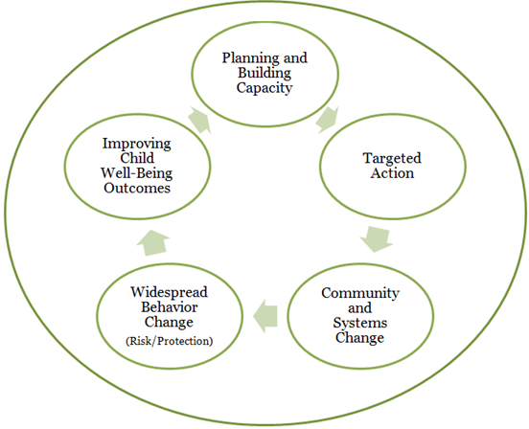
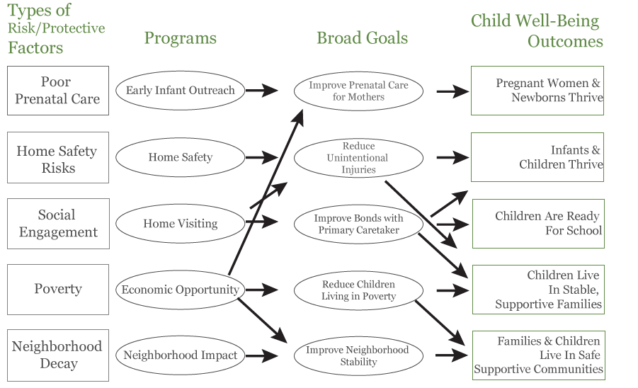

(Puddy, Fawcett, & Francisco, 2002)

Types of Involvement for Success (edit by decreasing citation word for word)
- PARENTING: Assist families with parenting and child-rearing skills, understanding child and adolescent development, and setting home conditions that support children as students at each age and grade level. Assist schools in understanding families.
- COMMUNICATING: Communicate with families about school programs and student progress through effective school-to-home and home-to-school communications.
- VOLUNTEERING: Improve recruitment, training, work, and schedules to involve families as volunteers and audiences at the school or in other locations to support students and school programs.
- LEARNING AT HOME: Involve families with their children in learning activities at home, including homework and other curriculum-linked activities and decisions.
- DECISION MAKING: Include families as participants in school decisions, governance, and advocacy through PTA/PTO, school councils, committees, and other parent organizations.
- COLLABORATING WITH THE COMMUNITY: Coordinate resources and services for families, students, and the school with businesses, agencies, and other groups, and provide services to the community.
(Epstein., Coates, Salinas, Sanders, & Simon (1997)

References (find additional references if needed)
Burger, J. M. (2009). Replicating Milgram: Would people still obey today? American Psychologist, 64(1), 1-11. Doi: 10.1037/a0010932
Creswell, J. W. (2008). Research design: Qualitative, Quantitative, and Mixed Methods
Approaches, (3rd ed.) [VitalSource BookShelf Online]. Retrieved from http://bookshelf.vitalsource.com/#/books/9781412989442/cfi/186
Epstein, J.L., Coates, L., Salinas, K.C., Sanders, M.G., & Simon, B.S. (1997). Epstein’s six types
of involvement. School, Family, and Community Partnerships: Your Handbook for Action. Thousand Oaks, CA: Corwin Press. Retrieved from
http://www.csos.jhu.edu/p2000/sixtypes.htm
Frankfort-Nachmias, C., & Nachmias, D. (2008).Research methods in the social sciences
(7th ed.) New York: Worth.
Fuchs, L. S., Fuchs, D., Hamlett, C. L., Phillips, N. B., Karns, K., & Dutka, S. (1997). Enhancing
students’ helping behavior during peer-mediated instruction with conceptual mathematical explanations. The Elementary School Journal, 97, 223–249.
McLeod, S. (2013). Internal and external validity. Simply Psychology. Retrieved from

http://www.simplypsychology.org/validity.html

Richard W. Puddy, Stephen B. Fawcett, and Vincent T. Francisco(2002). KU Work Group's

Action Planning Guide for Child Well-Being

http://ctb.ku.edu/en/4-developing-framework-or-model-change

Sage Journal(2015). Youth participation in qualitative research: Challenges and possibilities.
Qualitative Social Work. Retrieved from http://qsw.sagepub.com/content/early/2014/11/06/1473325014556792

Section 2: Craft a 5 page paper in which you do the following:
- Assess the strengths and limitations of each of the research designs presented in Weeks 2 and 3.
- Recommend a quantitative design for your research plan. Include a rationale for why that design would be most appropriate.
- For the designs that you did not choose, state why each one is not appropriate for your research questions, hypotheses, and variables.
- Support your work with references to the literature.
Section 3: Craft a 5 page paper that includes the following:
  - The levels of measurement that will be important for your study and why.
  - How you will ensure content validity, empirical validity, and construct validity for your study. If any of these types of validity do not apply to your plan, provide a rationale.
  - How you will ensure reliability for the measurement in your study.
  - The strengths and limitations of the measurement instrument you have selected in terms of reliability and validity.
  - Provide at least 10 references to the literature to support your choices and rationales.

