Group Discussion Board Forum Instructions
Topic: Accounting Information and Salary Negotiations
Thread: Each member of the group will write a thread in response to Chapter 5 CPA Skills Analysis and Research Case: Accounting Information and Salary Negotiations. In addition to the textbook requirements, support your advice with a biblical reference discussing the ethical implications that this case involves.
Each thread must be at least 300 words, excluding the reference section. Threads must be supported by at least 1 scholarly resource. Each thread will answer the questions following the case prompt as well as provide a biblical application.

Chapter 5 CPA Skills Analysis and Research Case:
Granger Eagles Players' Association and Mr. Doublecount, the CEO of Granger Eagles Baseball Company, ask your help in resolving a salary dispute. Mr. Doublecount presents the following income statement to the player representatives.
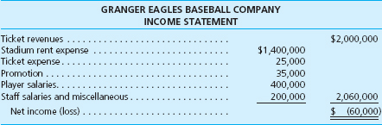
GRANGER EAGLES BASEBALL COMPANY
INCOME STATEMENT
Ticket revenues..... |  | $2,000,000
Stadium rent expense..... | $1,400,000
Ticket expense..... | 25,000
Promotion..... | 35,000
Player salaries..... | 400,000
Staff salaries and miscellaneous..... | 200,000 | 2,060,000
Net income (loss)..... |  | $ (60,000)
Mr. Doublecount argues that the Granger Eagles really lose money and, until things turn around, a salary increase is out of the question.
As a result of your inquiry, you discover that Granger Eagles Baseball Company owns 91 percent of the voting stock in Eagle Stadium, Inc. This venue is specifically designed for baseball and is where the Eagles play their entire home game schedule. However, Mr. Doublecount does not wish to consider the profits of Eagle Stadium in the negotiations with the players. He claims that “the stadium is really a separate business entity that was purchased separately from the team” and therefore does not concern the players. The Eagles Stadium income statement appears as follows:
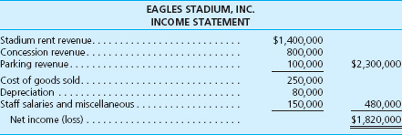
EAGLES STADIUM, INC.
INCOME STATEMENT
Stadium rent revenue..... | $1,400,000
Concession revenue..... | 800,000
Parking revenue..... | 100,000 | $2,300,000
Cost of goods sold..... | 250,000
Depreciation..... | 80,000
Staff salaries and miscellaneous..... | 150,000 | 480,000
Net income (loss)..... |  | $1,820,000

Required
1. | What advice would you provide the negotiating parties regarding the issue of considering the Eagles Stadium income statement in their discussions? What authoritative literature could you cite in supporting your advice?
2. | What other pertinent information would you need to provide a specific recommendation regarding players' salaries?

