TWO DOGS BITES INTO THE WORLD MARKET: FOCUS ON JAPAN

CREATION OF “TWO DOGS™”
On a cool winter day in Adelaide, South Australia, a city with a population of 1.1 million, Duncan MacGillivray found himself in a conversation with his neighbour who had too many lemons for which he was trying to find a use. MacGillivray, who owned a pub in the city, decided to brew the lemons into an alcoholic drink to serve as a refreshing alternative to draught beer. Thus was born the world’s first commercial brewed alcoholic lemon drink. The brew, which became known as TWO DOGS™ after a joke, became a highly popular drink and was soon made available on tap (draught) in pubs all around Adelaide, as shown in Figure 1.

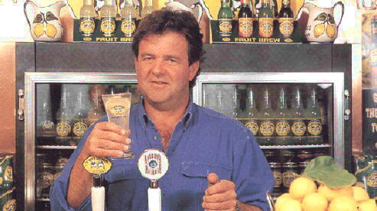
Figure 1: Creator, Duncan MacGillivray, with glass of original draught Two Dogs

The popularity of the drink quickly spread by word of mouth. In response to the dramatic increase in sales, the company commenced bottling the drinks in 1994 to increase its product availability in the distribution channel. To meet the demand, TWO DOGS™ was produced under contract by a local brewery in Adelaide. This enabled the company to focus its resources on marketing and brand building activities, instead of investing in a costly commercial brewing and bottling facility.
TWO DOGS™ quickly gained market acceptance, firstly because consumers loved the new taste sensation of ‘brewed alcoholic lemonade’, but also because it filled a real market niche for a ready-made beverage similar to beer but with an easy flavour profile. TWO DOGS™ exceeded initial expectations when it reached domestic sales of over 400,000 cases in the first twelve months, and extended its presence to the whole of Australia within one year of launch.
The success of TWO DOGS™ attracted competitors, who sought to emulate TWO DOGS™ and capitalise on the newly created and rapidly growing consumer niche. The first competitor came in late 1994 from Australia’s largest brewer (Fosters); the product ‘Sub Zero’ was a sweetened alcoholic soda targeted at young adults. By 1995, there were dozens of different sweet alcoholic drinks, all brightly coloured, exotically flavoured with catchy names including “Z”, “KGB”, “Cactus”, “Ruski”, “DNA”, shown below in Figure 2.
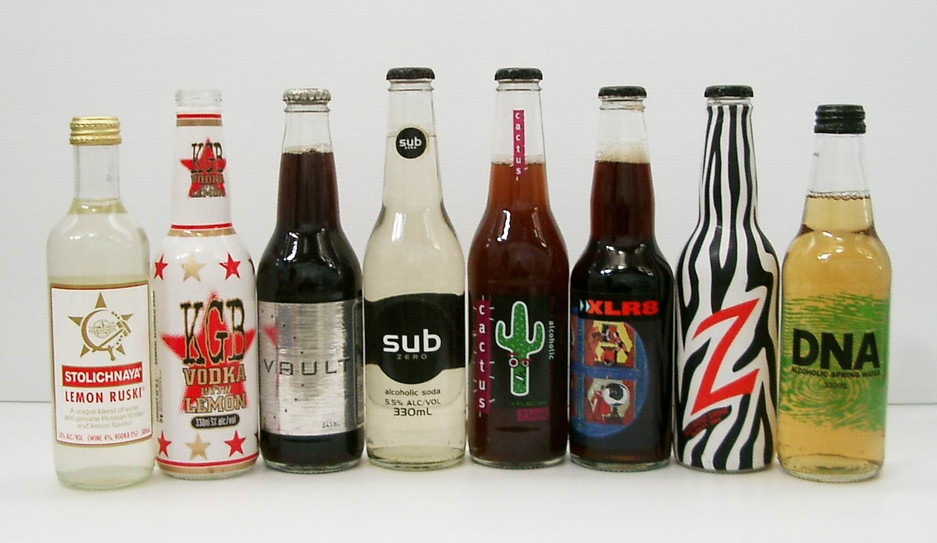
Figure 2: Early Competitors in Australia

INTERNATIONAL EXPANSION
In the face of fierce domestic competition, the company Two Dogs International (“TDI”) commenced an international expansion program in 1995.
Its first market entry was into the United Kingdom. In the Northern hemisphere summer of 1995, riding on the back of the close historical and cultural connections between Australia and the UK (including common language and similar legal and regulatory systems), the first eight shipping containers of TWO DOGS™ arrived in the UK. TDI initially adopted a direct export strategy, selecting and appointing a relatively small but well established English cider maker as its exclusive distribution partner. The appearance of TWO DOGS™ incited massive consumer interest, such that it was impossible to meet the surging demand given the six week shipping time from Australia. Therefore TDI quickly moved to a licensing strategy, allowing TWO DOGS™ to be produced in the UK. Within six months of its official launch in May 1995, TWO DOGS™ outperformed the initial annual sales target of 300,000 cases, and went on to achieve one million cases in 1996.
Following its UK market success, and utilising its production base within the European Union, TWO DOGS™ commenced export from the UK into continental Europe including Denmark, Finland, France, Germany, Italy, the Netherlands, Norway, Sweden and Switzerland.
Around the same time, in June 1996, TWO DOGS™ commenced its US market entry. Learning from the UK experience and also due to high import duty on alcoholic beverages, TDI adopted a licensing strategy incorporating local production from the start. By 2001, with annual sales around the one million cases, TWO DOGS™ was voted as one of the “Hot Brands” in the USA by Impact magazine.
The third key market in TDI’s international expansion program was Japan. TDI realised it needed distribution strength to be successful in Japan and in 1997 formed an exclusive import and distribution agreement with Kirin-Seagram, a joint venture between Japan’s leading brewer Kirin and international spirit company Seagrams. A direct export strategy was possible due to the relative proximity of Japan to Australia, only two weeks away by ship. Brand awareness was built gradually, first in Tokyo bars only, then expanding nationally. By 2000, TWO DOGS™’ distribution had extended from bars into most major convenience stores, and achieved the one million case sales benchmark in 2001.

Two Dog’s Path to Internationalization
TWO DOGS™’ rapid internationalisation is rare for a small company. By 1997 TWO DOGS™ had built a product presence in over 35 countries serviced by production across three continents, for which a detailed list is shown in Table 1.

Australian production serves opportunities in Australasia, Asia and Middle East  New Zealand  China  Hong Kong  Japan  Singapore  Taiwan  Malaysia  Thailand  United Arab Emirates  Bahrain  Sri Lanka  Papua New Guinea  Guam | UK production serves markets Europe  Great Britain  Scotland  Ireland  Austria  Bermuda  Cyprus  Denmark  Finland  France  Germany  Gibraltar  Greece  Italy  Malta  Netherlands, Belgium & Luxembourg
US production serves North and South Americas  United States  Canada  Brazil | Norway  Spain  Sweden  Switzerland
TABLE 1: TWO DOGS’ INTERNATIONAL NETWORK IN 1997

Overall, TDI has been able to achieve its rapid expansion by combining direct export strategies with licensed production within some key markets, alleviating the need to invest in capital equipment by utilising its partners’ excess production capacity.
TWO DOGS™’ strive for internationalization can be attributed to MacGillivray’s entrepreneurial nature combined with his background in commodity trading and shipping businesses. As with most entrepreneurial activities, TDI’s early expansion took place with limited capital.
In February 1997, Pernod Ricard acquired TWO DOGS™, ensuring a strengthened resources base which has allowed TDI to pursue its global expansion and brand building activities. By 2001, the retail value of the TWO DOGS™ brand’s sales approached A$100 million, the majority being in overseas markets.

PRODUCTS AND BRANDING

Product
TWO DOGS™ is a fermented beverage made with real lemons. No alcohol or spirit is added at any stage during the brewing process as all the alcohol is derived from the fermentation. While the flagship is the Australian Original Lemon Brew, other flavours have been developed to expand the range including Orange, Apple, Raspberry, and Blackcurrant Brews all with around 4 to 5% alcohol content. TWO DOGS™ is packaged in a variety of single serve packs to suit the market conditions with bottle sizes ranging from 250 ml to 355 ml and draught product is still available in selected markets. Examples of some TWO DOGS™ products are shown in Figure 3.
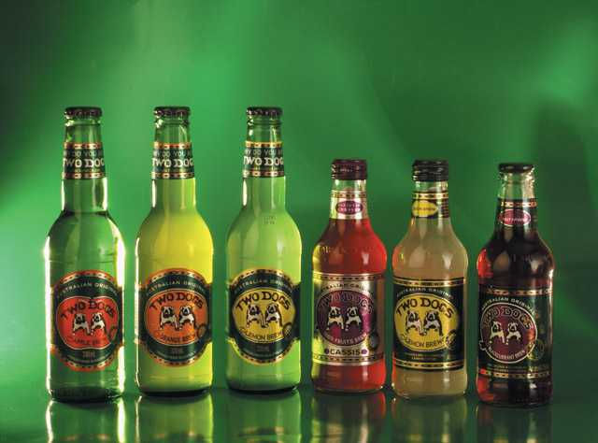
Figure 3: Examples of TWO DOGS™ product range, in 330 ml and 250 ml bottles.

Following its unusual name, a key feature on the packaging is the distinctive TWO DOGS™ brand logo, shown in Figure 4. Depicting two bulldogs, the logo communicates fun, honesty and companionship to consumers, and is used as a vehicle to position the brand as irreverent and mischievous capturing the perceived larrikin nature of Australians.
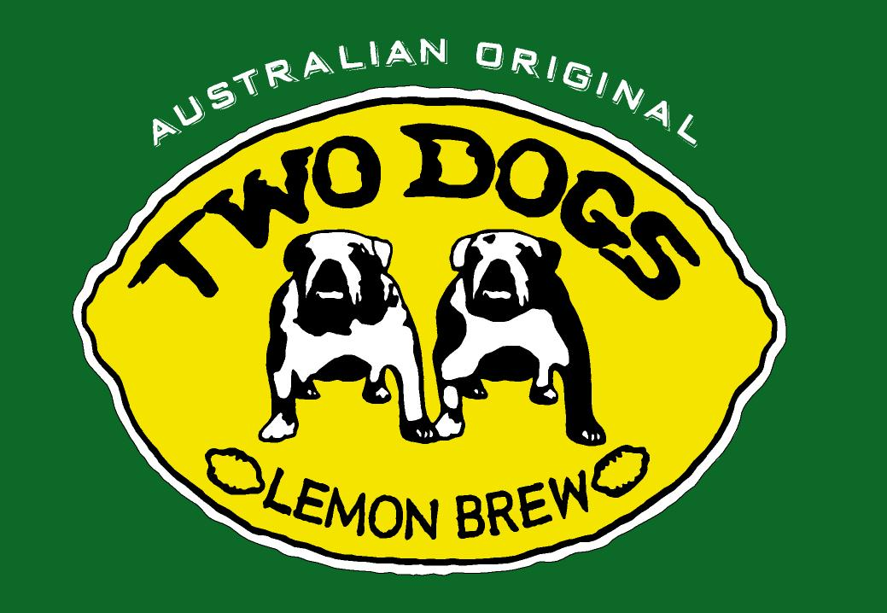
Figure 4: The distinctive Two Dogs brand logo

The Alcoholic Fruit Beverage Market
The alcoholic fruit beverage market seems to have emerged less than a decade ago. With its sweet flavour along with moderate alcohol content, core consumers were young adults and women who did not like beer or the taste of traditional wine and spirits. In particular, the young adults to whom these drinks appeal often demonstrate low brand loyalty and switch brands readily, in search of novelty. This type of lifestyle product is highly sensitive to trends and aspirations, and therefore the marketing mix needs to be adapted to suit local market conditions. Consumer preference is based on perceptions; hence, branding is critical to product differentiation.
The intensity of global competition is high. Barriers to entry are low, switching costs are low and consumer preferences fluctuate within trends, so there is good reason to believe that individual product life cycles within this category are likely to be short. For example, wine coolers were highly popular in the 1980’s but are now relegated to a niche market in the early 2000s. The threat of substitutes for any single brand or product is extremely high.

ENTRY TO THE JAPANESE MARKET

Pre-Entry Research
TDI’s market selection decision in the UK and the USA was based on perceived cultural similarity to Australia, all being modern western English speaking countries, so appropriate market positioning was readily understood. Expansion into Japan however was a different proposition in terms of unknown culture, laws, trends, lifestyle and beverage choices and therefore all activities needed to be based on considerable formal market analysis. Prior to market entry in Japan, TDI spent more than eighteen months conducting market research.

Preliminary Market Research
In order to evaluate the initial feasibility of entering the Japanese market and assess the market potential, TWO DOGS™ first conducted a preliminary assessment which was based on gathering data on the macro- and micro-environment including general economic outlook, political stability, population size, age of the population and wealth distribution and industry trends.

People and Culture
Japan has a highly urbanized population of approximately 127 million. Over 44 percent of the population lives in major cities such as Tokyo, Osaka and Nagoya. Japan is a homogeneous, affluent society, with an aging population and one of the longest life expectancy rates in the world (83.99 years for women and 77.1 years for men).
Japanese people respect long-term relationships, politeness and collectivity whereas Australians tend towards individualism. On the other hand, modern Japanese are great travellers and the young adult consumers in particular have embraced western culture and influences such as fast food, fashion, and music entertainment and lifestyle aspirations.
TDI used this data to estimate the size of its potential market in Japan. By segmenting its target market predominantly on the basis of consumer age, the target market size within 20 to 30 age group was estimated to about 19 million and accounted for 15 % of the total population of Japan.

Economy
Japan is the world’s second largest economy, after the USA. The Japanese economy is 12 times that of Australia but has remained in a prolonged state of recession for the last few years. Private sector demand remains sluggish due to uncertain economic times. Despite stimulus packages introduced by the government, Japan’s economy remains stagnant which has lead to fundamental changes in business structure such as the breakdown of traditional interlinked (keiretsu) business relationships.
Nevertheless, Japanese consumers’ per capita income is amongst the highest in the world (A$ 70,000 in 1999). The relative size of the Japanese market (in terms of population and affluence) coupled with its small agricultural resource base presents a good opportunity for food and beverage exporters. Japan is Australia’s largest foreign trading partner with merchandise exports from Australia worth A$21.3 billion in 2000, and the composition becoming increasingly diversified with processed foods and beverages.
Therefore, despite the fact that Japan’s economy was in a state of long-term recession, TDI determined that per capita income was sufficiently high that consumers would be able to afford foreign luxury products, such as TWO DOGS™.

Political and Legal Environment
Overall, Japan has a high level of political stability. Furthermore, although the Japanese government has little direct involvement in the operation of the private sector, through its ministerial bureaucracies, it maintains tight supervision of firms via regulation and mandatory administrative guidance. However in regards to trade barriers, the deregulation trend is in favour of foreign exporters; for example, the customs duty will be abolished on beer and low malt effervescent alcoholic beverages in 2002.
TDI obtained specific information regarding the customs classification of its product and the applicable customs duties and liquor taxes in Japan, in order to calculate whether the landed unit cost of its product appeared commercially viable.

Industry Trends
Finally TDI considered broad consumption trends especially of alcoholic beverages. TDI found that from 1990-1997, beer consumption was declining, spirits were flat, while wine was growing rapidly from a small base. These changing consumption patterns indicated that drink trends were shifting, and could indicate an opportunity for low alcohol drinks such as TWO DOGS™.

Primary Research
Having identified that Japan was an attractive market, TDI needed to assess whether the TWO DOGS™ product would appeal to Japanese consumers. The first step was to attend Foodex in Tokyo, the world’s largest food and beverage tradeshow, which offered the opportunity of conducting a large number of taste trials directly with Japanese consumers of various ages, gender and socio-economic status. This initial consumer feedback was positive; most people seemed to like the taste of TWO DOGS™.
Based on this, TDI sought a local company with a well established network to distribute TWO DOGS™ in Japan. The formal selection process included an initial search, cost and risk analysis before a decision was made. After investigation, TDI identified the major companies in the Japanese liquor industry, and through its international contacts arranged an introduction to Kirin-Seagram Ltd, a subsidiary of Kirin Brewery – Japan’s leading beer company. Aside from its strong distribution capability, Kirin-Seagram was evaluated highly for its marketing expertise in the liquor industry, as it was clear to TDI that a very close understanding the Japanese consumer would be necessary for success.
Together, TDI and Kirin-Seagram carried out more extensive research based on consumer surveys and focus groups of different age groups. The research focused on taste, packaging and labelling. Feedback from the research showed positive reactions from respondents. They liked the taste and responded to the TWO DOGS™ logo positively as “cute”. Based on this research, TDI proceeded confidently to launch TWO DOGS™ in Japan with Kirin-Seagram as its exclusive distributor in 1998.

Secondary Research
Even after launch, ongoing product testing and consumer surveys were conducted to ensure the brand continued to retain its appeal with Japanese consumers, and to evaluate the effectiveness of advertising campaigns. Consumer surveys conducted soon after launch found that Japanese consumers found the 350 ml TWO DOGS™ bottles too large; TDI reduced the bottle-size to 250 ml, and even though the smaller bottle was sold at the same price, paradoxically, sales increased.
In addition, brand tracking data was periodically gathered using independent research companies to conduct surveys every six months. Consumers would be surveyed on a range of dimensions including their level of brand awareness (whether they had heard of TWO DOGS™) and advertising awareness (whether they could recall seeing a TWO DOGS™ ad), as well as their recent drinking habits and purchase intentions. Consumer’s awareness of the TWO DOGS™ brand rose from 40% in April 2000 to over 80% by June 2001, demonstrating the success of an intensive national television campaign that was run over the same period. From a comparison of the same data collected on other alcoholic drinks, it was possible to also evaluate whether TWO DOGS™ was increasing its awareness and purchase intention relative to competitors, which serves as an indicator of improving market share and market positioning.

ADAPTATION OF THE MARKETING MIX

Product
The TWO DOGS™ Lemon Brew product required no adaptation to meet the requirements of the Japanese market. Japanese consumers liked the taste, appreciated the unique concept of a naturally fermented lemon brew, and the formulation met the necessary regulatory requirements for its liquor classification. Later, after Lemon Brew was established, other flavours of TWO DOGS™ were developed or adapted specifically for Japan. The first, launched in 2001, was “TWO DOGS™ Blackcurrant Brew” which needed to be renamed “Cassis Brew” as the Japanese did not recognise the word “Blackcurrant”. Then “TWO DOGS™ Lychee Brew” was developed specifically to appeal to the particular tastes of Japanese consumers.

Packaging
Notwithstanding the inclusion of Japanese language on the labels, there are two areas in which TWO DOGS™ packaging had to be substantially adapted in order to succeed in the Japanese market. The first was the bottle, which included the adjustment of bottle size from 350ml to 250ml as well as a change from its traditional green glass to clear glass bottles which are considered easier to recycle in Japan. The second was a series of changes to the bottle cap: the original product had a crown-seal cap (like beer) which requires a bottle opener. When TWO DOGS™ distribution was extended to the off-premise, the cap was changed to a “ring-pull cap” which is able to be opened by hand and therefore more convenient. However Japanese consumers were unfamiliar with ring-pull caps and found them difficult to open, so finally the product was changed to a “screw cap” as found on soft drinks. Figure 5 shows the different TWO DOGS™’ bottles and caps sold in Japan at various times.
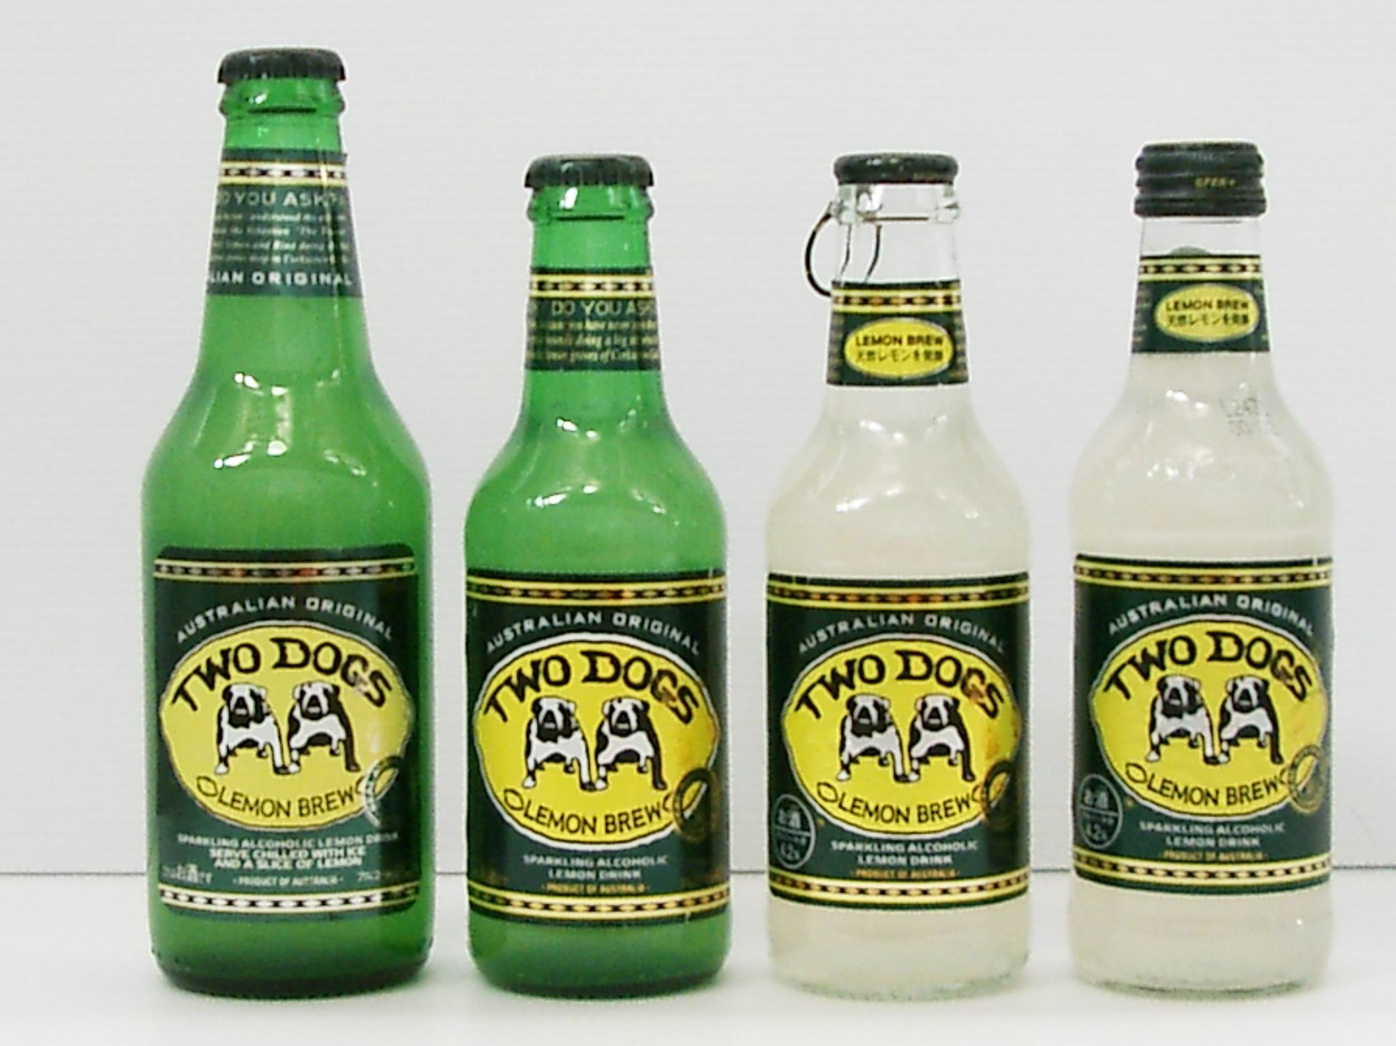
Figure 5: Packaging changes for Japan, from left to right: 350 ml with crown cap, 250 ml with crown cap, 250 ml bottle with Ripcap and 250 ml bottle with screw cap.

Place
The distribution channel for liquor can be divided into “on-premise” and “off-premise”. “On-premise” refers to outlets in which consumers buy and consume the product in the same place (i.e. on the premises) such as pubs, discos, bars and restaurants. “Off-premise” refers to retail stores in which the products are consumed away from the point of purchase such as convenience stores, specialty liquor stores and supermarkets. In Japan, the TWO DOGS™ brand was established in the on-premise exclusively for the first eighteen months after its initial launch, so it has built a relatively strong presence in metropolitan bars, western-style restaurants, but also in “Izakaya” chains (casual Japanese pubs). After this, TWO DOGS™ distribution was expanded into the off-premise with a key focus being convenience stores, such as 7-11 and Familymart, as this is where the majority of the young adults targeted by TWO DOGS™ tend to shop, perhaps on their way out to a party or while coming home from work. TWO DOGS™ is also sold in supermarkets, where it is available mainly for those who enjoy consuming the product at home. With its relative premium price, discount stores are not a targeted channel for TWO DOGS™.

Price
Retail prices for most consumer goods are relatively high in Japan, therefore it is expected that TWO DOGS™ is relatively more expensive than in its home country. In Australia one 330 ml bottle of TWO DOGS™ can be purchased at about A$2.00 dollars in the off-premise and A$5.00 in the on-premise, while in Japan the 250 ml bottle is priced (in Yen) equivalent to A$3.50 in the off-premise and up to A$9.00 in bars. The key pricing issue for TWO DOGS™ in Japan is its premium price against most of its competitors. Locally made “chu-hi” drinks are prices at Yen 130 while TWO DOGS™ is around Yen 220 per bottle – a 70% premium. This pricing is in line with the premium positioning of the brand and is influenced by several factors:
- Support to position its brand as premium brand.
- Heavy spending on advertisement and promotion
- Cost of adaptation of products on bottle size and cap
- Cost of importing the product.

Advertising and Promotion
TWO DOGS™ advertising campaign is different in Japan. An obvious distinction is the portrayal of the two dogs. In Australia and for other selected international markets such as the USA and Germany, the bulldogs are featured as tough party animals (refer Figure 7), while in Japan, the bulldogs are cute lovable characters (Figure 6) show the comparison between TWO DOGS™ posters in Australia and that of Japan.
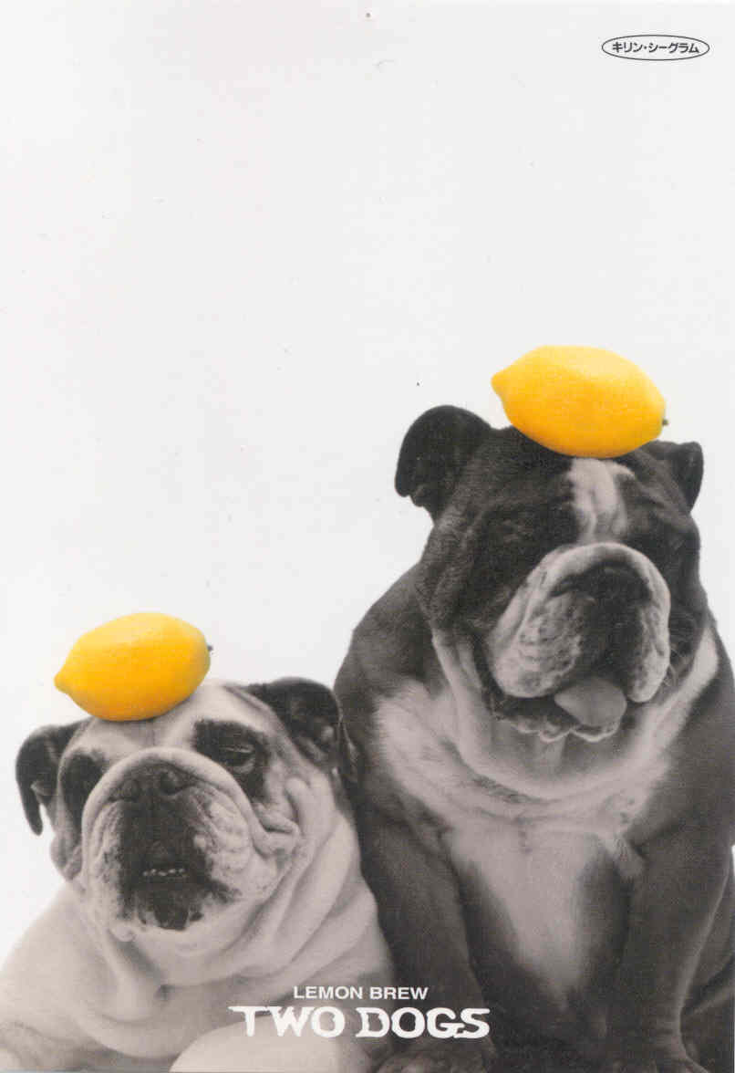
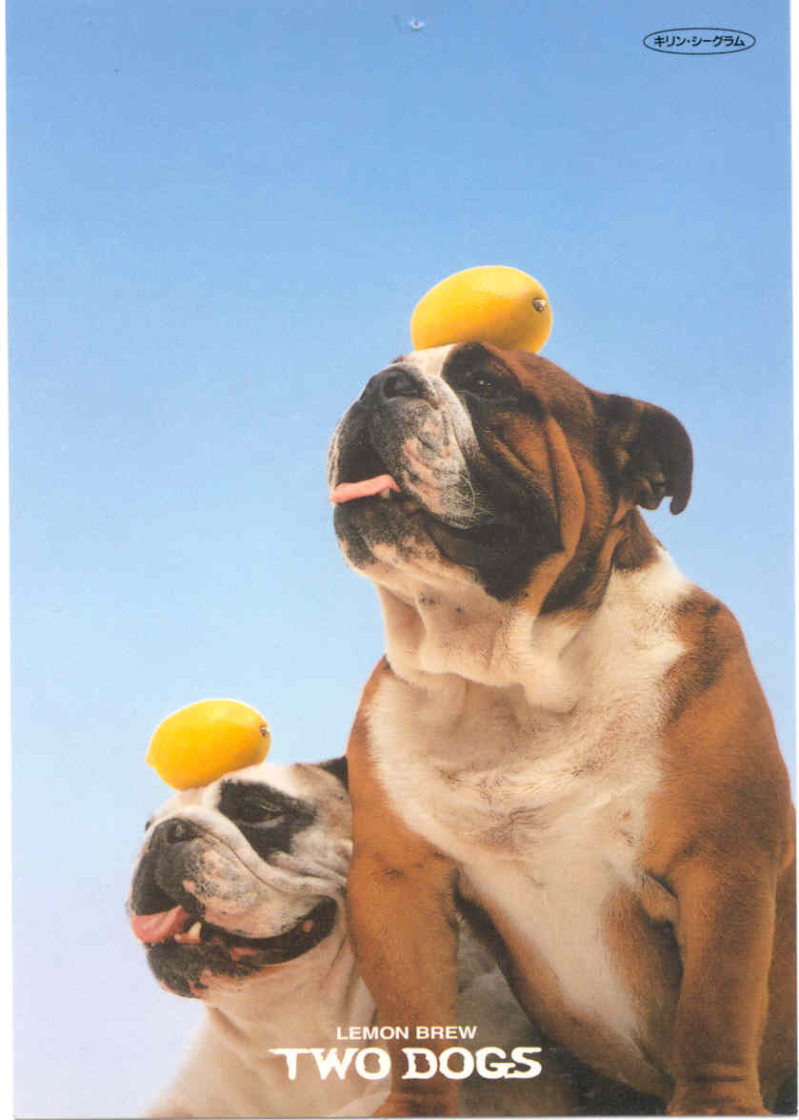
Figure 6: TWO DOGS™’ Posters in Japan

Figure 7: TWO DOGS™’ Poster in Australia

THE FUTURE
Undoubtedly TWO DOGS™ entry into the Japanese market has been successful due to the rigorous market research conducted, the strength of its distribution partner and its ability to adapt the marketing mix to suit local conditions. The ongoing challenge for management is to maintain and grow its market share in a highly competitive environment, while selling at a premium price in unfavourable macroeconomic conditions which are unlikely to improve in the short term.
The ongoing economic recession in Japan will continue to erode consumer purchasing power and confidence; luxury goods will suffer as consumers move toward cheaper products. This is already becoming evident: consumption of cognac and premium whisky is declining in Japan. Since TWO DOGS™ was launched in 1998, there has been massive growth in the sales volume of cheaper products, such as “Can Chu-Hi” and “Hyoketsu Chu-Hi”. These locally made Japanese brands are, in convenience stores, almost half the price of fully imported TWO DOGS™.

- Should TWO DOGS™ maintain its premium price and thus risk losing volume growth to cheaper products?
- What effect would lowering its price have on its brand positioning?
- Would lowering its price require TWO DOGS™ to change to a licensing strategy? Provide rationale for your position.
- What other options does TWO DOGS™ have?

  This case was prepared by Professor Amal Karunaratna of the University of Adelaide, Australia for class discussion rather than to illustrate either effective or ineffective management of a situation described (2003).
URL: http://www.austrade.gov.au
URL: http://www.stat.go.jp/english/data
URL: www.austrade.gov.au
URL: http://www.austrade.gov.au
URL: http://www.austrade.gov.au
URL: http://www.austrade.gov.au

