Texk 1

Household | Weekly | Weekly Food | Highest | Family | Gender
Name | Income | Expenses | Degree | Size | of Head
180 | 651 | 170 | S | 6 | M
304 | 316 | 49 | S | 1 | M
1 | 214 | 83 | P | 3 | F
5 | 762 | 218 | P | 8 | M
90 | 294 | 106 | P | 4 | F
486 | 518 | 133 | C | 5 | M
343 | 395 | 97 | S | 3 | M
119 | 580 | 130 | S | 5 | M
181 | 250 | 100 | P | 4 | F
446 | 238 | 27 | S | 1 | M
663 | 503 | 117 | S | 4 | M
728 | 631 | 141 | S | 5 | M
826 | 678 | 143 | C | 5 | M
501 | 214 | 83 | P | 3 | F
89 | 298 | 81 | P | 3 | M
145 | 207 | 46 | S | 1 | M
46 | 278 | 75 | P | 3 | M
15 | 429 | 122 | P | 4 | M
33 | 496 | 135 | S | 5 | M
222 | 396 | 106 | S | 4 | M
840 | 376 | 69 | S | 2 | M
509 | 350 | 78 | S | 3 | M
964 | 239 | 53 | S | 2 | M
727 | 962 | 220 | C | 8 | M
378 | 228 | 77 | P | 3 | F
188 | 420 | 101 | S | 4 | M
518 | 331 | 65 | S | 2 | M
508 | 207 | 79 | P | 3 | F
122 | 237 | 74 | P | 2 | M
305 | 218 | 46 | S | 1 | M
215 | 869 | 203 | C | 8 | M
800 | 297 | 97 | P | 3 | M
281 | 885 | 193 | C | 7 | M
220 | 225 | 83 | P | 3 | F
439 | 407 | 132 | P | 5 | F
370 | 250 | 82 | P | 3 | F
283 | 443 | 87 | S | 3 | M
783 | 443 | 87 | S | 3 | M
212 | 363 | 99 | P | 3 | M
56 | 638 | 177 | P | 7 | M
178 | 302 | 82 | P | 3 | M
458 | 210 | 69 | P | 2 | M
458 | 210 | 69 | P | 2 | M
972 | 382 | 121 | P | 4 | M
441 | 312 | 94 | P | 3 | M
526 | 339 | 101 | P | 4 | F
64 | 305 | 104 | P | 4 | F
681 | 250 | 100 | P | 4 | F
318 | 295 | 76 | S | 3 | M
123 | 529 | 145 | S | 5 | M

Task 2

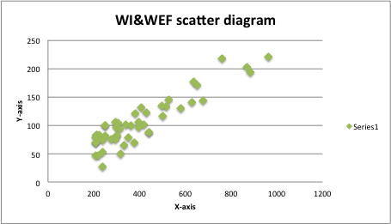

Task 3
3.1

HLE | Frequency
S | 20
P | 25
C | 5
Total | 50
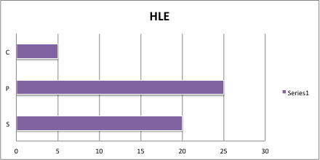

3.2

Gender | Frequency
F | 12
M | 38
Total | 50

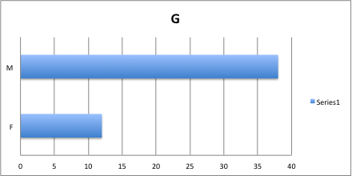

3.3

FS | Frequency | MAX | MIN
1~2 | 10 | 8 | 1
3~4 | 28
5~6 | 7
7~8 | 5
Total | 50

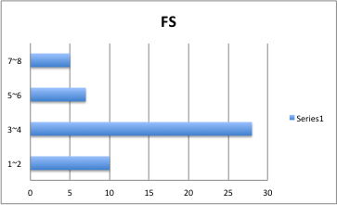

Task 4

Item | Median | Mode | Mean | Median vs Mean | Indication
WEF | 97 | 83 | 104.5 | 97<104.5 | Positively Skewness
WI | 335 | 250 | 397.4 | 335<397.4 | Positively Skewness
FS | 3 | 3 | 3.72 | 3<3.72 | Positively Skewness

Task 5

Items | 25% | 75% | IQR
WEF | 77.25 | 128 | 50.75
WI | 250 | 482.75 | 232.75
FS | 3 | 4.75 | 1.75

Task 6

Items | SDT | Variance | Mean | CV(SD/Mean)
WEF | 43.83980579 | 1921.928571 | 104.5 | 0.419519673
WI | 191.6704229 | 36737.55102 | 397.4 | 0.482311079
FS | 1.750102038 | 3.062857143 | 3.72 | 0.470457537

Task 7

Item | WEF | WI | SF
Maximum Value | 220 | 962 | 8
Minimum Value | 27 | 207 | 1
Sample Size (n) | 50 | 50 | 50
Mean | 104.5 | 397.4 | 3.72
Median | 97 | 335 | 3
Mode | 83 | 250 | 3
IQR | 50.75 | 232.75 | 1.75
Standard Dev | 43.83980579 | 191.6704229 | 1.750102038
25th percentile | 77.25 | 250 | 3
75t percentile | 128 | 482.75 | 4.75
CV | 0.4195 | 0.4823 | 0.4705

Non techinal report

