Write a program that tests the user’s ability to memorize a sequence of colors. As shown in the sample session, the program starts off by displaying a dialog box with a list of colors that are to be memorized – red, white, yellow, green, and blue. The user then enters the colors one at a time in a text box. If the user makes a mistake, the program prints a “Sorry” message. If the user correctly enters all the colors, the program prints a “Congratulations” message. Note that when the sorry or congratulations message is printed, the window’s original components get cleared away.

As always, you are required to write elegant code. In particular, you should avoid hard coding the color values in the interior of your program. You should declare those values one time in an array at the top of the program.

Include a class name MemoryGame
Use a simple FlowLayout layout manager scheme.
Use an inner class for the listener.
Use appropriate modifiers for your methods. The modifiers we’ve discussed are private, public, static, and final.
Use helping methods if appropriate.
Mimic the sample session precisely. In particular, note the dialog box’s text, the window’s title, and the window’s text.

First sample session (read the windows left to right):

The opening dialog box: After closing the dialog box, here’s the
main window:

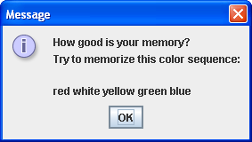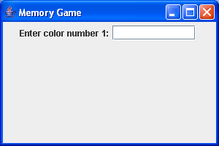

After typing the first color: After pressing enter and then typing the second
color:
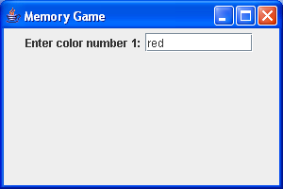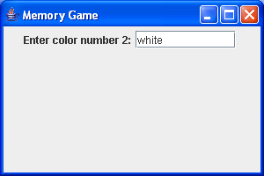

After entering all five colors correctly:
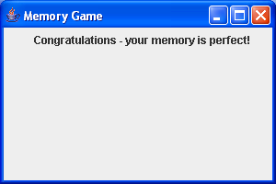

Second sample session (read the windows left to right):

After closing the dialog box and typing the first After pressing enter and then typing the second
color: color:

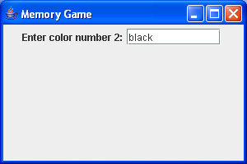

After pressing enter:

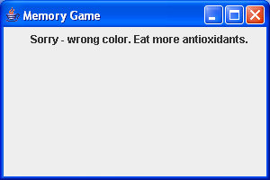

Provide a hint button that causes the current color’s first letter to appear in the text box. For example, since the first color is red, the first hint should be r. The hint button must cause focus to be put on the text box (i.e., the cursor should appear within the text box without the user having to click there with the mouse). To cause focus to be put on a component, use the requestFocusInWindow method. See Sun’s API documentation for requestFocusInWindow details.

Sample session (read the windows left to right):

After closing the dialog box, here’s the main After clicking the hint button:
window:

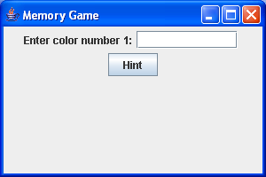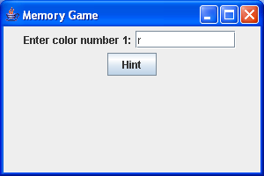

After typing the first color: After pressing enter and clicking the hint button:

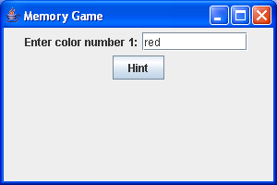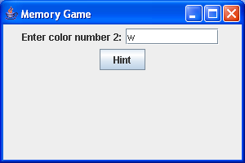

After entering all five colors correctly:

