Question 1

Name two host proteins that are required for Helper T-cells to be susceptible to an HIV infection?
Protein 1 Blank 1
Protein 2 Blank 2
Answer
2 points

Question 2

All cells that contain sialic acid residues on their surface will support entry and replication by influenza A virus?
Answer
True
False
1 points

Question 3

A drug that dramatically enhances the stability of the capsid of a non-enveloped virus will definitely improve the stability of the virus and allow it to more successfully replicate under a variety of conditions?
Answer
True
False
1 points

Question 4

Assume you can fluorescently label one of the genome segments of the influenza virus and use a confocal microscope to image the location of the fluorescent label in the cell. If you allow the labeled virus to infect a cell line that permits proper trafficking of virus but does not allow genome replication, in which cellular compartment would you expect the fluorescent label to accumulate?
Answer
 | A. | Endosomes
 | B. | Cytoplasm
 | C. | Endoplasmic reticulum
 | D. | Nucleus
1 points

Question 5

Using the same methods in Question 4, where would you expect the fluorescent label to accumulate if cells were treated with a drug that inhibits the activity of the viral M2 ion channel?
Answer
 | A. | Cytoplasm
 | B. | Endoplasmic Reticulum
 | C. | Nucleus
 | D. | Endosome
1 points

Question 6

Drugs that inhibit receptor-mediated endocytosis would inhibit the ability of all viruses to replicate.
Answer
True
False
1 points

Question 7

Which of the following statements are true about cellular receptors for viruses?
Answer
 | A. | All animal viruses require a cellular receptor
 | B. | All bacteriophage require a cellular receptor
 | C. | Plant viruses do not require a cellular receptor
 | D. | Viruses that infect fungi require a cellular receptor.
 | E. | All viruses of mammals require both a receptor and coreceptor
 | F. | Viruses of the same family must bind the same cellular receptor
 | G. | The only function of cellular receptors for viruses is to bind viruses
 | H. | Different viruses can bind to the same cellular receptor
2 points

Question 8

Watch this short video about the entry influenza viruses in assignments folder. The influenza virus video is from NPR and the reporter refers to the various macromolecules in the video by non-scientific names. Give the scientific names specific for influenza virus for each of the non-scientific terms used in the video.
The Lock Blank 1
The Key Blank 2
Welcoming Committee Blank 3
Wiggly things or viral recipes Blank 4
Big Pink Molecule/Mini-Factory Blank 5
Little Chefs/Blue Peanutty things Blank 6
Answer
2 points

Question 9

For all RNA viruses, the genome must be released from the capsid/nucleocapsid for RNA synthesis and genome replication
Answer
True
False
1 points

Question 10

A mutant HIV virus is created in which the viral GP41 protein is not functional. The virus is fluorescently-labeled so you can observe its location in the cell. Where would you expect to observe the virus if you infected cells in culture with the mutant virus (select one)?
Answer
 | A. | The virus would be in solution since it cannot attach to the cells.
 | B. | The virus would be attached to the extracellular side of the plasma membrane
 | C. | The virus would be attached to the cytoplasmic side of the plasma membrane
 | D. | The virus would be in the cytoplasm
 | E. | The virus would be in the nucleus
1 points

Question 11

Viral fusion proteins can rely on which of the following to mediate fusion of viral and cellular membranes (select all that apply)?
Answer
 | A. | Fusion proteins trap water at the membrane surface to facilitate fusion of viral and cellular membranes
 | B. | Acidification/Lower pH causes conformational change of viral fusion protein
 | C. | Proteolytic cleavage of fusion protein
 | D. | Exposure of viral fusion proteins must be highly regulated to prevent exposure prior to reaching appropriate cellular compartment.
 | E. | Phosphorylation
 | F. | Viral fusion proteins are highly charged to facilitate insertion in to cellular/viral membranes
2 points

Question 12

Which of the following are mechanisms which promote uptake and movement of viruses within the cell (select all that apply)?
Answer
 | A. | Clathrin-Coated vesicles
 | B. | Endosomes
 | C. | Passive Diffusion
 | D. | Microtubules
 | E. | Viral flagella
1 points

Question 13

A major difficulty studying the Hepatitis C virus (HCV) is there is no infectious animal model for the virus. HCV can only infect humans and higher order primates. Common laboratory mice are not susceptible to HCV infection. Therefore, scientists have tried to genetically engineer mice that are susceptible to HCV infection. The data below is such an experiment in which mice are genetically engineered to produce human proteins. The researchers used a specially modified virus that when it infects a mouse cell generates a luminescence signal that can be viewed with a specialized imager (colored pixels in left figure). The graph on the right shows the levels of HCV in the cells of mice engineered to produce the mouse (m) or human (h) proteins: CD81, Scavenger Receptor Class B (SCARB1), Claudin1 (CLDN1) and Occludin (OCLN). Based on the data in this figure, explain in 5-6 sentences why mice are not susceptible to HCV infection.

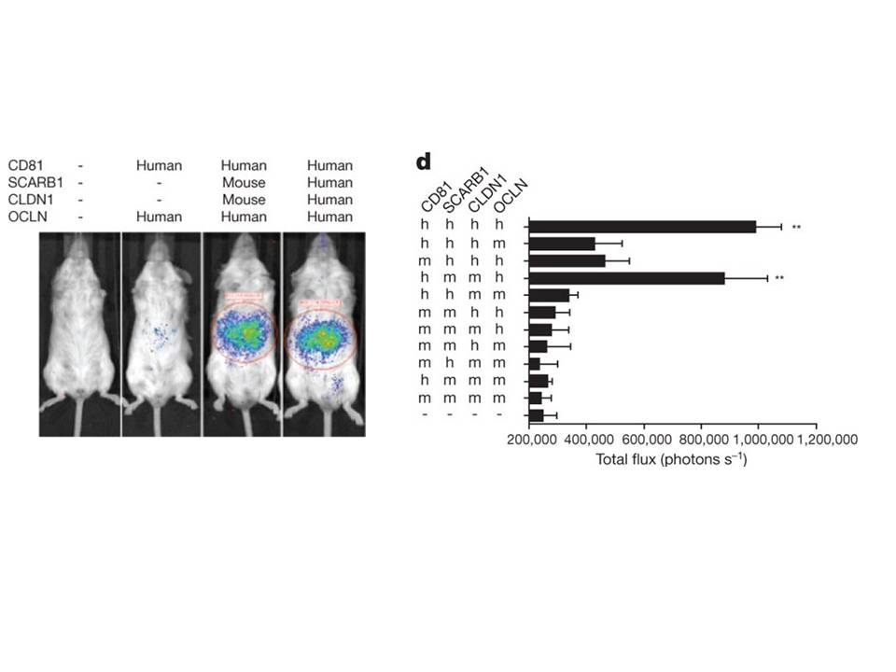
Answer
Press Tab to enter the content editor. For the toolbar, press ALT+F10 (PC) or ALT+FN+F10 (Mac).
Path: p
Words:0

2 points

Question 14

The release of the genome from a virion must be tightly regulated to ensure that the genome is only released when the virion attaches to the cell or is localized to the appropriate cellular compartment. Give an example of how a specific virus control the release of its genome so it only occurs at precisely the right point (max 4-5 sentences).
Answer
Press Tab to enter the content editor. For the toolbar, press ALT+F10 (PC) or ALT+FN+F10 (Mac).
Path: p
Words:0

2 points

Save and Submit

