### Operational Plan

Subway, LLC will be located at 284 W University Avenue in Gainesville, Florida. It is conveniently located near many bars and less than a mile from the University of Florida. The store will open every day at 7:00 in order to be able to serve breakfast. This will help take advantage of college students looking for a meal before their first classes which begin at 7:25. The location will close at 10:00 PM on Sunday through Wednesday nights. To take advantage of the customer base which may be up late on Thursday – Saturday night, this Subway location will choose to stay open until 1:00 AM on those nights. There are also many businesses around to provide significant customers for both lunch and dinner.

The first employee will arrive approximately one hour prior to opening in order to facilitate preparation for the day. After closing, whatever cleaning is necessary to ready the store for the next day will be performed before leaving the premises. Ideally, two employees will be available to open and close the store each day, however, one employee will be suitable on slower business days. During the busiest hours, three employees will be on hand to handle the production.

Explain the daily operation of the business, its location, equipment, people, processes, and surrounding environment.

##### Production

All products are prepared using the Subway standards. Bread is baked fresh daily from pre-prepared dough supplied by the corporation. Meats and egg will be delivered pre-portioned, cut and sealed to make preparations easier. Vegetables are sliced daily by those who perform the store opening. Soup is created using frozen, premade packages and is made by heating and adding water. Salads, chips, yogurt, and cookies are also available as dining options.

In order to ensure quality control, many products are delivered already prepared. Meat is provided and sliced prior to arriving at the Subway location. To ensure the consistency of bread, the dough is already prepared as well. To ensure freshness, the dough will be baked daily as needed, based on predicted customer volume.

FDA guidelines will be strictly followed to ensure the safety of food served. Frequent cleaning and will be performed to meet cleanliness standards. Cleaning products will be kept separately from food and food preparation surfaces. Temperature measurements will be taken hourly to comply with FDA guidelines for food safety. If food is found outside the allowed guidelines, it will be disposed of appropriately. Employees are required to wash hands their hands every time they re-enter the food preparation area. They must also wear gloves and wear a hat or hair net whenever around food.

There is currently no historical data to predict the amount of customers for this location. Ordering practices will need to be adjusted as time goes on to match expected demand.

Work practices will be based on the number of employees working at the time. During slow hours, an employee can handle the whole process. This includes cutting bread, cooking ingredients, adding sandwich stuffing, cashing out customers and providing other services. When more employees are available, tasks will be designated between them. For example, one employee could be preparing bread and meats, another employee could add toppings and a third employee could cash out customers while maintaining the rest of the restaurant.

To ensure the best customer service is always delivered, Subway participates in a few programs. Using a receipt, a customer is able to attain a free cookie after taking a 1-minute survey at [www.tellsubway.com](http://www.tellsubway.com). Without a receipt, a customer can still contact customer service at <http://www.subway.com/ContactUs/frmCustomerService.aspx>. In store customer service training is addressed by the restaurant’s management.

New product suggestions will be supplied to the Subway franchise from Subway’s corporate offices. Management is allowed to create their own sandwich combinations at their own discretion.

##### Location

Subway LLC, at 284 W University Ave in Gainesville Florida, is located in close proximity to many organizations that will provide customers. Nearby are many businesses and the University of Florida which will provide many breakfast, lunch and dinner customers. Over 50,000 customers enrolled at the university become potential customers once the location opens its doors.

Subway LLC is physically located in a strip mall with four other tenants. It is located in a heavy traffic area of the strip mall which will help bring additional business into the location. The other strip mall tenants include a Chinese takeout restaurant, a flower shop, a beauty parlor, and a FedEx/Kinko’s store. The location in the strip mall is 1000 square feet at a cost of $10,000 a month and is zoned for retail. Easy parking and walking access is available for all tenants of the strip mall location.

Power and utilities are paid for by the tenant but were prepared and installed in advance by the landlord. All equipment runs on the typical 120/208 volt electric installation already available.

The interior of the location will fitted with a main counter in which to prepare the food and interact with customers. A small, unisex restroom for employees and customers will be constructed. A back storage room with refrigeration will be constructed to hold supplies and food. Lastly, a small dining area will be constructed with the remaining space available to provide ample room for seating without overcrowding the remaining space. Please see the floor plan provided in Appendix B.

The following expenses will be paid to outfit the restaurant location appropriately with equipment necessary for operation.

* Rent: Rent for the 1000 ft. facility. Includes trash removal.

$10,000 / month

* Construction cost: Building improvements to install a counter, restroom, back storage area, and seating for customers.

$60,000 one time

* Equipment Lease: The equipment is provided through an equipment leasing option. This includes refrigeration, a toaster, an electric oven, and a convection microwave.

$6,500 / month

* Security System: A security system will be installed for surveillance to deter theft and other criminal activity. It will typically be recorded but not regularly monitored, unless desired by management.

$3,500 one time

* Outside SUBWAY sign: A classy, exterior “SUBWAY” sign used to attract customers.

$4,000 one time

* Monthly Prorated Fees: Includes tax share, property insurance and common area maintenance.

$700 / month

* Utilities: Includes electricity, water, and sewer. Heat is electric heat when necessary.

$300 / month

The following business hours will be posted on a sign at the front door of the restaurant:

|  |  |  |  |
| --- | --- | --- | --- |
| Day | Open |  | Close |
| Sunday | 7:00 AM | To | 10:00 PM |
| Monday | 7:00 AM | To | 10:00 PM |
| Tuesday | 7:00 AM | To | 10:00 PM |
| Wednesday | 7:00 AM | To | 10:00 PM |
| Thursday | 7:00 AM | To | 1:00 AM |
| Friday | 7:00 AM | To | 1:00 AM |
| Saturday | 7:00 AM | To | 1:00 AM |

##### Legal Environment

Describe the following: <I still need to complete this section, finishing research. –Michael Jennings>

* Licensing and bonding requirements
* Permits
* Health, workplace, or environmental regulations
* Special regulations covering your industry or profession
* Zoning or building code requirements
* Insurance coverage
* Trademarks, copyrights, or patents (pending, existing, or purchased)

##### Personnel:

##### Shift Managers

The following employees will be the shift managers of the Subway restaurant:

* Michael Jennings
* Ryan Manning
* Eva Morales
* Tammy Wilson

**Part-Time Employees**

Hired, part-time employees will be paid an hourly wage of $10.00. While employee retention is important, most part-time employees will not be there long term and therefore their names are not included in the business plan. Multiple employees will be hired and trained by the store’s first opening in order to handle the expected customers. A prime target for employee recruitment will be the main campus of the University of Florida since it is less than a mile from the restaurant location.

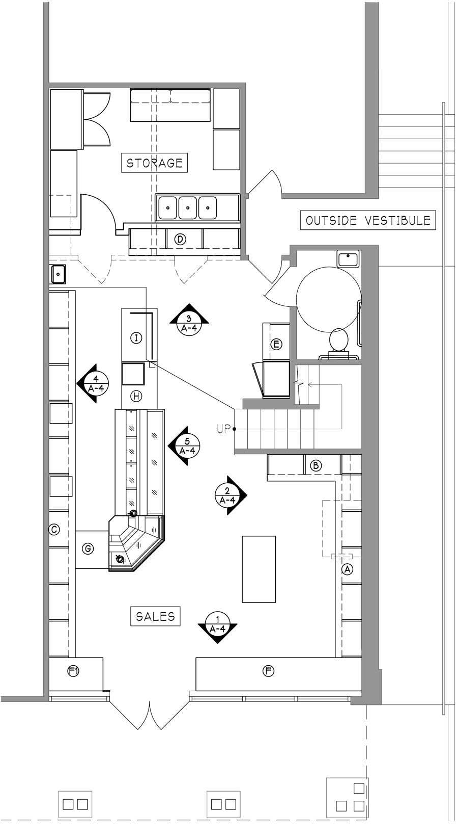

##### Inventory

* What kind of inventory will you keep: raw materials, supplies, finished goods?
* Average value in stock (i.e., what is your inventory investment)?
* Rate of turnover and how this compares to the industry averages?
* Seasonal buildups?
* Lead-time for ordering?

##### Suppliers

Identify key suppliers:

* Names and addresses
* Type and amount of inventory furnished
* Credit and delivery policies
* History and reliability

Should you have more than one supplier for critical items (as a backup)?

Do you expect shortages or short-term delivery problems?

Are supply costs steady or fluctuating? If fluctuating, how would you deal with changing costs?

##### Credit Policies

**You will be strictly cash and credit card. Therefore, you should not have any receivables.**

Managing Your Accounts Payable

You should also age your accounts payable, what you owe to your suppliers. This helps you plan whom to pay and when. Paying too early depletes your cash, but paying late can cost you valuable discounts and can damage your credit. (Hint: If you know you will be late making a payment, call the creditor before the due date.)

Do your proposed vendors offer prompt payment discounts?

A payables aging looks like the following table.

|  |  |  |  |  |  |  |
| --- | --- | --- | --- | --- | --- | --- |
|  | Total | Current | 30 Days | 60 Days | 90 Days | Over 90 Days |
| Accounts Payable Aging |  |  |  |  |  |  |
|  |  |  |  |  |  |  |