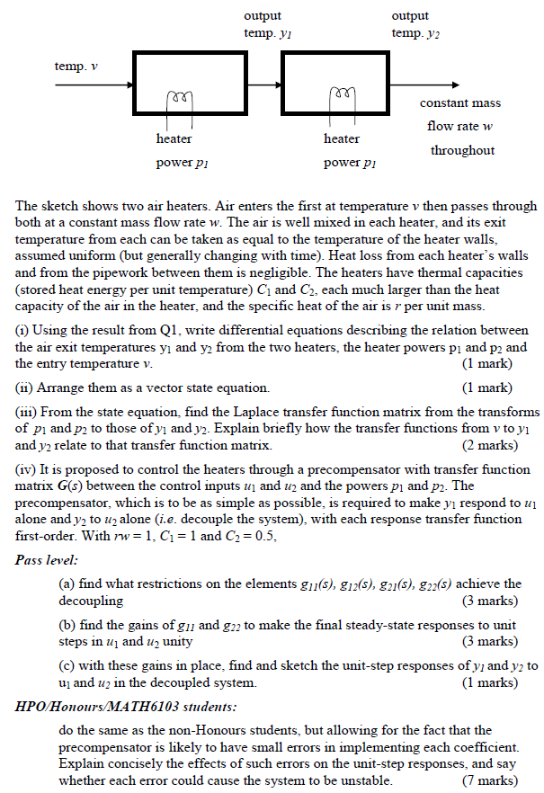

This is the heater equation from Q1 for solving (i)
