Task Sheet (Week 5 )
ENG 101

Article / Video Title | Sustainability and third world
Author, Year, Journal / Book / Web site / link
Purpose:  - Content | Socio-political aspects of Sustainability
- Skills Practiced | Textual analysis, paraphrasing, summarising

Vocabulary to check :

Task A:
Consider the following questions before you start reading the article called ‘Sustainability and third world development’. (You may need to do some research). Be ready to discuss them in class. You may take notes and use them in class.
- What do you understand by the terms “first world” and “third world”?

- Where does Turkey fit into this categorization?

- What problems do developed countries face?

- What about less-developed countries?

- Do the needs of these different countries converge or diverge? Why?

- Do developed countries have a moral obligation to provide support to less-developed/developing countries?

- What do the following diagrams show us about sustainable development?
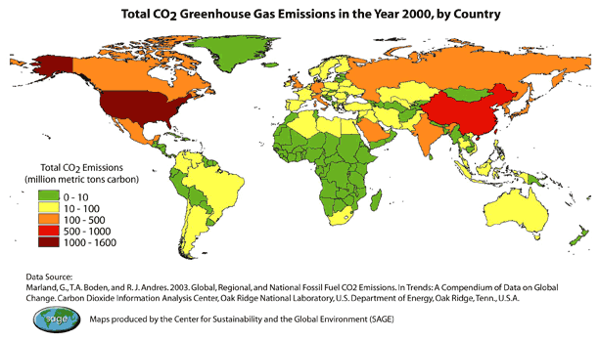
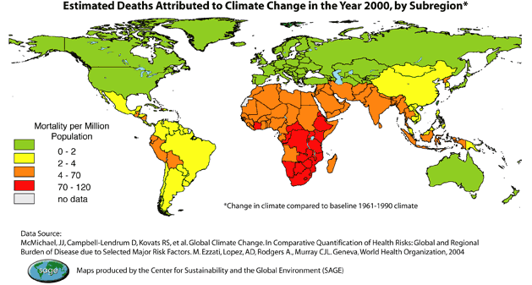
Task B: Now read the article carefully and answer the following questions:
- What did the World Conservation Strategy promote as important issues?

- How was the Brundlandt report different to the World Conservation Strategy?

- “... the task of finding common ground was Herculean...” Paraphrase this in your own words.

- According to the article, what are the main disagreements between North and South countries?

- The Rio Declaration can be described as a compromise and global agreement. Read lines 418-433. What can be inferred about the writer’s opinion of the agreement?

- What are the main principles of Agenda 21? Summarise them in your own words.

