Tables that were created by CREATE TABLE and Insert statements:
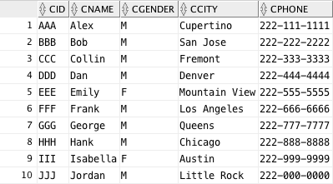
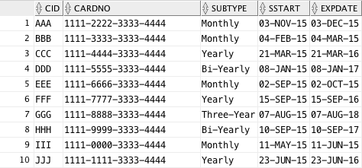
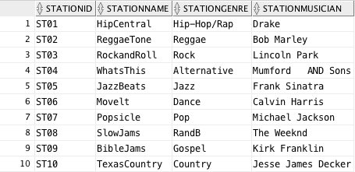
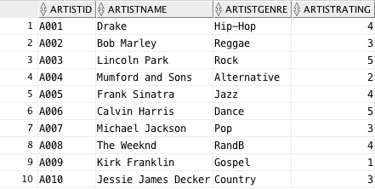

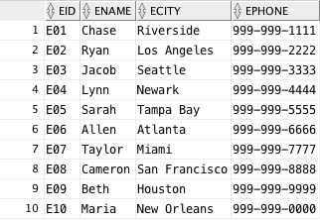
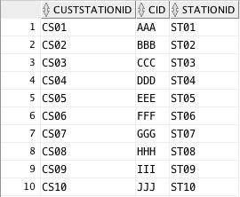

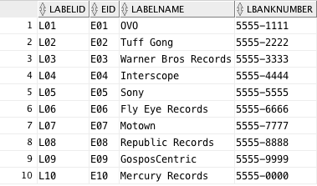

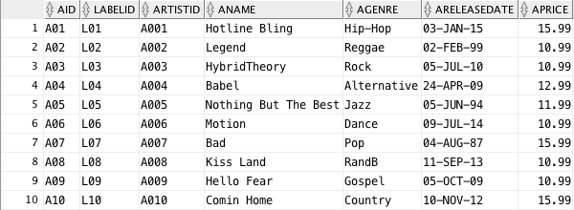

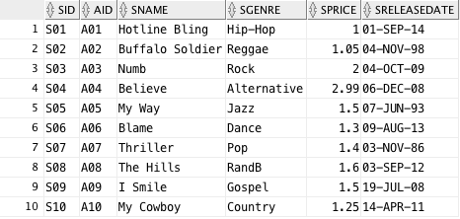

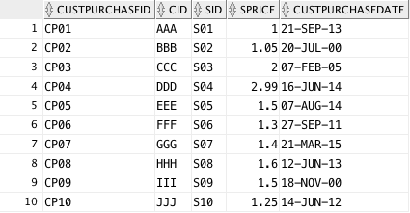

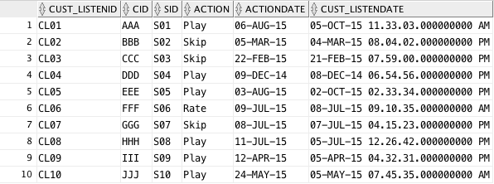

Revised Relational Model:

CUSTOMER (CID, Cemail, Cgender, Cage, Cname,
Caddress, Cstate, Ccity, Czipcode)
*we included the gender attribute into customer in our revised relational model to determine if it is a male or female customer

TRIAL (CID, Tstart)
Foreign Key CID References CUSTOMER
Not Null
On Delete Cascade

SUBSCRIBED (CID, CardNo, Sub_Type, Sstart, ExpDate)
Foreign Key CID References CUSTOMER
Not Null
On Delete Cascade
*we included the subscription type attribute in our revised relational model to detemine whether the customer is a monthly, yearly, bi-yearly, or three year subscriber. Also an experiation date attribute to understand when subscription is coming to an end.

STATION(StationID, StationName, StationGenre, StationMucisian)

ARTIST (ArtistID, ArtistName, ArtistGenre, ArtistRating)
*we included ArtistRating attribute in our relational model to show the average rating given by customers.

ACCOUNT EXECUTIVE (EID, EName, ECity,
EState, EZip, EAddress, EPhone)
*we included the executive phone number attribute in our relational model to obtain contact information.

CUS_STATION (Cust_StatID, CID, StationID)
Foreign Key CID References CUSTOMER
Not Null
On Delete Restrict
Foreign Key StationID references STATION
Not Null
On Delete Restrict

RECORD LABEL (LabelID, EID, LabelName, LPercentage, LBankNumber)
Foreign Key EID references ACCOUNT EXECUTIVE
Not Null
On Delete Restrict

ALBUM (AID, LabelID, ArtistID, AName,
AGenre, APrice, AReleaseDate)
Foreign Key LabelID references LABEL
Not Null
On Delete Restrict
Foreign Key ArtistID references ARTIST
Not NULL
On Delete Restrict
*we included the album genre to better understand what genre of albums customers could be looking for.

SONG(SID, AID, SName, SReleaseDate, SGenre, SPrice)
Foreign Key AID references ALBUM
Not Null
On Delete Restrict

CUS_PURCHASE (Cust_PurchaseID, CID, SID, SPrice)
Foreign Key CID References CUSTOMER
Not Null
On Delete Restrict
Foreign Key SID references SONG
Not Null
On Delete Restrict
*we included song price attribute in the revised relational model to determine the price of a song when a customer purchases it.

CUS_LISTEN (Cust_ListenID, CID, SID, Action, ActionDate)
Foreign Key CID References CUSTOMER
Not Null
On Delete Restrict
Foreign Key SID references SONG
Not Null
On Delete Restrict
*we included Action and ActionDate attributes in our revised relational model to determine what action occurs, such as skip, play, rate, and what date does this action occur.

