Raymond Vernon captured the classic rationale for international diversification.⁹ He suggested that typically a firm discovers an innovation in its home-country market, especially in an advanced economy such as that of the United States. Often demand for the product then develops in other countries, and exports are provided by domestic operations. Increased demand in foreign countries justifies making investments in foreign operations, especially to fend off foreign competitors. Vernon, therefore, observed that one reason why firms pursue international diversification is to extend a product's life cycle.
figure 8.1 Opportunities and Outcomes of International Strategy
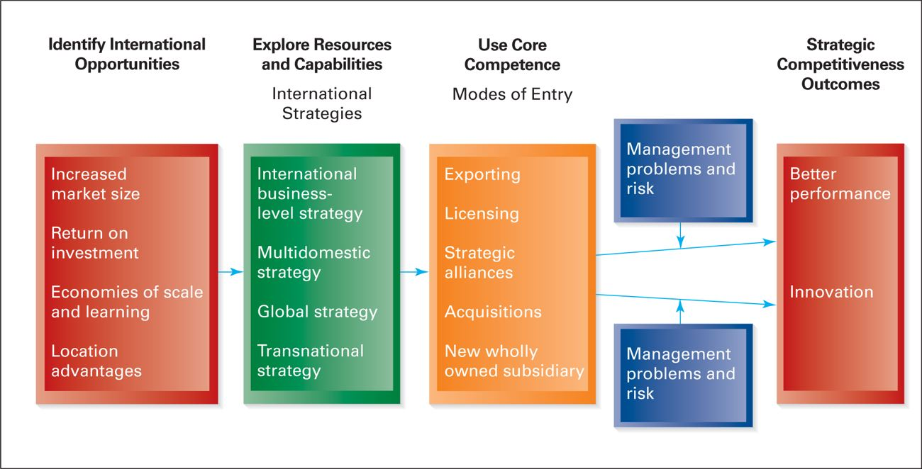
Another traditional motive for firms to become multinational is to secure needed resources. Key supplies of raw material—especially minerals and energy—are important in some industries. Other industries, such as clothing, electronics, and watchmaking, have moved portions of their operations to foreign locations in pursuit of lower production costs. Clearly one of the reasons for Chinese firms to expand internationally is to gain access to important resources.¹⁰
(Hitt 219-220)
Reference:
. M. W. Peng & E. G. Pleggenkuhle-Miles, 2009, Current debates in global strategy, International Journal of Management Reviews, 11(1): 51-68; M. A. Hitt, L. Tihanyi, T. Miller, & B. Connelly, 2006, International diversification: Antecedents, outcomes and moderators, Journal of Management, 32: 831-867.
8. Y. Luo & R. L. Tung, 2007, International expansion of emerging market enterprises: A springboard perspective, Journal of International Business Studies 38: 481-, 498; J. E. Ricart, M. J. Enright, P. Ghemawat, S. L. Hart, & T. Khanna, 2004, New frontiers in international strategy, Journal of International Business Studies, 35: 175-200.
9. R. Vernon, 1996, International investment and international trade in the product cycle, Quarterly Journal of Economics, 80: 190-207.
10. He & Lyles, China's outward foreign direct investment; P. J. Buckley, L. J. Clegg, A. R. Cross, X. Liu, H. Voss, & P. Zheng, 2006, The determinants of Chinese outward foreign direct investment, Journal of International Business Studies, 38: 499-, 518.

Hitt, Michael A., R. Duane Ireland, Robert E. Hoskisson. Strategic Management: Concepts and Cases, 9th Edition. South-Western, 2014-01-02. <vbk:1111505187#outline(8.11)>.

Hitt, Michael A., R. Duane Ireland, Robert E. Hoskisson. Strategic Management: Concepts and Cases, 9th Edition. South-Western, 2014-01-02.

