- Determine whether the statement is true or false. If it is true, rewrite it as a true statement.
In a frequency distribution, the class width is the distance between the lower and upper limits of a class.

- Use the given minimum and maximum data entries, and the number of classes, to find the class width, the lower class limits, and the upper class limits.
Minimum = 12, maximum = 56, 6 classes

- Use the given frequency distribution to find the
- Class width.
- Class midpoints.
- Class boundaries.
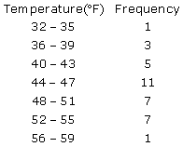

- Use the frequency distribution shown below to construct an expanded frequency distribution.
High Temperatures (ºF)

Complete the table below.

- Use the ogive to approximate
- The number in the sample.
- The location of the greatest increase in frequency.

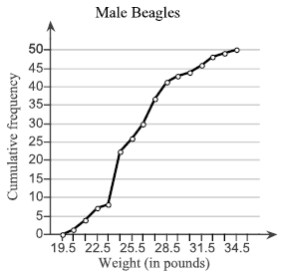

- The relative frequency histogram is shown below.
Complete parts (a) through (c).

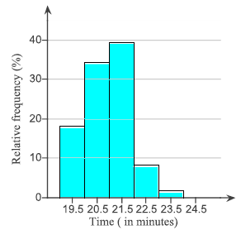
- Use the relative frequency histogram to identify the class with the greatest relative frequency.
Use the relative frequency histogram to identify the class with the least relative frequency.
- Use the relative frequency histogram to approximate the greatest relative frequency.
Use the relative frequency histogram to approximate the least relative frequency.
- Use the relative frequency histogram to approximate the relative frequency of the second class.

- The data represent the time, in minutes, spent reading a political blog in a day. Construct a frequency distribution using 5 classes. In the table, include the midpoints, relative frequencies, and cumulative frequencies. Which class has the greatest frequency and which has the least frequency?
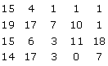

Which class has the greatest frequency?

Which class has the greatest frequency?

- The data set below contains information about the number of children of world leaders. Use the data to construct a frequency distribution using six classes and to create a frequency polygon.
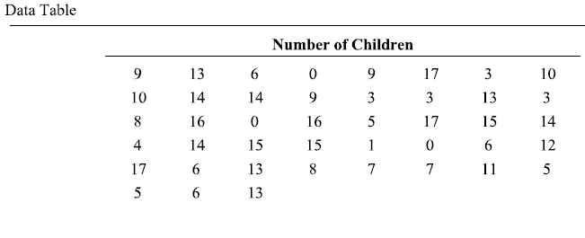

- Use the stem-and-leaf plot to list the actual data entries. What is the maximum data entry? What is the minimum data entry?
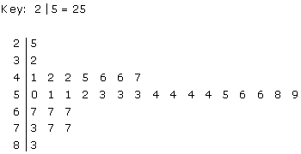

- Use the dot plot to list the actual data entries. What is the minimum data entry?
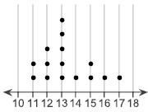

- An auction company sold 15 handheld computers last month. The final prices (in dollars) at which the items sold are as follows.
242, 252, 229, 219, 244, 228, 233, 219, 237, 228, 226, 208, 248, 249, 249
- Construct a stem-and-leaf plot.
- Summarize what this plot tells you about the data.

- Use a pie chart to display the data. The data represent the number of countries in a treaty by continent. What can you conclude about the data?
North America 22 Europe 42 Africa 53
South America 13 Oceania 15 Asia 46

- Construct a scatter diagram using the data table to the right. This data is from a study comparing the amount of tar and carbon monoxide (CO) in cigarettes. Use tar for the horizontal scale and use carbon monoxide (CO) for the vertical scale. Determine whether there appears to be a relationship between cigarette tar and CO.
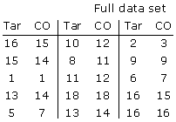

- Determine whether the statement is true or false. If it is false, rewrite it as a true statement.
The mean is the measure of central tendency most likely to be affected by an extreme value (outlier).

- Consider a frequency distribution of scores on a 50-point test where a few students scored much lower than the majority of students. Match this distribution with one of the graphs shown below.
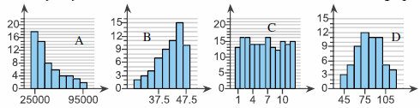

- The maximum numbers of seats in a sample of 13 sport utility vehicles are listed below. Find the mean, median, and mode of the data.
8 8 11 11 8 9 7 7 7 7 7 7 10

- Find the mean, median, and mode of the data, if possible. If any of these measures cannot be found or a measure does not represent the center of the data, explain why.

A sample of seven admission test scores for a professional school are listed below.
10.7 10.2 11.7 11.4 10.2 10.2 10.9

- Find the mean, median, and mode of the data, if possible. If any of these measures cannot be found or a measure does not represent the center of the data, explain why.

The typing speeds (in words per minute) for several stenographers are listed below.
240 215 120 165 136 120 170 180 220 150

- The heights (in inches) of 20 female students in a physical education class are shown below.
Approximate the mean height of students in a class.
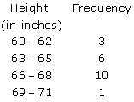

- Students in an experimental psychology class did research on depression as a sign of stress. A test was administered to a sample of 30 students. The scores are shown below.
44 51 11 91 76 36 64 37 43 72 54 62 36 74 51
72 37 29 39 61 47 63 36 41 22 37 51 46 85 14

To find the 10% trimmed mean of a data set, order the data, delete the lowest 10% of the entries and the highest 10% of the entries, and find the mean of the remaining entries. Complete parts (a) through (c).
- Find the 10% trimmed mean for the data.
- Compare the four measure of central tendency, including the midrange.
- What is the benefit of using a trimmed mean versus using a mean found using all data entries?

- Find the range, mean, variance, and standard deviation of the population data set.
20, 10, 2, 7, 12

- Find the range of the data set.
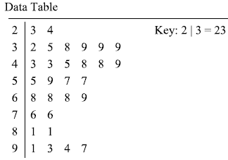

- Both data sets have a mean of 235. One has a standard deviation of 16, and the other has a standard deviation of 24.

Which data set has which deviation?
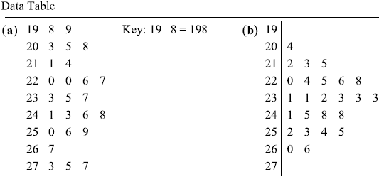

- Researchers conducted experiments with trees. Listed below are weights (kg) of trees given no fertilizer and trees treated with fertilizer and irrigation. Find the range, variance, and standard deviation for each of the two samples, then compare the two sets of results. Does there appear to be a difference between the two standard deviations?
No treatment: 0.13 0.11 0.12 0.29 0.36
Fertilizer and irrigation: 0.95 1.53 0.63 0.84 1.91

- Compare the three data sets on the right.
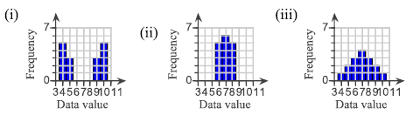
- Which data set has the greatest sample standard deviation?
- Which data set has the least sample standard deviation?
- How are the data sets the same? How do they differ?

- Heights of men on a baseball team have a bell-shaped distribution with a mean of 182cm and a standard deviation of 8cm. using the empirical rule, what is the approximate percentage of the men between the following values?
- 174cm and 190cm
- 158cm and 206cm

- From a sample with n = 36, the mean duration of a geyser’s eruptions is 3.15 minutes and the standard deviation is 0.65 minutes. Using Chebychev’s Theorem, determine at least how many of the eruptions lasted between 1.85 and 4.45 minutes.

- The coefficient of variation CV describes the standard deviation as a percent of the mean. Because it has no units, you can use the coefficient of variation to compare data with different units. Find the coefficient of variation for each set. What can you conclude?
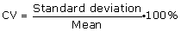

Data Table
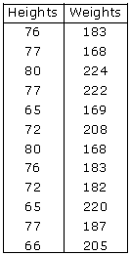

- The English statistician Karl Pearson (1857-1936) introduced a formula for the skewness of a distribution.
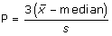

Most distribution have an index of skewness between -3 and 3. When P > 0 the data are skewed right. When P < 0 the data are skewed left. When P = 0 the data are symmetric. Calculate the coefficient of skewness for each distribution. Describe the shape of each.

- Determine whether the statement is true or false. If it is false, rewrite it as a true statement.

The second quartile is the median of an ordered data set.

- Use the box-and-whisker plot to identify
- The minimum entry.
- The maximum entry.
- The first quartile.
- The second quartile.
- The third quartile.
- The interquartile range.
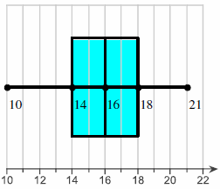

- The data show the number of vacation days used in a recent year by a sample of 12 employees.
- Find the data set’s first, second, and third quartiles.
- Draw a box-and-whisker plot that represents the data set.
1 8 3 6 5 8 6 5 5 7 7 9

- The mean for statistics test scores is 62 and the standard deviation is 6.0. For the biology test scores, the mean is 25 and the standard deviation is 3.7. The test scores of a student who took both tests are given below.

A student gets a 78 on the statistics test and a 26 on the biology test.
- Transform each test score to a z-score.
- Determine on which test the student had a better score.

- You can find the percentile that corresponds to a specific data values x by using the following formula.

There have been 75 winners for an acting award. Nine winners were older than Jane Doe when they won the award. Find the percentile that corresponds to Jane Doe’s age.

- A certain brand of automobile tire has a mean life span of 33,000 miles and a standard deviation of 2,150 miles. (Assume the life spans of the tires have a bell-shaped distribution.)

- The life spans of three randomly selected tires are 33,000 miles, 38,000 miles, and 31,000 miles. Find the z-score that corresponds to each life span.

- The life spans of three randomly selected tires are 28,000 miles, 37,000 miles, and 33,000 miles. Using the empirical rule, find the percentile that corresponds to each life span.

