The Design and Planning Stage

I have chosen to design and create a website on shipping line coast which will be needed to my website.

Main Purpose and Topic

The main purpose of this website is to show to our customer what we do in daily day activities especially for people how are shipping goods to abroad via sea, air and Road haulage. My website will be used by main penitential customers to my business and new comers, the website will show different activities we do include prices, information about shipping goods via different ways.
My website which l has built will be used later on for ecommerce once it has been approved and checked by others shareholder. But at the moment will not be shown in public ,but will be used in class course work to display the information about shipping line and how customer are getting in touch with us .

Target Audience
My audience target will be anyone who is interesting to ship goods to Africa, and must be the age of 18+, My website will target the youth and adults as they would be the audience to contact us for booking and enquires about pricing, shipping date and to check the available line to Africa. My website will be designed by professional colour which will not affect user while browsing the website including images which will be attractive to our customers’ will not use many colours on my website because it will put off my customers, it has to be consistent colour while browsing through pages. Due to this it will make audience target to be more attracted.

Website Objectives
The main objectives of Shipping line is to provide the current and relevant information to wide range of audience base, customer can do booking via online or Telephone and to provide navigable channel to wide audience. To ensure all information are provided and accessible by manner usable and to promote and maintain the image of shipping line. All links and graphics will be displayed appropriate including the navigation button. Customer will have the option to send the email for general enquires
To make the customer happy the loading time will be fast when opening the page throughout while navigating, the consistent of style and logo throughout the website.

Producing the website
The website will be created by HTML, CSS, Javascript an to ensure l meet the client objectives and efficiency of the website .While l am developing the website, no Dreamweaver will used to develop the website production’s will develop the website from scratch by using the notepad++ throughout the development .
Two steps will be used to produce the website development, design and build .Through these the documentation will be needed to record the process to finish the website.

Comparable Sites
Before I design the website I will discuss the designs of other relevant websites and highlighting the similarities found on them relating to this topic.
http://www.zambezifreight.com/
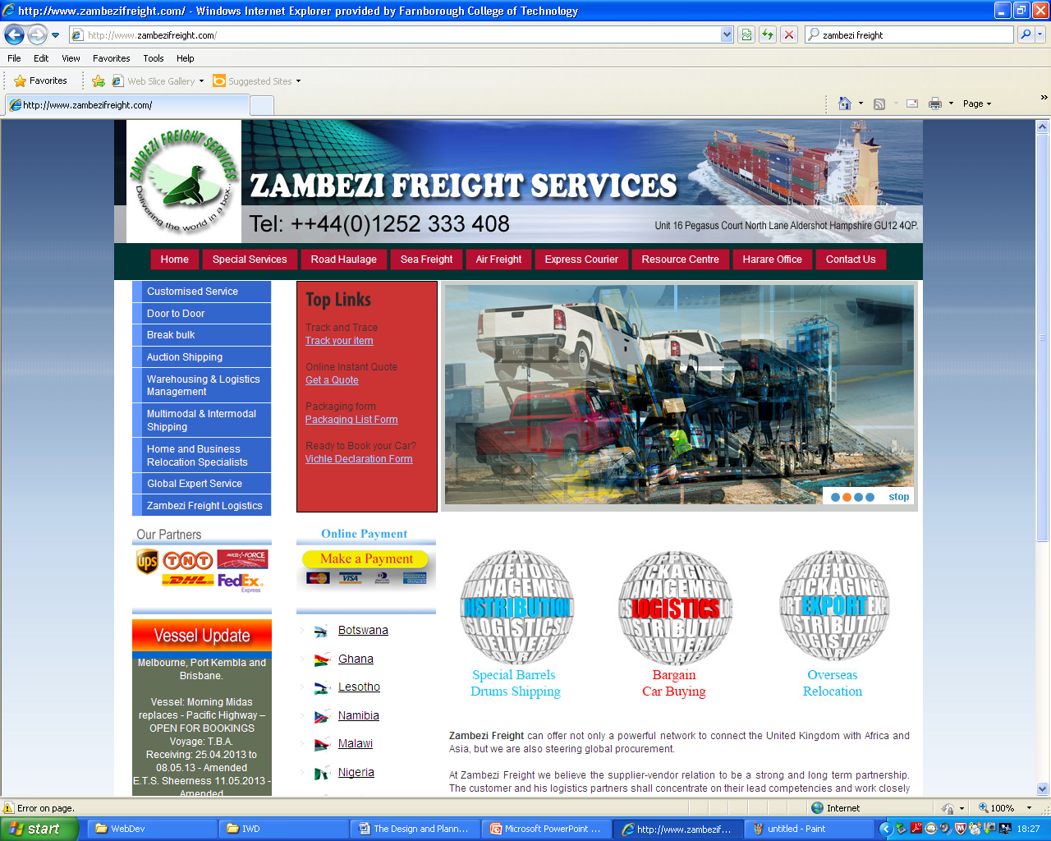

http://www.maerskline.com/appmanager/
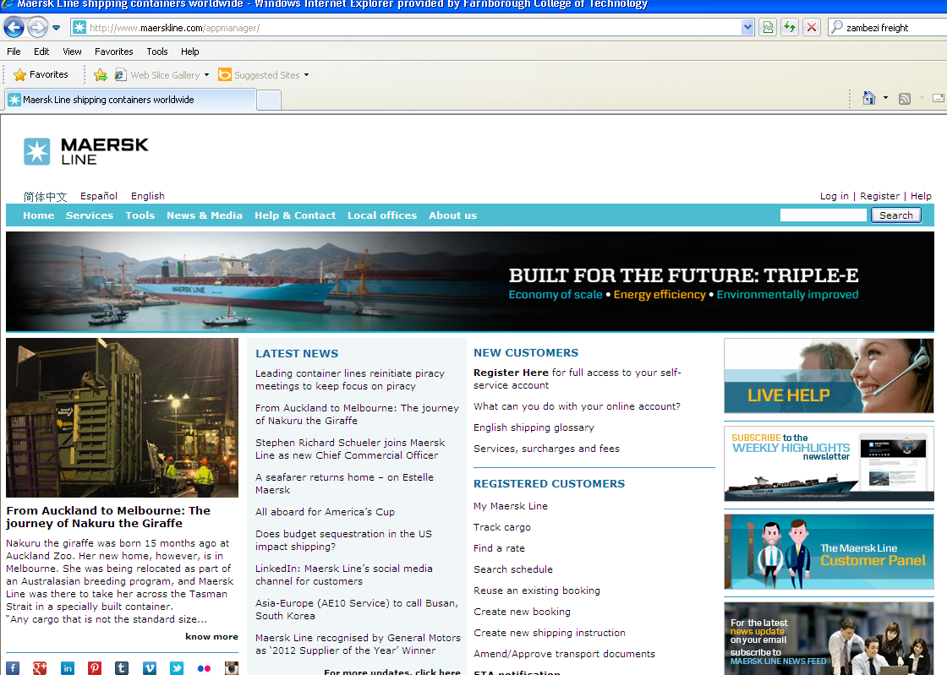
The above two website are shipping company to Africa and it matches with my choice topic to design the website.These two website are lookin similar in function in displaying the information although they not look alike but the link names and layout looks are alike.Both are are doing the same business of shipping goods to africa and other part of the world.The design of these website are simple and staright forward for those with colour blind.Both they use some same colors as white as main.These webiste has some features of interactive . Although there’s some difference between them ,one is specialing wil sea only as main shipping while other does both jobs.
My website design will differ from the design as the colour scheme will be more attractive and appealing. I think that the layout consistency between these two websites is efficient and I will design a similar layout to stay consistent throughout the website.

Computer Facilities Required
In order for customer to access the website they will need the pc, laptop and the connection of internet with aid of web browser such as Internet explorer.

Testing
Once the website is well built-up the testing will carried out to see if there’s any errors and to resolve and before goes live in air .Any testing error will be addressed and resolved immediately .The test plan for this website will be documented on excel/word like inputs and output including the changes of layout and browsers.

Security and Maintenance
Once the website has been built up and live on air it becomes vulnerable to hackers and viruses, to prevent to be hacked we need some measures to tackles these .Anti virus Software Virus will implemented by scanning regularly the website to prevent the penitential threat which make functionality of the website to be poor and slowly .To install the firewall to prevent the unwanted access activities to the website .As part of security we need the back incase it fail we can put back to normal before the customers as realized.
The bleach of security can occurs in any means example in contact form the customer can send an email to request any information about the service but we don’t know what are inside ,we suggest to use the firewall to the website server block the unwanted activities and to ensure the customer information are kept safe and able to opened. There many types of firewall to prevent an authorized activities via website e.g. Zone alarm etc.
The Maintenance of website must be checked regularly and documented in log book, to ensure the efficiency and safety of the website. Website information must be update and display current information which is accurate for customers. Example changes of prices and routing time table must be updated otherwise will annoy the customers.
Security Software must be update all the times because of threat on the internet, every single day we have a new threat and we have to protect to our maximum to avoid cyber attack.
Website Company must have the quality security software and well maintained, otherwise the customers will be scare to open to avoid their pc to be attacked by Virus.

Site Map
This is the site map of the website which detail how the pages in the website will be linked together.
Homepage.html
Eastern and Southern Africa Cargo

Events.html
Have information of horse shows etc in Berkshire
Contactus.html
Have their contact information and a option to send an email through the website
Prices.html
Contain their prices on lessons and stabling
Horses&ponies .html
Contain images and descriptions of current horses.
Aboutus.html
Have general information about the website.

External link
An external webpage with relevant information.

Story Board
This story board will contain the overall layout and design for every page included in the website.

Logo
Title
Title : font: Broadway : Size 36 BGcolour: Aqua 60%

.
Navigation Bar: font: Broadway size: 16 BGcolour: #66CCFF
Navigation Bar
Main information: where the relevant information about each page. The information would contain relevant images: Font: Calibri size: 14

Main Information

Logo design and Colour Scheme
In this section is a description of what colour scheme shall be used throughout the website design although it will not the all project during the development of website.
Although l am not keen of making logo but through it ,the customer will know which part of our business is covered,The logo itself it shows where our business is covered to Africa.

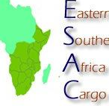

Heuristic Evaluation
Once the website has been completed and evaluated against of customers and users .The evaluation will be written in report form and it will show the exact bad and
Background/ colour scheme and layout
The colour scheme of the website will be calm and cool for attractive to the customers, this part id very crucial and it has to portray the professional looking for Eastern and Southern East Cargo (Esacargo) Ltd. Colour scheme is very important to the audience, no bright colours to confuse the customers while browsing. Colour must be user friendly and more attractive to view and browsing.
My layout is very simple to navigate from one page to another to entire website which makes more efficient for the user to use. My layout will be using three rules to click. The navigation bar will be to each page and back clear path to the main home page.

Fonts
The font l have chosen for heading is Roman Times to the entire website. The font must be clear and under stable including the consistence of design.All text must line up to look more professional .
Compatibility
The website has been tested and documented to work in other web browsers such as internet explorer.
Hyper Links /Navigation
The website contains some hyperlinks to some pages through all pages’ made some external link web page to link to other website as part of the assignment

Images/accessibility/copyright
To this part of the images, l have used Google image picture which l don’t have to ask for permission. Images choice is relevant and satisfactory to my needs of my website.

Conclusion
In this assignment I have efficiently designed and created a website to meet certain user requirements. I have also tested and evaluated the website to ensure that it is fit for purpose.

