Smith’s House
Project Progress Report

12/16/2012
ABC Construction Inc.
Project Manager

TABLE OF CONTENTS

introductioN 1
Major Project activities 1
ASSUMPTIONS 2
ORIGINAL PROJECT Network schedule 3
Project Responsibility Matrix 4
Project cost summary 5
COST ASSUMPTIONS 5
CHANGE REQUEST format 7
revised schedule analysis 7
REVISED PROJECT SCHEDULE 8
REVISED COST SUMMARY 9
SUMMARY 10
REFERENCES 11

introductioN
Mr Smith wants to build a 2-storey framed house and so he has appointed ABC construction Inc. for construction of the house. Mr Smith has got the blue prints ready through XYZ architects and has issued the letter of intent to ABC Inc. with a project deadline of 14 weeks. The contract clauses include penalty for delays and bonus for early completion. The material procurement is excluded from the scope of ABC Inc. and it’s a free issue material through a local vendor fixed by Mr Smith. The project has progressed into its 6 week and activity 9 is under progress. Mr Smith now wants to change the original configuration of the house by adding a wing to it. A formal change request has been raised and this report analyses the effect of the change on the schedule and cost of the project. A copy of the change request form is also attached.
The main stake holders in this project are:
- Mr Smith as investors and owner.
- XYZ architects as consultants.
- Material supplier
- ABC Construction Inc. as project construction contractors.
- Civic authorities involved in approving the project.

Major Project activities

Activity No | Activity description | Duration  (days) | Effort Staff days | Predecessor | Remark
1 | Get a building permit. | 5 | 1
2 | Clear the site. | 5 | 20 | 1
3 | Dig the foundation and footings. | 3 | 9 | 2
4 | Install forms. | 3 | 9 | 3
5 | Pour concrete. | 1 | 5 | 4
6 | Wait for the concrete to harden. | 5 | 0 | 5 | Not an activity
7 | Remove forms. | 1 | 3 | 6
8 | Back-fill and compact | 2 | 2 | 7
9 | Build the floor. | 1 | 5 | 8
10 | Frame the first floor. | 2 | 10 | 9
11 | Build the second floor. | 2 | 10 | 10
12 | Frame the second floor. | 3 | 15 | 11
13 | Sheath the house. | 3 | 12 | 12
14 | Install windows and doors. | 4 | 8 | 13
15 | Install siding. | 2 | 6 | 14
16 | Put up roof framing. | 2 | 8 | 12
17 | Shingle the roof. | 1 | 4 | 16
18 | Install plumbing. | 4 | 8 | 17
19 | Inspect the plumbing. | 1 | 0 | 18
20 | Install wiring. | 6 | 12 | 17
21 | Inspect the wiring. | 1 | 0 | 20
22 | Hang and finish sheetrock. | 4 | 12 | 18, 21
23 | Paint the interior. | 3 | 9 | 22
24 | Install the hardwood flooring. | 3 | 6 | 23 | Before carpet
25 | Lay the carpet. | 2 | 6 | 24 | After flooring
26 | Install trim. | 3 | 6 | 24 | After paint
27 | Procure the certificate of occupancy. | 5 | 0 | 25,26 | Final activity

ASSUMPTIONS
- Materials along with transportation are excluded from scope of ABC Inc.
- All debris and construction waste shall be collected at one corner of the plot. The disposal of the same is excluded from the scope.
- Project start Date is 12th July 2012.
- Back-fill and compaction has been considered as an activity after removal of form work.
- Lay of carpet has been considered after installation of hardwood flooring.
- Saturday and Sunday are weekly holidays.

ORIGINAL PROJECT Network schedule
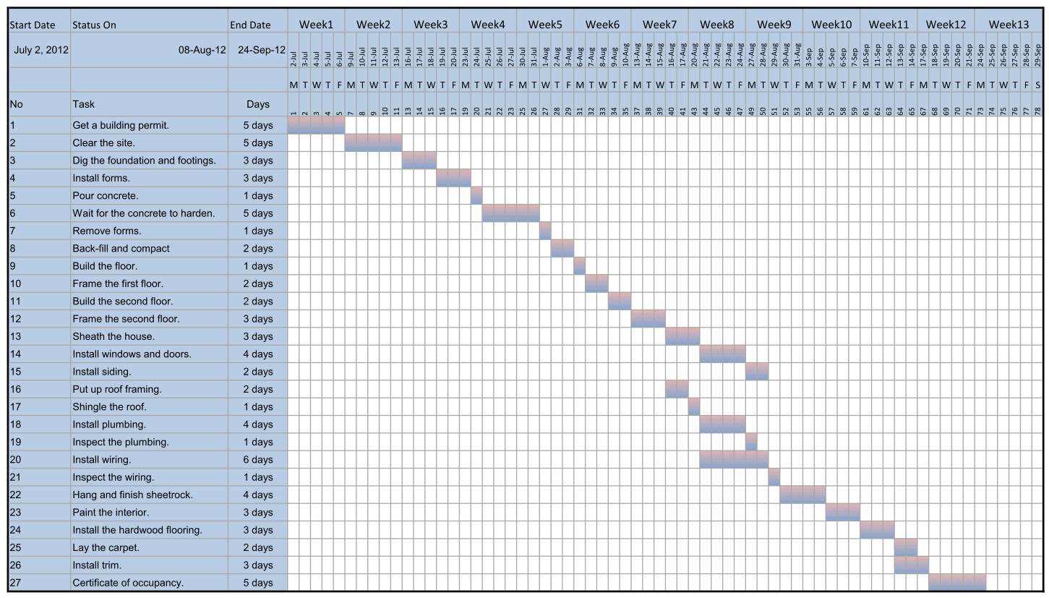

Project Responsibility Matrix

Resources |  | General contractor | Heavy-equipment operator | Concrete worker | Framer | Siding installer | Window/door installer | Roofer | Painter | Electrician | Flooring installer | Trim carpenter | Plumber
No | Task
1 | Get a building permit. | 1
2 | Clear the site. |  | 1
3 | Dig the foundation and footings. |  | 1
4 | Install forms. |  |  | 1
5 | Pour concrete. |  |  | 1
6 | Wait for the concrete to harden.
7 | Remove forms. |  |  | 1
8 | Back-fill and compact |  | 1
9 | Build the floor. |  |  | 1
10 | Frame the first floor. |  |  |  | 1
11 | Build the second floor. |  |  | 1
12 | Frame the second floor. |  |  |  | 1
13 | Sheath the house. |  |  |  |  | 1
14 | Install windows and doors. |  |  |  |  |  | 1
15 | Install siding. |  |  |  |  | 1
16 | Put up roof framing. |  |  |  |  |  |  | 1
17 | Shingle the roof. |  |  |  |  |  |  | 1
18 | Install plumbing. |  |  |  |  |  |  |  |  |  |  |  | 1
19 | Inspect the plumbing. |  |  |  |  |  |  |  |  |  |  |  | 1
20 | Install wiring. |  |  |  |  |  |  |  |  | 1
21 | Inspect the wiring. |  |  |  |  |  |  |  |  | 1
22 | Hang and finish sheetrock. |  |  |  |  | 1
23 | Paint the interior. |  |  |  |  |  |  |  | 1
24 | Install the hardwood flooring. |  |  |  |  |  |  |  |  |  | 1
25 | Lay the carpet. |  |  |  |  |  |  |  |  |  | 1
26 | Install trim. |  |  |  |  |  |  |  |  |  |  | 1
27 | Procure the certificate of occupancy. | 1
1: Actual responsibility

Project cost summary
Rate Table:
Resource | Hourly Rate $/hour
General contractor | 40.00
Heavy-equipment operator | 50.00
Concrete worker | 30.00
Framer | 20.00
Siding installer | 20.00
Window/door installer | 30.00
Roofer | 20.00
Painter | 20.00
Electrician | 35.00
Flooring installer | 20.00
Trim carpenter | 35.00
Plumber | 35.00

COST ASSUMPTIONS
- Rates as per table above
- All resources with Actual responsibility are assigned 100 % loading.
- All cost is based on 9-hours per day basis.
- All over-heads and direct cost are assumed to be taken care in Man-hour rate.
- Man-hour rate includes contractors profit also.
- Inspection days are reduced to single days for both wings.
 |  | Effort (staff days) | General contractor | Heavy-equipment operator | Concrete worker | Framer | Siding installer | Window/door installer | Roofer | Painter | Electrician | Flooring installer | Trim carpenter | Plumber
No | Task |  | Man-hours
1 | Get a building permit. | 1 | 9
2 | Clear the site. | 20 |  | 180
3 | Dig the foundation and footings. | 9 |  | 81
4 | Install forms. | 9 |  |  | 81
5 | Pour concrete. | 5 |  |  | 45
7 | Remove forms. | 3 |  |  | 27
8 | Back-fill and compact | 2 |  | 18
9 | Build the floor. | 5 |  |  | 45
10 | Frame the first floor. | 10 |  |  |  | 90
11 | Build the second floor. | 10 |  |  | 90
12 | Frame the second floor. | 15 |  |  |  | 135
13 | Sheath the house. | 12 |  |  |  |  | 108
14 | Install windows and doors. | 8 |  |  |  |  |  | 72
15 | Install siding. | 6 |  |  |  |  | 54
16 | Put up roof framing. | 8 |  |  |  |  |  |  | 72
17 | Shingle the roof. | 4 |  |  |  |  |  |  | 36
18 | Install plumbing. | 8 |  |  |  |  |  |  |  |  |  |  |  | 72
20 | Install wiring. | 12 |  |  |  |  |  |  |  |  | 108
22 | Hang and finish sheetrock. | 12 |  |  |  |  | 108
23 | Paint the interior. | 9 |  |  |  |  |  |  |  | 81
24 | Install the hardwood flooring. | 6 |  |  |  |  |  |  |  |  |  | 54
25 | Lay the carpet. | 6 |  |  |  |  |  |  |  |  |  | 54
26 | Install trim. | 6 |  |  |  |  |  |  |  |  |  |  | 54
 | Total Man-hours |  | 9 | 279 | 288 | 225 | 270 | 72 | 108 | 81 | 108 | 108 | 54 | 72
 | MH Rate |  | 40 | 50 | 30 | 20 | 20 | 30 | 20 | 20 | 35 | 20 | 35 | 35
 | Total cost |  | $ 49140.0

CHANGE REQUEST format

Change Request - GENERAL INFORMATION
CR | CR001
Type of CR | Enhancement | Defect
Project/Program/Initiative
Submitter Name | Mr. Smith
Brief Description of Request | Addition of another wing with the existing under-construction framed structure.
Date Submitted | [08/10/2012]
Date Required | [08/16/2012]
Priority | Low | Medium | High |  | Mandatory
Reason for Change | Owners Preference
Other Artifacts Impacted | All works after sheathing i.e. activity 13
Assumptions and Notes | All change in schedule and cost are accountable to the Owner.
Comments | 6- Weeks of delay.
Attachments or References | Yes | No
 | Link: Blue prints of new house
Approval Signature | ABC. Inc. |  | Date Signed | 08/10/2012

revised schedule analysis
The change request has been submitted on 10th August 2012 and after approval from Change Board the work for the new wing will commence on 20th August 2012. The activity of the original building will continue till sheathing and stop till the new-wing sheathing is completed. From week 8-12 there will be no work in the original building. The work for installing doors and windows along with other activities will commence after week 13 and end by week 20. A total delay of 6-weeks is expected.

REVISED PROJECT SCHEDULE

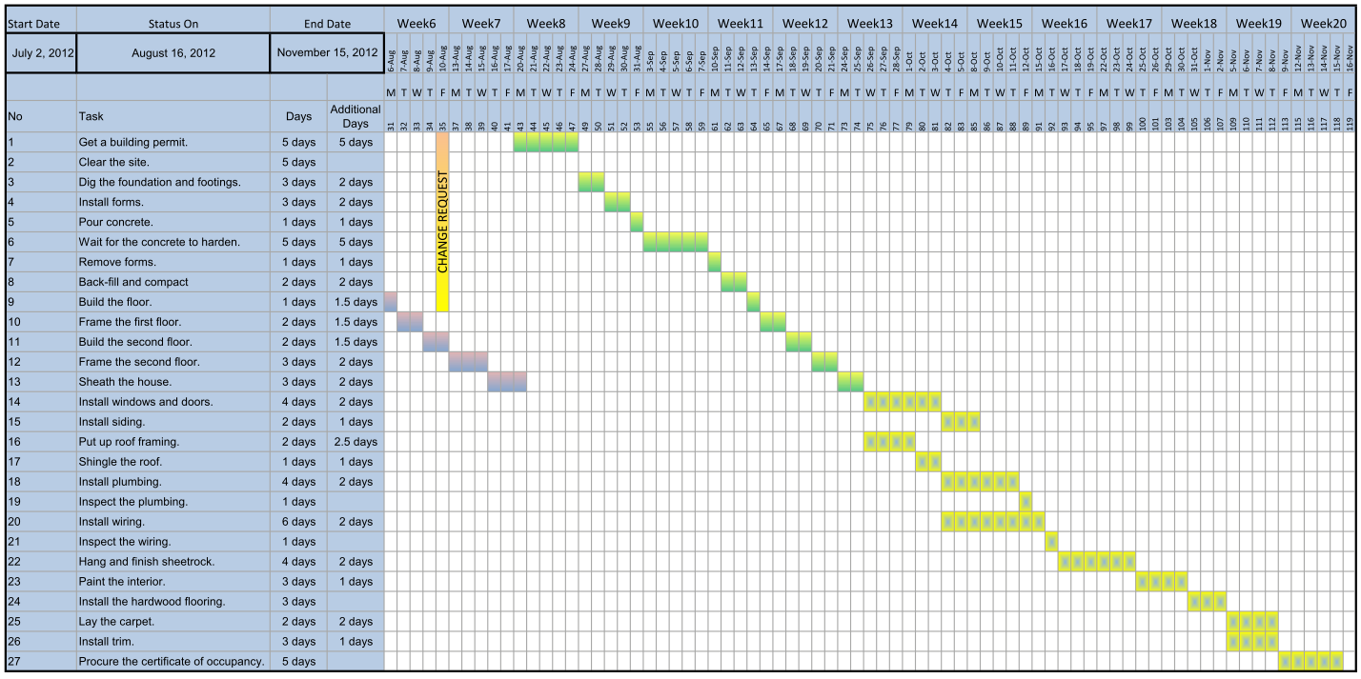

REVISED COST SUMMARY

 |  | Effort (staff days) | General contractor | Heavy-equipment operator | Concrete worker | Framer | Siding installer | Window/door installer | Roofer | Painter | Electrician | Flooring installer | Trim carpenter | Plumber
No | Task |  | Man-hours
1 | Get a building permit. | 2 | 18
2 | Clear the site. | 20 |  | 180
3 | Dig the foundation and footings | 15 |  | 135
4 | Install forms. | 15 |  |  | 135
5 | Pour concrete. | 8 |  |  | 72
7 | Remove forms. | 5 |  |  | 45
8 | Back-fill and compact | 4 |  | 36
9 | Build the floor. | 9 |  |  | 81
10 | Frame the first floor. | 14 |  |  |  | 126
11 | Build the second floor. | 14 |  |  | 126
12 | Frame the second floor. | 23 |  |  |  | 207
13 | Sheath the house. | 18 |  |  |  |  | 162
14 | Install windows and doors. | 12 |  |  |  |  |  | 108
15 | Install siding. | 9 |  |  |  |  | 81
16 | Put up roof framing. | 14 |  |  |  |  |  |  | 126
17 | Shingle the roof. | 7 |  |  |  |  |  |  | 63
18 | Install plumbing. | 12 |  |  |  |  |  |  |  |  |  |  |  | 108
20 | Install wiring. | 16 |  |  |  |  |  |  |  |  | 144
22 | Hang and finish sheetrock. | 18 |  |  |  |  | 162
23 | Paint the interior. | 12 |  |  |  |  |  |  |  | 108
24 | Install the hardwood flooring. | 9 |  |  |  |  |  |  |  |  |  | 54
25 | Lay the carpet. | 6 |  |  |  |  |  |  |  |  |  | 54
26 | Install trim. | 9 |  |  |  |  |  |  |  |  |  |  | 81
 | Total Man-hours |  | 18 | 351 | 459 | 333 | 405 | 108 | 189 | 108 | 144 | 108 | 81 | 108
 | MH Rate |  | 40 | 50 | 30 | 20 | 20 | 30 | 20 | 20 | 35 | 20 | 35 | 35
 | Total cost |  | $ 69795.0

SUMMARY
Original Project End Date: 24th sept 2012
Original Project Cost: $49140.0
Revised Project End Date: 15th Nov 2012
Revised Project Cost: $69795.0

REFERENCES
Meredith, Jack and Mantel, Samuel (2008) Project Management: A Managerial Approach, London: John Wiley & sons
Leach, Lawrence (2000) Critical Chain Project Management, Norwood: Artech House, Inc.

