Budgets for ZMG Hospitalist Practice
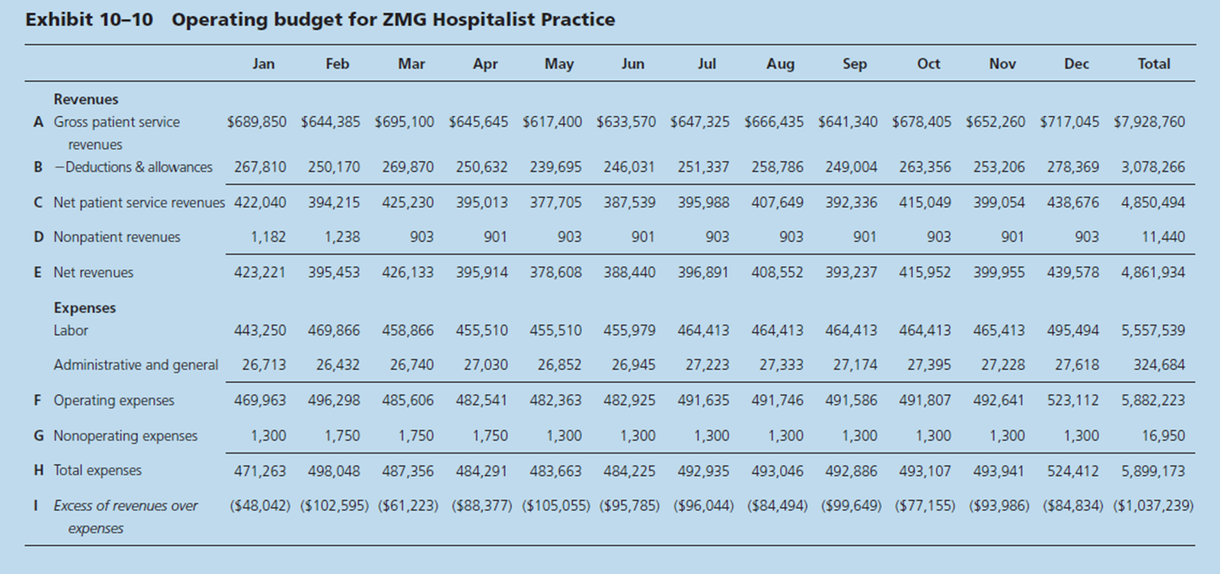
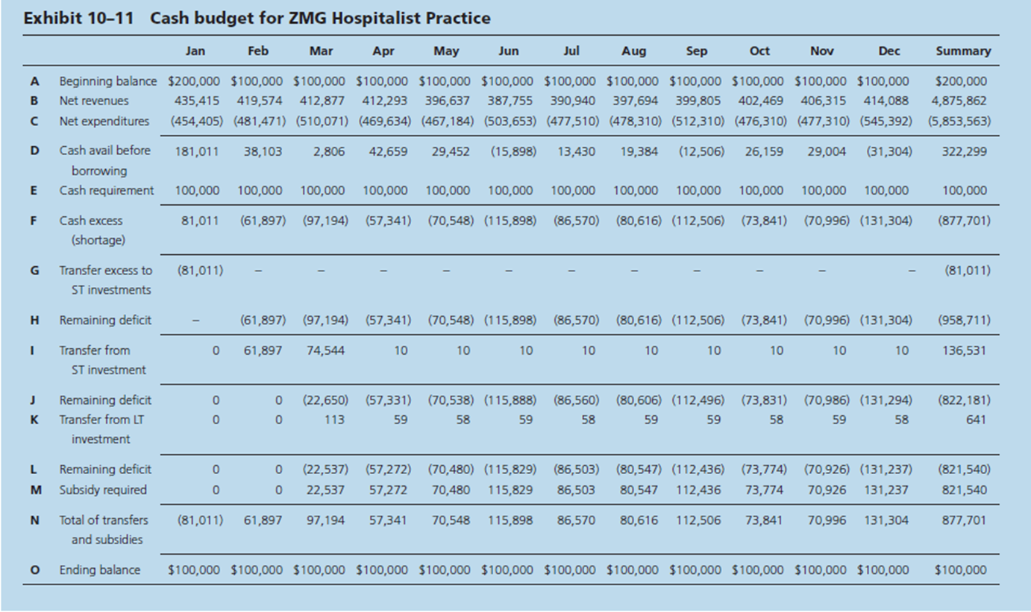
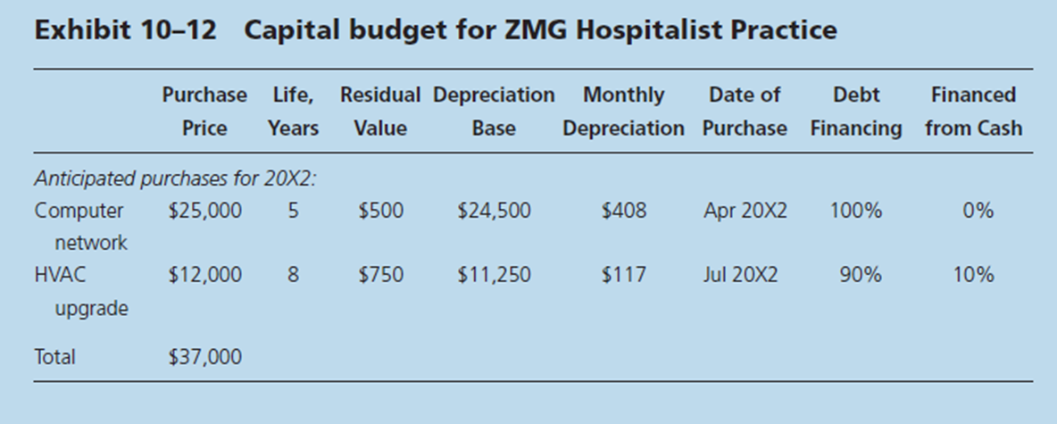
Reference
Zelman, W. N., McCue, M. J., & Glick, N. D. (2009). Financial management of health care organizations. San Francisco, CA: Jossey-Bass.

