QUESTIONS 1 AND 2 ARE BASED ON THE FOLLOWING INFORMATION:

Suppose that 800 students in Michigan State University are taking elementary statistics this semester. Two samples of size 50 are needed in order to test some pre-course skill against the same skill after the students complete the course.

1. Describe how you would obtain your samples if you were to use dependent samples.
2. Describe how you would obtain your samples if you were to use independent samples.
3. Explain why studies involving identical twins result in dependent samples of data.
4. Describe how one could select two independent samples from among his/her co-workers to compare the salaries of female and male workers.

5. Twenty people were selected to participate in a psychology experiment. They answered a short multiple-choice quiz about their attitudes on abortion and then viewed a 50-minute film. The following day the same 20 people were asked to answer a follow-up questionnaire about their attitudes. At the completion of the experiment, the experimenter will have two sets of scores. Do these two samples represent dependent or independent samples? Explain.

6. A study of the purchase decisions of three stock portfolio managers, A, B, C, was conducted to compare the numbers of stock purchases that resulted in profits over a time period less than or equal to 1 year. One hundred randomly selected purchases were examined for each of the managers. Do the data provide evidence of differences among the rates of successful purchases for the three managers?
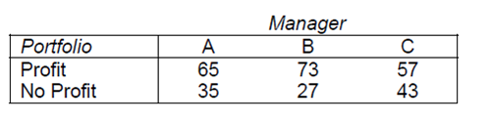

QUESTIONS 7 THROUGH 11 ARE BASED ON THE FOLLOWING INFORMATION:
In a one-factor ANOVA, assume there are “t” levels of the factor being tested, and the total number of observations is “N”.

7. What are the degrees of freedom for SS(error)?
8. What are the degrees of freedom for SS(factor)?
9. What are the degrees of freedom for SS(Total)?
10. The F-value is a ratio of two variance estimates. What variance is used as a denominator of the ratio?
11. The F-value is a ratio of two variance estimates. What variance is used as a numerator of the ratio?

QUESTIONS 12 AND 13 ARE BASED ON THE FOLLOWING INFORMATION:
The scores (x) on a computer science aptitude test range from 0 to 25, and the course grade (y) with possible values: 0.0, 1.0, 1.5, 2.0, 2.5, 3.0, 3.5, 4.0, were recorded for 20 students in an introductory computer science course as shown below.
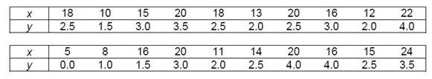
12. Find the coefficient of linear correlation for this data.
13. Give the p-value if this data is used to test H o: ρ = 0(≤) vs. Ha: ρ > 0 at α = 0.1.
What is your decision?

QUESTIONS 14 THROUGH16 ARE BASED ON THE FOLLOWING INFORMATION: Consider the following bivariate data.
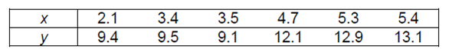
14. Find the critical value of r.
15. Find the calculated value of r; namely r* .
16. State the decision.
QUESTIONS 17 THROUGH 25 ARE BASED ON THE FOLLOWING INFORMATION:
The average number of client contacts per month, x, and the sales volume, y (in $1000), were recorded of each of 10 salespeople.
17. Draw a scatter diagram of the data
18. Does the scatter diagram suggest a linear relationship between x and y?
QUESTIONS 19 THROUGH 26 ARE BASED ON THE FOLLOWING INFORMATION:
The price (in $) and the carat weight of a diamond are its two most known characteristics. In order to understand the role carat weight has in determining the price of a diamond, the carat weight and price of 20 loose round diamonds, all of color D and clarity VS1, were obtained recently as shown below.
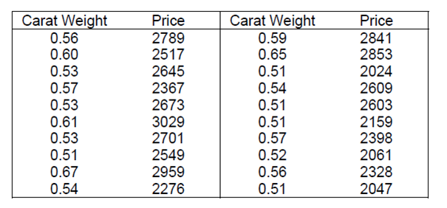
19. Draw a scatter diagram of the data: carat weight (x) and price (y).
20. Does the data suggest a linear relationship for the domain 0.50 to 0.66 carats?? Discuss your findings in question 205.
21. Diamonds smaller than 0.50 carats and diamonds larger than 0.66 carats may not fit the linear pattern demonstrated by this data. Explain.
22. Use computer to find the equation for the line of best fit.
23. According to the results obtained in question 208, what would be a typical price for a 0.50 carat loose diamond of this quality?
24. On the average, by how much does the price increase for each extra 0.01 carat in weight? Within what interval of x-values would you expect this to be true?
25. Use computer to find the variance of y about the regression line.
26. Graph and display the line of best fit on the scatter diagram. What characteristics in the scatter diagram support the large value obtained in question 211?

QUESTIONS 27 THROUGH 30 ARE BASED ON THE FOLLOWING INFORMATION:
The following data were collected on 12 business students who graduated from an MBA program, where U = Undergraduate GPA, and G = Graduate GPA at Graduation.
27. Rank the undergraduate GPA and the graduate GPA for the 12 students, and present your results in a table.
28. Compute the Spearman rank order correlation coefficient for the two sets of rankings.

29. State the appropriate null and alternative hypotheses in testing that a positive correlation exists between undergraduate GPA and GPA at graduation from a graduate business program.

30. Test the hypotheses in question 273 at the 0.05 level of significance using the p-value approach.

