1. Text reading
Chapter 1, Chapter 2, Chapter 3, Chapter 4, Chapter 5
“Security Controls for Computer Systems: Report of Defense Science Board Task Force on Computer Security” (accessed via the URL provided below)
2. Textbook questions
http://www.coursesmart.com/
tb1144@nova.edu
sct2bell
Chapter 1
Problems: 1.4
1.4 For each of the following assets, assign a low, moderate, or high impact level for the loss of confidentiality, availability, and integrity, respectively. Justify your answers.
a. An organization managing public information on its Web server.
b. A law enforcement organization managing extremely sensitive investigative information.
c. A financial organization managing routine administrative information ( not priva-cy- related information).
d. An information system used for large acquisitions in a contracting organization contains both sensitive, pre- solicitation phase contract information and routine administrative information. Assess the impact for the two data sets separately and the information system as a whole.
e. A power plant contains a SCADA ( supervisory control and data acquisition) system controlling the distribution of electric power for a large military installa-tion. The SCADA system contains both real- time sensor data and routine admin-istrative information. Assess the impact for the two data sets separately and the information system as a whole.

Chapter 2
Review questions: 2.6 (note: the question should refer to Figure 2.6, instead of Figure 2.4 shown in the question.)
Problems:
2.3 (note: there are some errors in the question. Question part a) should read “…as a function of C, K1 and K0… ”. Hint: You may need to define another operator “additive inverse” for the operations.)

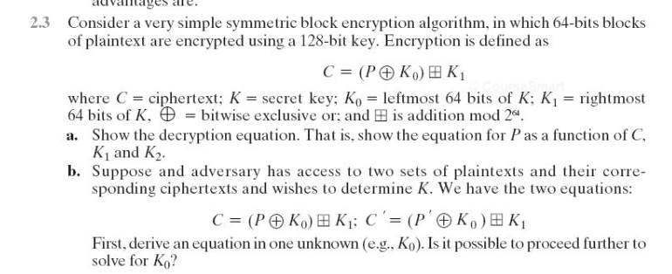
2.6

Chapter 3
Review questions: 3.4, 3.9
Problems: 3.3, 3.5, 3.6
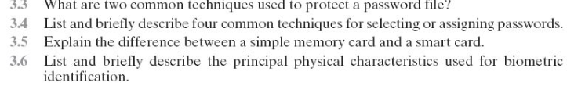

Chapter 4
Review questions: 4.1
Problems: 4.1
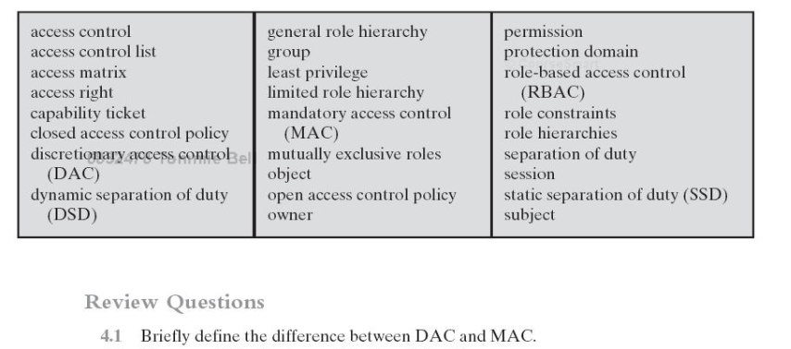

Chapter 5
Review questions: 5.8
Problems: 5.5

3. Article summary: (40 points)
Please read the article “Security Controls for Computer Systems” at the following URL.
http://www.rand.org/pubs/reports/R609-1/index2.html

1. Write a 1-2 page report (single-spaced, not counting quotations used) according to the following requirements.
 Pick up one specific technical issue related to authentication from the Rand report.
 Justify your choice – why is this an authentication issue?
 Answer – does the technical issue you choose still exist in today’s computer systems? Why or why not? Elaborate your answer.

I would appreciate your critical thoughts on these questions. Referring to materials beyond the report and the textbook is highly recommended. If you choose to do so, please include a list of references, and use the APA format for citations and references where appropriate. I would appreciate your critical thoughts on these issues.

2. Repeat the same process shown in #1 with a technical issue on access control from the Rand report. All requirements are the same except for the topic you choose for discussion

