Please write step by step solutions.
Not just the answers only.
Question 1
A toroid of mean radius 24 cm and circular cross section of radius 2.5 cm is wound with a superconducting wire of length 1000 m that carries a current of 360 A.
(a) What is the number of turns on the coil?
(b) What is the magnetic field at the mean radius?
T
(c) Assuming that B is constant over the area of the coil, calculate the magnetic energy density u_{m} and the total energy U_{m} stored in the toroid.
u_{m} =
J/m³
U_{m} =
kJ

Question 2
Three resistors (R₁ = 120 Ohms, R₂ = 330 Ohms, and R₃ = 240 Ohms) and an ideal inductor (L = 1.6 mH) are connected to a battery (V = 9 V) through a switch as shown in the figure below.
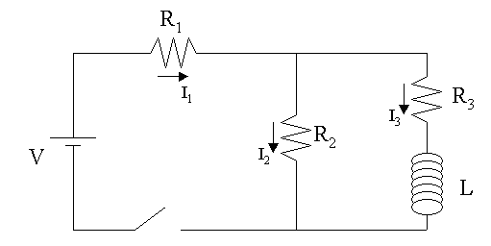
The switch has been open for a long time before it is closed at t = 0. At what
time t₀, does the current through the inductor (I₃) reach a value that is 63% of
its maximum value?
t₀ = s
Question 3
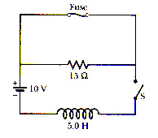
Figure 31-93
In Fig. 31-93, the component in the upper branch is an ideal 2.8 A fuse. It has zero resistance as long as the current through it remains less than 2.8 A. If the current reaches 2.8 A it 'blows' and thereafter has infinite resistance. Switch S is closed at time t = 0 . Use the numerical values : E=14 V, L=5.1 H.
When does the fuse blow ?
s
Question 4
If the current through an inductor were doubled, the energy stored in the inductor would be
- quadrupled.
- quartered.
- doubled.
- the same.
- halved.
Question 5
The current in a coil with a self-inductance of 1 mH is 2.3 A at t = 0, when the coil is shorted through a resistor. The total resistance of the coil plus the resistor is 15.0 .
(a) Find the current after 0.5 ms.
A
(b) Find the current after 10 ms.
A
Question 6
The current in an RL circuit is zero at time t = 0 and increases to half its final value in 3.8 s.
(a) What is the time constant of this circuit?
s
(b) If the total resistance is 8 , what is the self-inductance?
H
Question 7
A solenoid of 1900 turns, area 11 cm², and length 30 cm carries a current of 4.0 A.
(a) Calculate the magnetic energy stored in the solenoid from 1/2 LI ².
J
(b) Divide your answer in part (a) by the volume of the solenoid to find the magnetic energy per unit volume in the solenoid.
J/m³
(c) Find B in the solenoid.
T
(d) Compute the magnetic energy density from u_{m} = B²/2₀.
J/m³
Compare your answer with your result for part (b).
- smaller than (b)
- same as (b)
- greater than (b)
Question 8
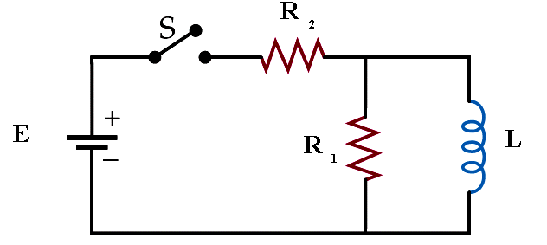
Given the circuit shown in the figure, assume that the switch S has been closed for a long time so that steady currents exist in the inductor, and that the inductor has negligible resistance. Assume L=3 H, the larger resistance R₁=99 , the smaller resistance R₂=15 and the emf =10 V.
Find the battery current.
A
The current in the larger resistor
A
The current in the inductor.
A

