Working with Health IT Systems: HIT and Aspects of Patient-Centered Care
Application Activity

In this activity for unit 10, HIT and Aspects of Patient-Centered Care Application Activity with Key, students will complete a hands-on activity with an example of HIT in support of patient-centric care from the VA. Instructors may choose other publicly available examples of this type of HIT-enablement for patient-centered approaches to health such as Microsoft HealthVault, MyPHR, etc. if desired. This activity however is crafted specifically for MyHealthe-Vet, and will illustrate the function of a feature launched in the fall of 2010 called “The Blue Button.” Blue Button is a joint activity between the VA and the Center for Medicare and Medicaid Services (CMS) to allow participants to not only create an online personal health record (PHR), but to download it for transport to other care providers.
Video Orientation

You will watch the entire “My Healthe-Vet” Orientation Video that is located at:

https://www.myhealth.va.gov/mhv-portal-web/ShowDoc/BEA%20Repository/multimedia/mhv_tour/tour.html

A full transcript of the video can be found at (you may need to cut and paste the link):

https://www.myhealth.va.gov/mhv-portal-web/ShowDoc/BEA%20Repository/multimedia/MHVVirtualTour_transcript.doc
Hands-on Assignment
In this assignment, you will interact with My Healthe-Vet after setting up an account to illustrate functionality. You should approach this activity from the perspective of a patient or a patient’s caregiver (i.e. a parent of a sick child, or the child of a sick parent). Building upon material covered to date in component 7 – you will learn to use the system, make a few minor entries/changes to the demo account, use the “Blue Button” feature to export their PHR (the demo PHR with modifications) and critique is usefulness and usability – from a patient perspective. **NOTE: students should not enter ANY personal information when creating an account.

Here is a sample walkthrough of how to create a mock account with My Healthe-Vet.

- After going to the my Healthe-Vet Web site, select the option to register as a new user, as shown in the picture below.
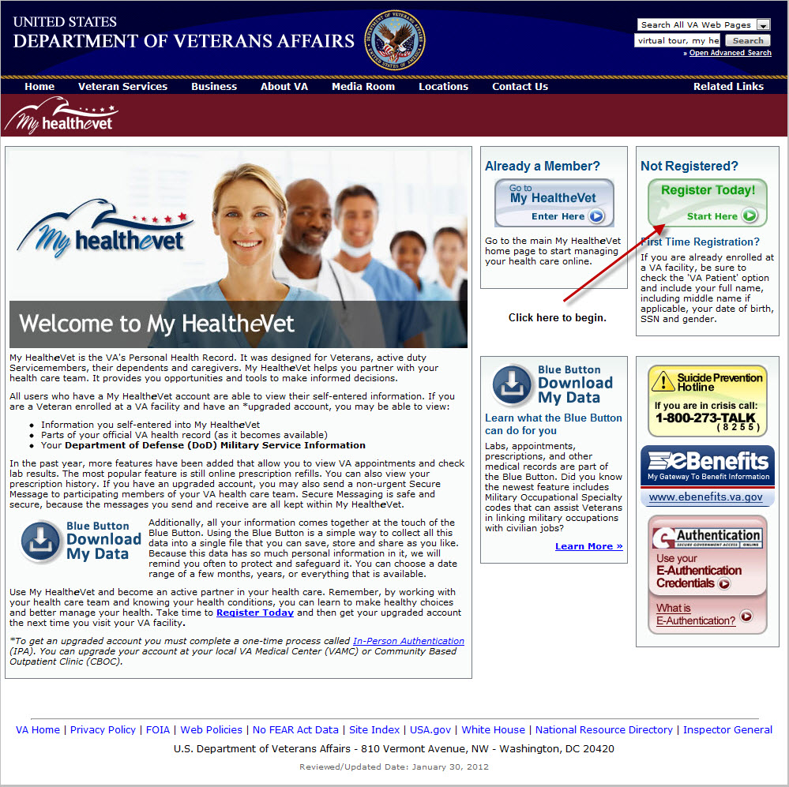

- Once you have clicked on the option to register today a new window should open. You’ll be asked to give a variety of information to the government Web site in order to establish an account. If you do not wish to create an account you may give fake or, “dummy,” information. Note that you only need to fill in information where you see a *.
- First provide identification information. You can either provide personal information or make up information. Choose either option based on your comfort level.
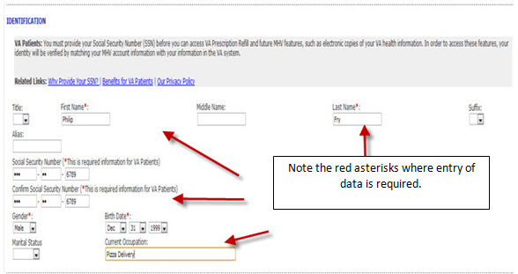
- Now identify what type of user you’ll be of the Web site. In this instance, select other.
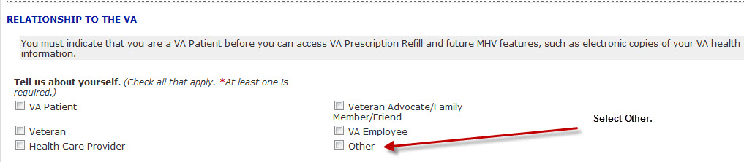

- Now provide the web site information on your residence. If you are uncomfortable providing personal information, you can provide fake information as well.
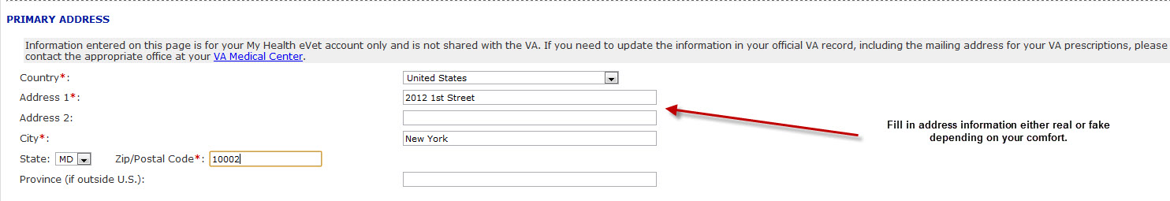
- Now the website will need a means to contact you. Either provide a real or fake phone number or email address.
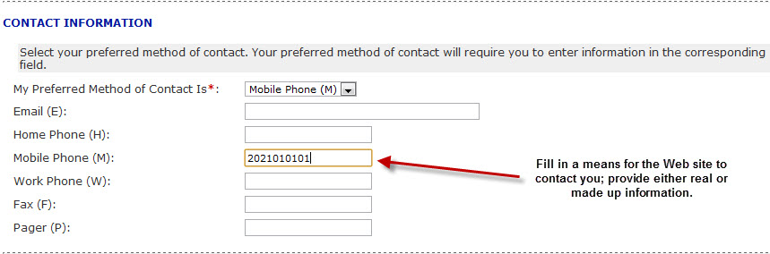
- We’re approaching the end of the 1st time registration process. Now you’ll need to create a login ID and password for the Web site. Make sure you read and understand the requirements for the password and user ID as described on the Web page.
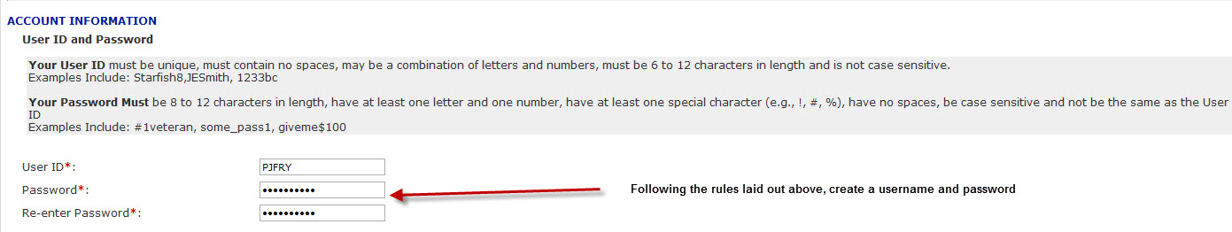

- Now select two questions from the pull down menu and answer them. The questions and your answers will assist you in retrieving your login information should you forget them.
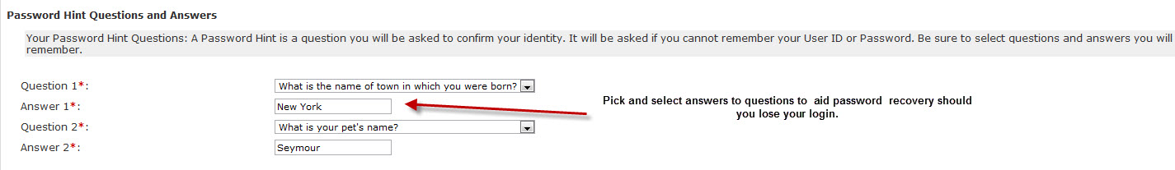
- Finally, you’re asked to read and accept the Terms and Conditions as well as the Privacy Policy in order to use the Web site.
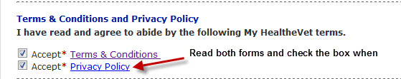

- Following the observation of the video and creating an account, you will explore each of the tabs on the toolbars and each of the “quick links” pictured in the image below.

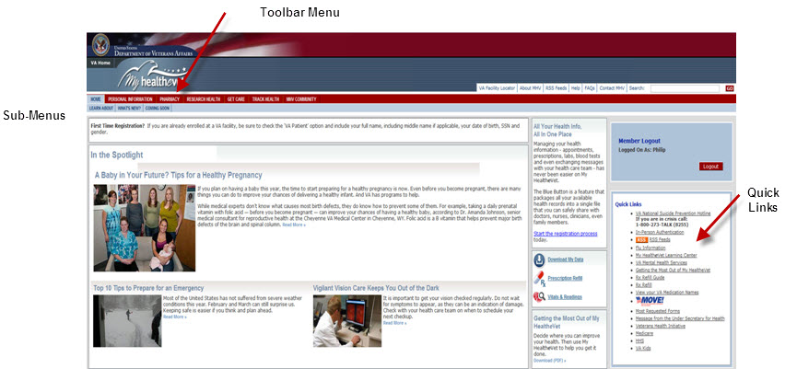

- Put yourself into the shoes of a patient and click into each of the menu items in the TOOLBAR (Personal Information; Pharmacy; Research Health; Get Care; & Track Health) and review the sub-menus.
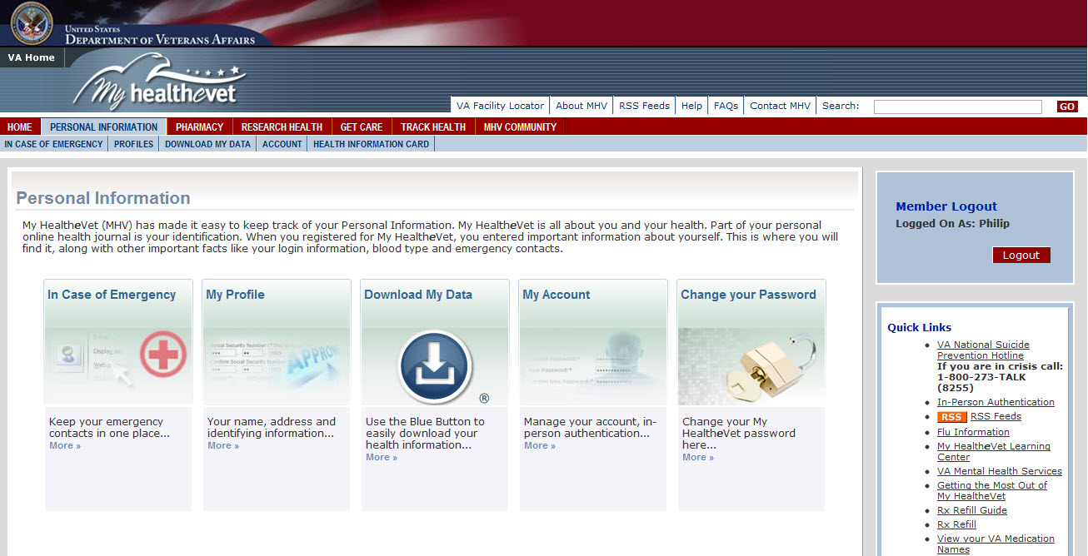

- For menu item “PERSONAL INFORMATION” add a web link to a health-related site (such as smoking cessation from the American Cancer Society or recipes for diabetics, etc.)

- In the menu items of Pharmacy; Research Health; Get Care; & Track Health – choose from any of the sub-menus that allow data input – and enter at least one new piece of data in each menu item from the toolbar. All actions should be from the perspective of a patient.
  - For example, under the menu item of PHARMACY, only the icon for My Medications and Supplements allows for data entry. Add at least one new medication of any type.
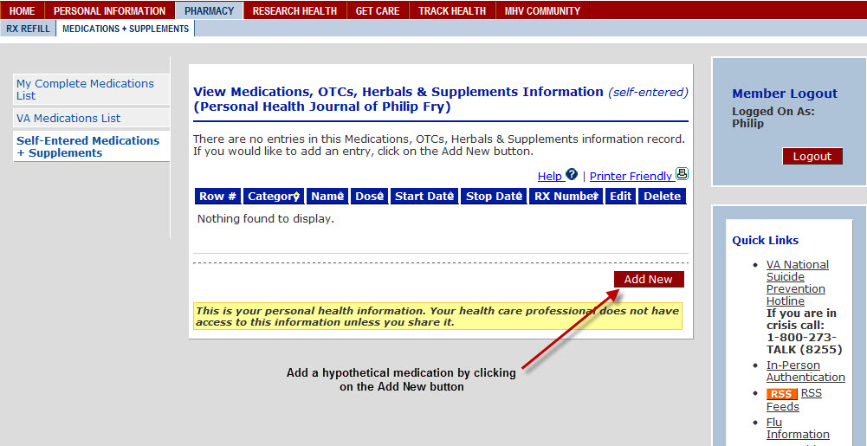
  - Under the menu item of TRACK HEALTH – all 4 icons/sub-menus allow data entry. Choose only one of the icons and make at least one data entry.
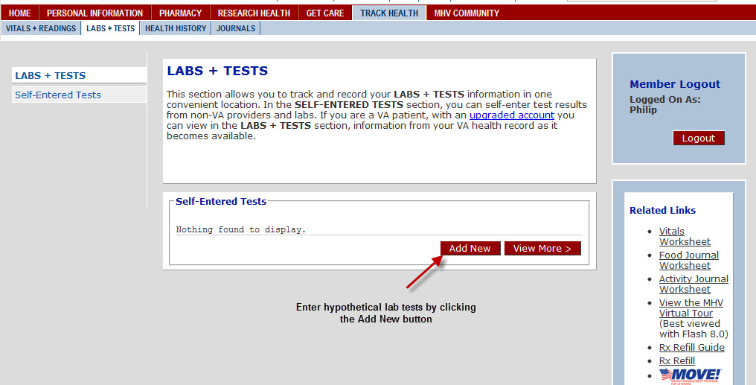
  - Continue until all menu items (skipping, “MHV COMMUNITY,”) have at least one, “new,” data element added.

WHAT TO HAND IN:
The two deliverables for this assignment are: 1) a print out (or a digital file) that reflects the PHR output after making the modifications detailed above AND 2) a print out (or digital file) of the patient’s “HEALTH INFORMATION CARD”
- Return to HOME in My Healthe-Vet toolbar. Chose “DOWNLOAD MY DATA”.
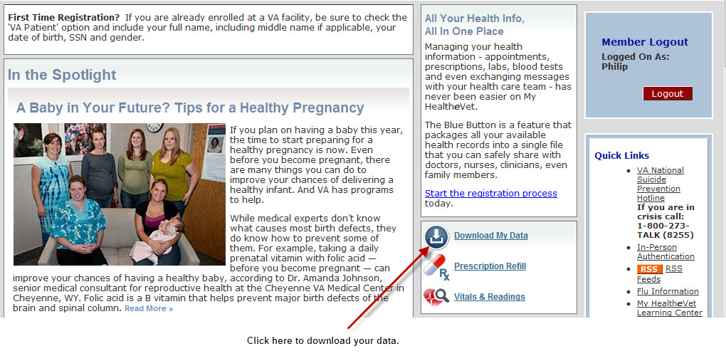
- Choose “VIEW/PRINT” to review and verify that your entered data appears. If so, do NOT print (could be very long). Return to the “DOWNLOAD” option (instead of view/print). If your entered data does not appear, you should return to the entry process and validate and/or re-enter it prior to submission.
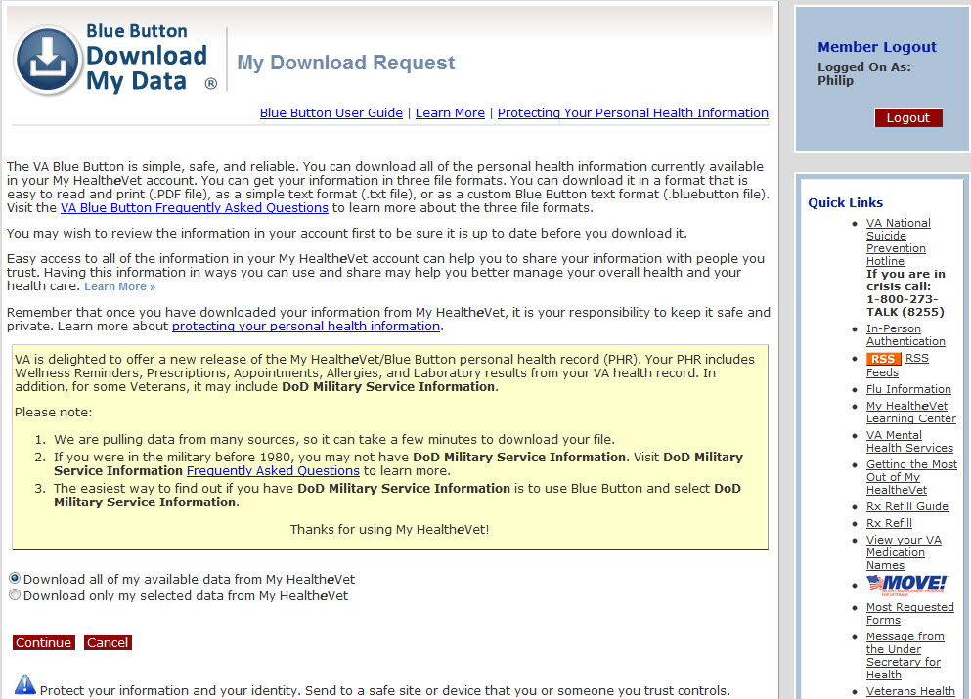
- Download your data file (the “BLUE BUTTON” formats to a .txt file – the HEALTH INFORMATION CARD simple prints/appears as a single sheet). From the BLUE BUTTON output - highlight the data that you entered.
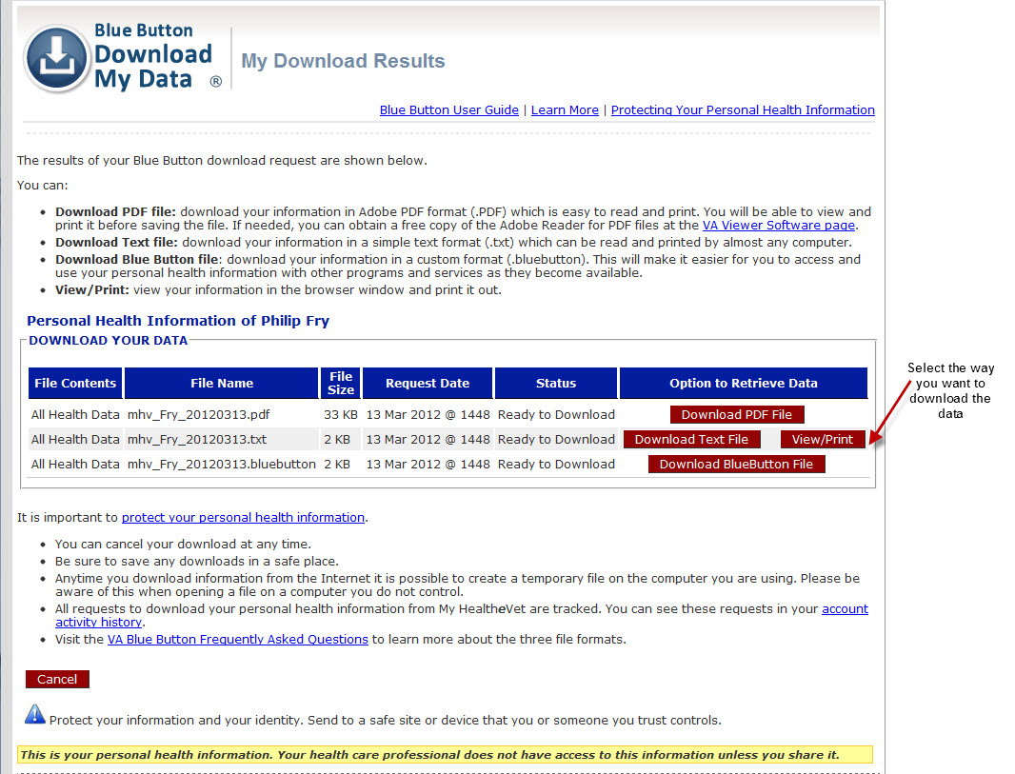
- Check with your instructor for submission instructions.

NOTE to Instructors: It may be more efficient for students to reduce the size of the BLUE BUTTON file for submission. My Healthe-Vet pulls a large amount of prior prescriptions and medical record data ─ which is exactly what it is supposed to do (allowing the patient to take large parts of their medical records & history with them).

However, it may be too extensive for submission. Your instructors will inform you what output of the, “BLUE BUTTON,” should be turned in.

It may be a good learning experience for you to examine the pros and cons of providing this information to the patient and/or to figure out how to make rows and rows of text data more useable and understandable.

Objectives:
- Suggest HIT-enabled solutions/strategies to enhance patient involvement in health and healthcare
- Assess the effectiveness of HIT systems in supporting patient-centered care

