
School of Engineering (TAFE)
Assignment / Project Cover Sheet

Student Name/s:
Student ID No/Nos: | ID_________________ Class: ________________
Assessment Due Date: |  | Assessment: 2  Assessment Weighting 20%
Course (Competency) Title: | Interpret and Process Survey Data
RMIT Competency Code: | CIVE5660/BUIL5995C | National Unit Code:
Assignment/Project Title: | Traverse and Feature & Detail Survey
Instructions to Students:
- Late submission approval will be in line with RMIT policy Application for extension of submittable work (7 calendar days or less) form.
- Special consideration for assessment Application for special consideration form.
- Students must attach a copy of the ‘Assignment Coversheet’ to the front page of all submissions for assessment. This cover sheet is available from SOET Reception, Building 57, Level 5.
- For areas student were deemed NYC: outline agreed deadlines for the student to demonstrate competency
- The date(s) must be within enrolment dates for the this competency otherwise the student will need to re-enrol and an overall result of NYC will be recorded.
Assessment Activity/Task | Grade*  (As applicable) | Feedback/Gap Resolution/ Action Plan
Traversing | 8
Feature Survey | 6
Report | 4
JSA | 2
* Graded assessment only Assessors: Stephen Falzon/William Ntuwah
Overall Result for this task /20 Date: __________________________

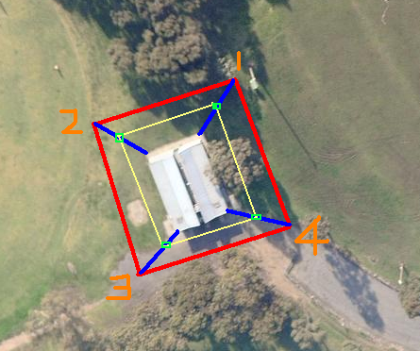

INSTRUCTIONS
You are required to traverse around the Toilet West block, radiate to the corners, take offsets and radiation to trees surrounding the toilet block.

TASK 1

- Measure the length and width of the toilet block.
- Traverse from peg 1, 2,3 and 4 by measuring bearings and horizontal distances on FL & FR. Radiate to the range poles and measure offsets from the corners of the toilet block
- Radiate to the trees that are near the instrument station.
- Determine misclose of the traverse bearing (it should be less than 40”) and accuracy.
- Compare measured lengths of the toilet block to measurements computed from traversing.
- Plot details from your field notes and determine the accuracy.
- Prepare a report that outlines the purpose, procedures, equipment, formulae and computations involved in carrying out this exercise. Include details of the accuracies achieved and any problems encountered, the possible causes of such problems and suggested changes to the process to improve the results.

TASK 2

1) Radiate to the 4 Range poles from instrument stations 1, 2, 3 and 4 respectively to
determine the positions.
2) Take offsets from line joining range poles to the corners of the toilet block and chainages
on all four sides.
3) Plot the corners of the block from chainages and offsets. Compare with measured distances.

SDN 1364 SETTING OUT CORNERS OF A BUILDING BY TRAVERSING AND RADIATION

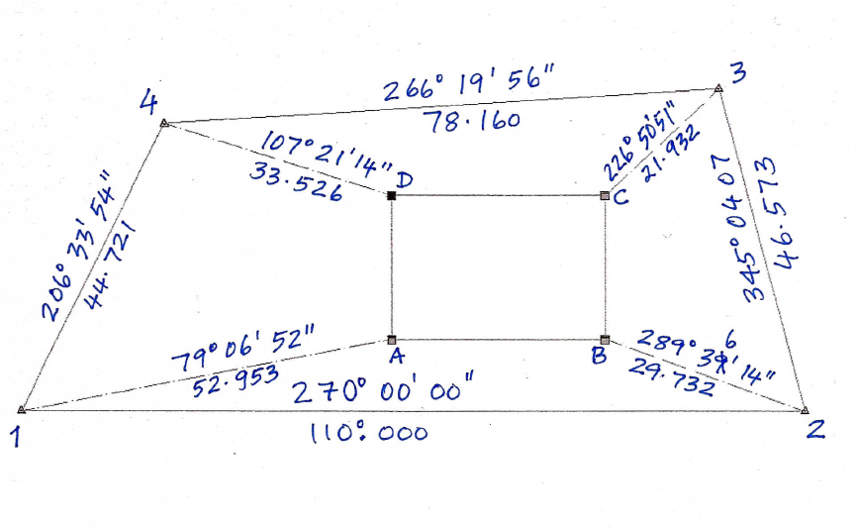

AT | TO | BEARING | DISTANCE
2 | 1 | 270º 00’ 00’’ | 110.000 | FL
 | 3 | 345º 04’ 10’’ |  | FL
 | 3 | 165º 04’ 06’’ |  | FR
 | 1 | 90º 00’ 02’’ |  | FR
3 | 2 | 165º 04’ 07’’ | 46.573 | FL
 | 4 | 266º 19’ 58’’ |  | FL
 | 4 | 86º19’ 56’’ |  | FR
 | 2 | 345º 04’ 09" |  | FR
4 | 3 | 86º19’56’’ | 78.160 | FL
 | 1 | 206º33’58’’ |  | FL
 | 1 | 26º33’52’’ |  | FR
 | 3 | 266º19’58’’ |  | FR

AT | TO | BEARING | DISTANCE
1 | 4 | 26º 33’ 54’’ | 44.721 | FL
 | 2 | 90º 00’ 00’’ |  | FL
 | 2 | 270º 00’ 02’’ |  | FR
 | 4 | 206º 33’ 56’’ |  | FR
1. Compute the coordinates of the traverse points:
Station | Bearing | Distance | ∆E | ∆N | E | N
1 |  |  |  |  | 1000 | 5000
1-2 | 90º 00’ 00’’ | 110.000
2-3 | 345º 04’ 07’’ | 46.573
3-4 | 266º 19’ 56’’ | 78.160
4-1 | 206º33’54’’ | 44.721

SDN 1364 SETTING OUT CORNERS OF A BUILDING BY TRAVERSING AND RADIATION

2. Radiations were taken from traverse stations to corners of the building. Compute coordinates of A,
B, C and D

From | To | Bearing | Distance | ∆E | ∆N | E | N
1 |  |  |  |  |  | 1000 | 5000
 | A | 79º 06’ 52’’ | 52.953
2
 | B | 289º 39’ 14’’ | 29.732
3
 | C | 226º 50’ 51’’ | 21.932
4
 | D | 107º 21’ 14’’ | 33.526

3.Plot the corners of the block from bearing and distance. Compare with computed dimensions of
the building from coordinates of A, B, C and D

SETTING OUT BY OFFSETS & CHAINAGES

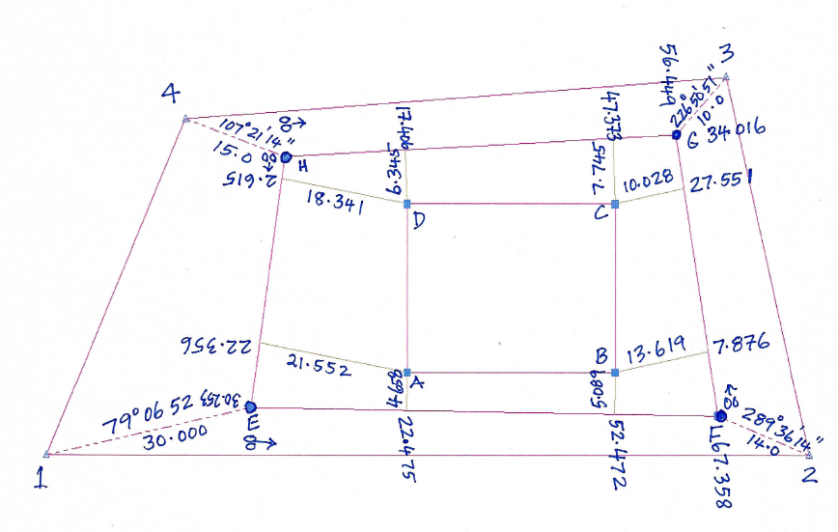
4. Plot the corners of the block from chainages and offsets. Compare the dimensions of the block with
the one determined by traversing and radiation.

