Gaurav

Second assessment
Website of converse
Gaurav kayastha
Stubent no : 12729/0061025769

Content
About business……………………………………Page no3
Web application linked with IIS……………Page no3
Web forms in the solution explorer………Page no3
Information about date entry and validation…………………………………………….Page no4
Data entry prototype…………………………..Page no 4
Data base and table…………………………….page no 5

About the business (Converse)
This is the website which sells a revolutionary show and most popular shoe in youngster. Around 1908, marquis mills converse decided to start a rubber sneaker company. Everyone has a history and account of the things they have done during the time they have been around the world. This rubber show has change the world and brought revolution in fashion world. This shoe is most common and most popular sneakers around the world. This website not only sells shows but also the other clothing like t-shirts, jumpers, shocks etc.
Web application linked with IIS
This is the screen shot of web application linked with iis
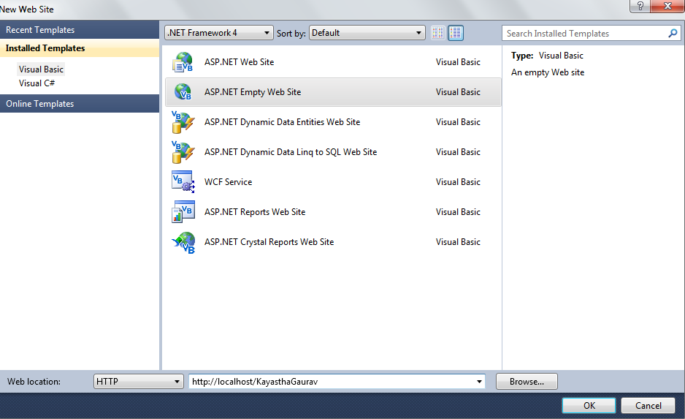

Web forms in the solution explorer
This is the screen shot of solution explorer which contain the

Information about data entry and validation
Data | Data Type | Database type | Validation control | Validation in code-behind | Valid input | Reg. Expr.
first name | String  Text box | Text | Required field  validator | Validation method in a Customer class | Must not be left blank
Last name | String  Text box | Text | RequiredField  Validator | Validation method in a Customer class | Must not be left blank
Email | String  Text box | Text | RegularExpressionValidator | Validation method in a Customer class | Must be valid email format | Internet e-mail address
contact no | String text box | Number | Regular Expression Validator | Validation method in a Customer class | Must be valid mobile no with area code | Valid mobile number
Date of birth | String text box | String and in number | Regular Expression Validator | Validation method in a Customer class | Must no be date after today | Valid date
Area code | String, drop down box | Integer | Required field validation | Validation method in a Customer class | Numbers only
password | String integer | Integer string | Range validator | Validation method in a Customer class | Numbers and text must not be blank
Payment |  | Number | Range validator | Validation method in a Customer class | Credit card no

Data entry prototype

Database and tables

Xml
<productdetails>

- <product>
- <productID>101</productID>
- <productname>Desktop Computers</productname>
- <producprice>$500-$1000</productprice>
- <description>Different brands such as Dell, Toshiba, Hp , Sony are in cheap prices today . Hurry up !!!!!</description>
- </product>

- <product>
- <productId>102</productId>
- <productname>Laptops</productname>
- <producprice>$1000-$3000</productprice>
- <description>Different brands such as Dell, Toshiba, Hp , Sony are in cheap prices today . Hurry up !!!!!</description>
- </product>

- <product>
- <productId>103</productId>
- <productname>HardDisk</productname>
- <producprice>$100-$300</productprice>
- <description>Different brands such as Dell, Toshiba, Hp , Sony are in cheap prices today . Hurry up !!!!!</description>
- </product>

- <product>
- <productId>104</productId>
- <productname>Printers</productname>
- <producprice>$100-$1000</productprice>
- <description>Different brands such as Dell, Toshiba, Hp , Sony are in cheap prices today . Hurry up !!!!!</description>
- </product>

- <product>
- <productId>105</productId>
- <productname>ADSL</productname>
- <producprice>
- $100-$500</productprice>
- <description>Different brands such as Dell, Toshiba, Hp , Sony are in cheap prices today . Hurry up !!!!!</description>
- </product>

- <product>
- <productId>106</productId>
- <productname>Pen Drives</productname>
- <producprice>
- $10-$100</productprice>
- <description>Different brands such as Dell, Toshiba, Hp , Sony are in cheap prices today . Hurry up !!!!!</description>
- </product>

- <product>
- <productId>107</productId>
- <productname>Software Packages</productname>
- <producprice>$100-$5000</productprice>
- <description>Different Software packages are available in cheap price today only . Hurry up !!!!!</description>
- </product>

- </productdetails>

