MGM355-1404A-01
Quesadra D. Goodrum
Individual Project Phase 4
Colorado Technical University
Instructor: Juan Roman
11/03/2014

Table of Contents
Abstract 2
Introduction 2
Possible challenges in the new environment 2
Legal and political environments 3
Government involvement in the private sector 3
Type of economic system in China 4
China’s involvement in international trade 5
The chosen location 7
Overall assessment as a manager 7
Advising an MNC on Latin America investment plan 8
References 9

Abstract

Starting up an organization in a foreign country can be difficult. There are a lot of factors to take into consideration before endeavoring on an adventure of this kind of magnitude. During the course of this paper I will cover all of the important factors a company would need to consider before launching into international expansion.

Introduction
Launching on the endeavor of international expansion can be taxing on the mind as well as the organization. There are a number of factors that exist that need to be included. Items to consider are things such as barriers which may exist for instance upon entry into a foreign countries economic market. Other such variables to consider are the countries legal system, consumer base, your companies possible growth would fair, your international economic performance, and the cultural influences surrounding your chosen markets. If your organization fails to dissect and correctly interpret these factors can have a major impact on the success of your organization and thus become detrimental to organization (Schill, 2014). The course of this paper we will talk about all the factors affecting the expansion of a regional bank. In addition, to all that it would need to place into consideration before launching a move towards international expansion into China for this case. For instance the Union Bancshares (UNB) is a Californian based regional bank.

Possible challenges in the new environment
A myriad of perspectives are at play when it comes to what one views as possible challenges. One must take into consideration the discrepancies in the level and quality of education an individual receives the cultural differences at play, in addition to other social demographics at play. When one refers to culture it is merely the social of norms of its members within the society itself. The differences between right and wrong are both determined and defined by the society itself. Individuals within the organization feel the effects of cultural differences on an everyday bases because organizations today are multicultural. We will take a look at the UNB. In order for the UNB to achieve its goal in attaining a positive reputation in the public sector the company itself will need to become diverse or in short multi-cultural.
Despite the conflict that is sure to arise from making the move into being a culturally diverse organization. However, take in mind that simply differing cultural expectations place on individuals by society it will only ensure poor performance which will negatively impact the organization. In addition to cultural diversity an organization also faces the level of education between individuals and potential employees within the area the company is choosing to establish itself. Certain technical programming personnel might be inadequate in persuading China and UNB’s management to agree in the outsourcing of workers from various foriegn locations. The hesitancy in them agreeing to these terms is due to the fact that this can be a costly process.

Legal and political environments
Chine has a pliable legal system in place which differs from the most static systems. This in itself presents huge challenges for foreign investors which needs to be overcome. Laws in China can change at a moment’s notice when it comes to foreign investors which can ultimately yield a negative impact during the time of the investment. The current laws that govern the business sector inside the PRC (People’s Republic of China) are drawn up by the NPC (National People’s Congress). This is the judicial system that is in place that has been delegated to make sure that all parties comply with the current governing laws. When considering whether or not to make a foreign direct investment they key thing is to know in great detail both the pros and cons of the industries business and what gains that China’s economy has. As long as the gains are great and pros outweigh the cons then all factors are satisfied and the venture should be a go. China is a politically stable country this is a positive indicator for UNB. Because of this indicator it means that business operations are not likely to be disrupted due to political clash.

Government involvement in the private sector
In contrast to how we conduct business here in the US our practices are used as a method to gauge how much the government intervenes with in the private business sector in PRC. To illustrate this concept refer to the table below.
Table 1
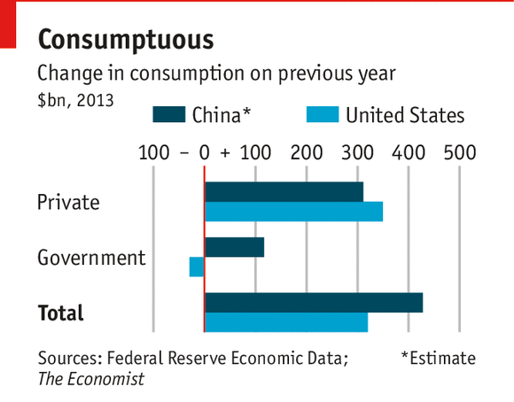
The above tablet indicates that the Chinese government involvement in private sector business practices is less than that of the United States. This could be simply due to the fact of regulatory methods already in place. Intervention has both its advantages as well as its disadvantages when it comes to the Chinese economy and the UNB. My suggestion would be to weigh both sides of the matter before proceeding any further. The more the government intervenes in business mean that harsher and more regulative measure are incorporated and put in place. This makes it a very costly measure in which to run business in. This is because the amount of revenue collected is then split in accordance with agree terms and percentage’s thus reducing the level of ROI (return of investment) seen

Type of economic system in China
In existence today there are a multitude of economic systems at play. The main four economic systems used in societies today are command, market, mixed and traditional economic systems. Since we are thinking of conducting business in China that is where our primary focus will be. China economic system is a mixed economics (Naughton, 2007). It is a mix between both market as well as command systems. This places the Chinese government in full control of major resources that are crucial in determining the operations of one’s business. The system in place is an advancement of the traditional economic system where no centralized regulation of businesses and resources exist. When resources increase it creates a need for the federal government to take control of the use of the resource this kind of system existed in China until 1949 when the command economic system replaced it and was put into use.
There are many events that can have such a profound and negative impact on an economy. One such instance for China is the The Korean war of 1952 it lasted four long years and it took such a toll on the surrounding markets that it called for modification of the cultural framework. This modification took place between the years of 1968 to 1976. It resulted in instrumentation of the nation’s economic resources by adopting a market economic system in 1980 (Drabek and Mavroidis, 2013). From 2005 to date, a mixed economic system has been witnessed. Growth of GDP in each economic system is presented below from 1952 to 2004.

Table 2
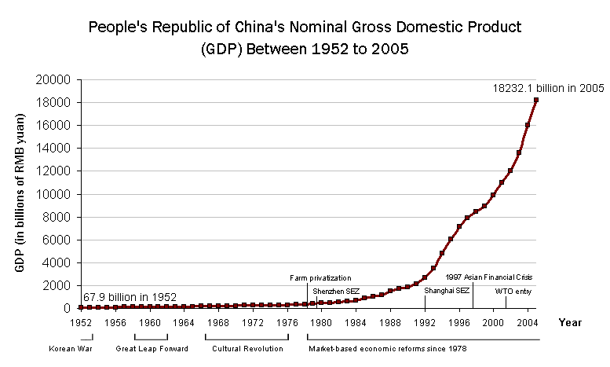

China’s involvement in international trade
China is the second largest economy globally by GDP after the US. In addition, China is one of the lead countries when it comes to impacting global economics. Much like the United States China does a lot of Importing and Exporting. Australia Is China’s main trading partner with all of Australia’s Importing and Exporting firms inside of China it makes up a significant portion of China’s foreign investors. The regulatory functions in place help the government function. It does this by setting taxation and monitoring it. In addition to monitoring the nature of imports as well as exports which helps the government formulates new policies to ensure better business practices. With China’s encouragement of importing and exporting it will help UNB’s investments in the country. UNB will be the facilitator of foreign exchange services, financial consultation, and money lending services, and other banking services for foreign investors, not only from Australia but across the globe.
UNB presence in China will help influence other investment plans the organization has for expanding eastward. China will be UNB central market and from it investments into other developing markets will be made. Markets such as: Pakistan, Malaysia, Thailand, Cambodia, Kazakhstan, and Taiwan. China is a major consumer for these nations due to its ever growing population. Due to this fact it will act as the central source of supplies in these nations. As the regional lead banking institution it will make it easier to identify and aid developing countries. The image below strengthens the central location of the ‘economic powerhouse’, China, which is surrounded by many developing nations with investment opportunities for UNB.
Figure 1
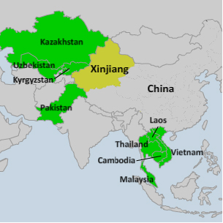
China is involved in regional integration efforts; it supports the come-together of nations in facilitating regional trade and other developmental factors. It is a member of the Asia Cooperation Dialogue (ACD) of which Laos, Japan, South Korea, Pakistan, Thailand, Vietnam, Cambodia, India, Indonesia, Myanmar, Philippines, Singapore and Brunei are member states. The purpose of ACD is to foster collaboration of the member states through intertwining of their political, economic and educational plans. Additionally, it is in place to ensure the previously separate regional organizations in the East such as ASEAN and SAARC are integrated together. This is a clear demonstration that China is in full support of regional integration.

The chosen location
There are a myriad of reasons making China the ideal choice for our investment destination for a regional bank like UNB. Because of the surrounding well performing economic sectors it plays as an important factor that will aid in a steady flow of new participants entering into the Chinese market. UNB will act as a mediator transferring monies between both buyer and seller. Our neutral political stability will be a factor which reflects out internationalism thus encouraging more foreign investments in China with few legal limitations. UNB good relations with the US and China makes UNB a safe and successful investment choice for developing markets.

Overall assessment as a manager
Taking a look at our current situation from the perspective as a manager facing expansion in foreign country requires major contributions in the banking sector and a heavy investment the risk faced by the business are great. Being the manager of UNB regional bank it would be my recommendation to assess the areas and the risks associated with them before making a final decision. Uses the information gathered and create your risks and risks level matrix. Weigh the benefits that can be seen by the stakeholders and then decided on the best way to enter into the market.
There is risk associated with any endeavor. The key is to assume as low a risk level as possible to ensure the success of one’s business. Due the fact that China is economically stable the risks associated with it are minimal at best. China’s high performance market would prove beneficial for business as well as the stakeholders. Increase return on investment for the company means higher dividend payouts for shareholders. The idea is to set attainable objectives and goals for the company to achieve. Embark on a joint venture to establish the organizations presence in the foreign market. This would prove more suitable for future operations as well as reducing the risks associated with the venture even further.

Advising an MNC on Latin America investment plan
A Multinational Corporation (MNC) is a large firm with global operations. To facilitate its financing in Latin America, assessment of foreign currency risk should be considered as an important factor for the company’s management. Foreign exchange rates are never static; they keep changing from time to time in accordance with world economic performance. 1 Chinese Yuan equals 0.16 US dollars. This figure may increase or decrease with time. To succeed in its foreign investment plans, the MNC’s management should put in place measures that monitor performance of the dollar and enter Latin American market at the time when the exchange rate is at its lowest. This will ensure that the company faces minimal financial milestone.
Swap and Exchange-traded fund are the two foreign exchange instruments that the MNC may use to minimize foreign exchange risks. The latter are open ended investment companies that are capable of being traded daily while Swap is an exchange between two parties over a given period of time. Both instruments help cushion the risk associated with currency fluctuation.

References
Drabek, Z., & Mavroidis, P. C. (2013). Regulation of foreign investment: Challenges to international harmonization. Singapore: World Scientific Publishing Company.
Naughton, B. (2007). The Chinese economy: Transitions and growth. Cambridge, MA: MIT Press.
Schill, S. (2014). The multilateralization of international investment law.
Wang, L. (2011). Foreign direct investment and urban growth in China. Burlington, VT: Ashgate.
XE: (USD/CNY) US Dollar to Chinese Yuan Renminbi Rate. (n.d.). Retrieved from http://www.xe.com/currencyconverter/convert/?Amount=1&From=USD&To=CNY

Consumptions Table
China’s GDP
UNB affected Region

