HW5: Logistic Regression

1. Marentette and El-Masri (2011) used logistic regression to identify predictors of obtaining seasonal influenza vaccination among hospital-based nurses in Canada. Their results are shown in table 1:

Table 1. Logistic Regression Model of Independent Predictors of Influenza Vaccination.
Predictor | β | SE | OR | 95% CI
Vaccination in previous season | 3.55 | .50 | 34.81 | (12.99, 93.28)
Job at risk | 2.50 | .95 | 12.14 | (1.87, 78.08)
Immune system protects | -1.24 | .50 | 0.29 | (0.11, 0.77)
Inconvenient | -1.50 | .56 | 0.22 | (0.07, 0.67)
Workplace clinics | 1.06 | .48 | 2.88 | (1.12, 7.38)

The following questions are based on the results shown in table 1 above. Read each statement and indicate whether the statement is true or false.

a. Nurses who think their job is at risk if they are not vaccinated are 12 times more likely to be vaccinated than nurses who do not perceive that their job is at risk.

b. The perception that obtaining the vaccine was inconvenient was not a significant predictor of whether a nurse would be vaccinated.

c. The best predictor of obtaining the influenza vaccination was whether or not the nurse had received the vaccination in the previous season.

The remaining questions are based on Table 2 below.

The table is from the following study:

Cardwell, C.R., Shields, M.D., Carson, D.J., & Patterson, C.C. (2003). A meta-Analysis of the Association Between Childhood Type 1 Diabetes and Atopic Disease. Diabetes Care, 26, 2568-2574.

Table 2. Meta-analysis of the Association between diabetes and asthma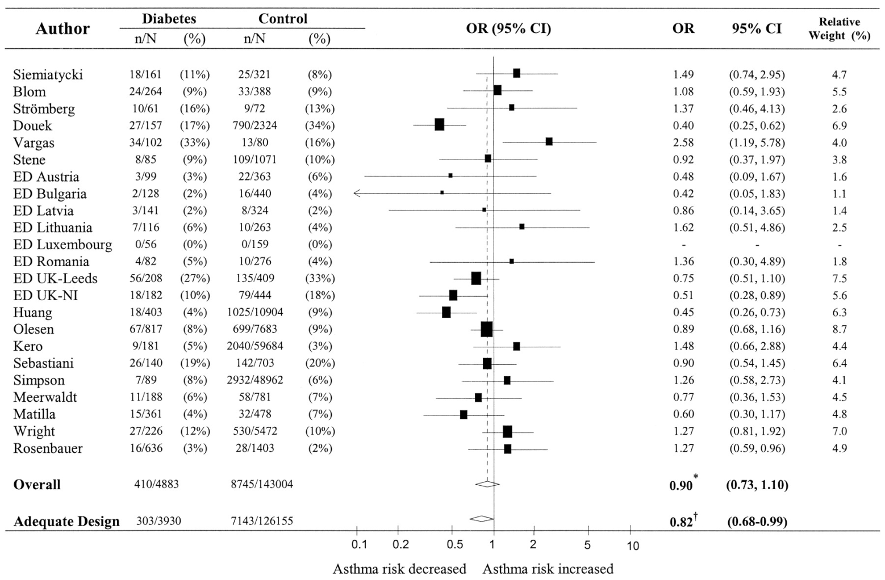
- From table 2, which articles reported significant results? List the name of the author as appeared in table 2, the OR, 95% CI, and the direction indicating lower risk or higher risk of asthma among patients with diabetes.
- For the study by Douek, how many of the sample had diabetes? How many did not have diabetes (control)? What is the total N?
- For the study by Douek:
  - Whatwas the prevalence of asthma among people with diabetes?
  - What was the prevalence of asthma among the controls?
  - What was the RR? (you need to calculate the RR)
  - Interpret the results based on the reported percentages and OR

- Overall, how many subjects with diabetes were included in all of the 23 studies? Among them, how many had asthma? How many subjects without diabetes were included all the studies? Among them, how many had asthma?
- What were the overall OR and 95% CI? Was the result significant?

